

**CYBER-PHYSICAL SYSTEMS**

**AND IOT SECURITY**

**2024/2025**

**Prof. Alessandro Brighente**

Written by Michael Amista’

**Index of contents**

1. Course program 3

2. Introduction 4

3. CAN bus 7

3.1 Data transmission 9

3.2 CAN bus access and attacks 13

3.2.1 The BUS-OFF attack 15

3.2.2 WeepingCAN attack 22

4. Keyless Car Security 26

4.1 Replay attack 27

4.2 Rolling Codes 29

4.3 RollJam/RollBack attack 31

4.4 AUT64 33

5. Autonomous Vehicles 37

5.1 Control systems 38

5.1.1 Types of controllers 38

5.1.2 Adaptive Cruise Control (ACC) 40

5.1.3 Cooperative Adaptive Cruise Control (CACC) 41

6. Drones Security and Privacy 48

6.1 Safe Hijacking 55

7. Industrial Systems Security 62

7.1 Attacks and Detection in ICS 80

7.1.1 Honeypot 91

7.1.2 Stuxnet 99

8. IoT Security and Privacy 109

8.1 IoT Authentication 120

8.1.1 Group Pairing and Key Exchange 126

8.2 Remote Attestation 133

# **1. Course program**

**Fundamentals**

• What is a Cyber-Physical System

• Security Requirements in CPS

**Automotive Security**

• The CAN bus protocol

• Error handling in CAN bus and bus-off attack

• Network attacks on CAN bus

• Keyless cars security and attacks to distance bounding protocols

**Autonomous Driving**

• Introduction to controllers

• Levels of automation and modes of operation

• Attacks on controllers and countermeasures

**Hardware Security**

• Execution flow of modern processors

• Evict+Time, Prime+Probe, Flush+Reload

• Spectre and Meltdown attacks

• Side channel attacks

**Drones**

• Drone components and basic functioning

• Protocols for drone location and fail-safe procedures

• Drone detection systems

**Industrial Control Systems**

• Industrial Control Network Protocols

• PLC and their functioning

• Attacks and countermeasures to industrial control systems

**Internet of Things**

• Network protocols for the internet of things

• Remote attestation

• Intrusion and anomaly detection

# **2. Introduction**

**Cyber-Physical Systems** (**CPSs**) are characterized by the deep complex intertwining among:

* the world of **Operational Technology**, or **OT** [*physical / mechanic operations*];
* the world of **Information Technology**, or **IT** [*communication operations*].

In CPSs there are devices that create and send information [*IT devices*] (for instance, with the CAN bus) and some devices that receive the information and do physical operations [*OT devices*] (example: steering the wheel).

Some examples of CPSs are smart grid, smart cars, industrial control systems, e-Health devices.

**Traditional IT Systems**  VS **Cyber-Physical Systems**

 

In this scenario we still have the IT system structure, but we also have the **OT devices** and some monitoring infrastructure to control their flow (*example*: car without physical keys 🡪 the monitoring infrastructure needs to check if the car is really closed when we are not near it).

Anyway, **adding new devices to a standard IT system means that the number of breakpoints increases 🡪 more possible attacks**. If we don't have security manager, we cannot know if all devices are working correctly.

Security: capability of a system to stand the possible security attacks. More layers that manage the security of the systems 🡪 just one is not enough 🡪 assume we have different controllers for all the devices, if one falls the entire system doesn't fall.

In this scenario we have devices connected to the network. In this type of system, the possible attacks are limited with the communication parts and/or the connected devices.

Basic idea: If I want to get the information generated by IT Systems I must access to the device or to the active communication.

According to the literature on Cybersecurity, **CIA paradigm** is reversed:



**Top 🡪 down priority**

In our case the most important problem is the **availability of the system**. If nothing is responding we are not able to control if all devices are working correctly.



***Confidentiality***: only the confidential parts of the system should have access to the information. If we are storing customers data, we don't want others to access to this information.

***Integrity***: the detected information should not be manipulated by others --> example: man in the middle.

***Availability***: we want the usability of the system when requested.

**Examples of CPSs**:

In the car we have some different devices (battery, breaks, small computer, etc.) and these devices are all connected to the CAN bus (Controller Area Network) that permit to connect different electronic devices. **But each CAN bus represent a possible point to attack**.

Another important device/possible breakpoint is the antenna that connect the car to the outside 🡪 the car delivers and receive information.

**Vehicles platoon**

Benefits of organizing vehicles in platoons: Fuel Efficiency; Road Capacity; Road Safety; “Greener”.

A vehicle can also communicate with another one. For example: communicate to the platoon that the initial vehicle is breaking so the other ones can break.

**Industrial Systems**

- have dedicated networks and components;

- operational technology + information technology;

- dedicated computing systems.

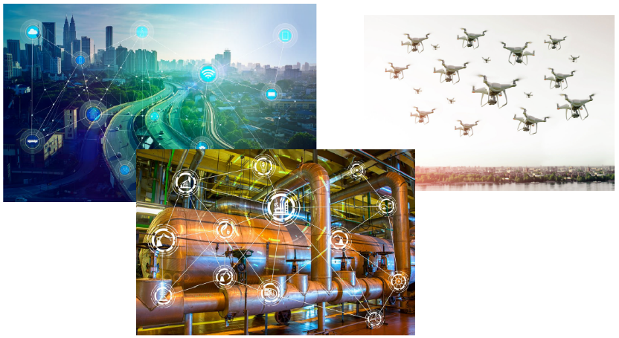**IoT devices** are resource constrained and battery limited devices. Data provided by IoT devices can be altered by an attacker and since IoT devices manage important systems it is crucial to consider even in this scenario the possible attacks.

# **3. CAN bus**

What is there in a car? A lot of different interconnected devices:



Modern vehicles contain a large number of **Electronic Control Units** (**ECUs**). ECUs areembedded systems that control one or more (sub)system in a car or other vehicles and connected to the CAN bus. Examples: engine control module, powertrain control module, transmission control module, suspension control module.

ECUs are nodes in a rather complex in-vehicle network, where they should communicate one another to report many different types of information.

**Controller Area Network** (**CAN**) is an in-vehicle network bus-based standard developed in 1986 by Bosch. It allows in-vehicle components (ECUs) to communicate one another. It has broad application in automotive systems, including power train, suspension, and braking. The problem in CAN bus communications is the security, we do not have any implemented control.

The Society of Automotive Engineers (SAE) standardized CAN bus communications to have asynchronous data rate up to 1 Mbps at a 40 m distance. Maximal cable lengths should be between 500 m (125 kbit/s) and 40 m (1 Mbit/s).

Why CAN bus:

* **Robustness**: ideal for safety applications thanks to its durability and reliability (bit stuffing, bit monitoring, frame check, ack and CRC checks).
* **Low cost**: objective is to reduce errors, weight, wiring and costs.
* **Flexibility**: it is a message-based protocol, so nodes can be added or removed without updating the system. First security problem: the system is easily reconfigurable.
* **Efficiency**: messages with high priority are clearly marked and have prioritized access to the bus.

To achieve reliability, it is important to prevent message collision such that no data gets lost. Furthermore, thanks to the shared bus and the message handling system, CAN allows for a reduced number of wires to achieve reliability. Redundancy is the best way to achieve reliability, however it comes with a higher communication implementation cost (huge number of wires). Point-to-point communications were used before CAN bus but since modern vehicles have a large number of ECUs a lot of wired connections are costly and difficult to place efficiently in a car.

**CAN BUS ARCHITECTURE**



**ECU ARCHITECTURE**

1) **MICROCONTROLLER**: the host processor (also called *microcontroller*) decides what the received messages mean and which messages it wants to transmit. Sensors, actuators and control devices can be connected to the host processor.

2) **CAN CONTROLLER**:

- **Receiving**: the CAN controller stores the received serial bits from the bus until an entire message is available, which can then be fetched by the host processor (usually by the CAN controller triggering an interrupt).

- **Sending**: the host processor sends the message(s) to transmit to a CAN controller, which transmits the bits serially onto the bus when the bus is free.

3) **CAN TRANSCEIVER**:

- **Receiving**: it converts the data stream from CAN bus levels to levels that the CAN controller uses. It usually has protective circuitry to protect the CAN controller.

- **Transmitting**: it converts the data stream from the CAN controller to CAN bus levels.

## **3.1 Data transmission**

CAN bus uses **differential wired-AND signal**. ECUs emit two signals (two voltage values) to send a message: CAN High (CAN-H) and CAN Low (CAN-L). They are either driven to a *dominant state* with CAN-H > CAN-L or driven to a *recessive state*, with CAN-H ≤ CAN-L.

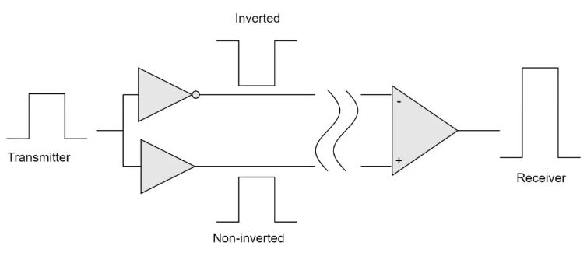**Differential**: once the signal is emitted an inverted signal is computed and the received signal corresponds to the original signal minus the inverted signal. This is done to avoid interference providing robust transmissions.

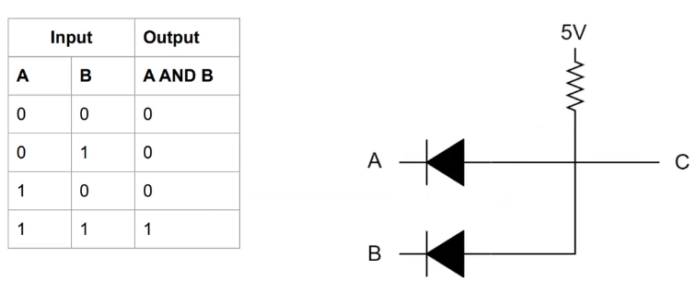

**Wired-AND signal**: basically, we are implementing the AND operation considering the two different voltages values applied to CAN-H and CAN-L lines and computing so the transmitted bit.

The CAN specifications use the terms ***dominant bits*** and ***recessive bits***, where **dominant is a logical 0** (actively driven to a voltage by the transmitter) and **recessive is a logical 1** (passively returned to a voltage by a resistor). The idle state is represented by the recessive level.

By using this process, any node that transmits a logical 1, when another node transmits a logical 0, loses the arbitration and drops out. A node that loses arbitration re-queues its message for later transmission and the CAN frame bit-stream continues without error until only one node is left transmitting. Since the 11 (or 29 for CAN 2.0B) bit identifier is transmitted by all nodes at the start of the CAN frame, the node with the lowest identifier transmits more zeros at the start of the frame, and that is the node that wins the arbitration or has the highest priority.

Here below an example of a CAN bus transmission using two different voltage values corresponding to CAN-H and CAN-L (here highest voltage value corresponds to bit 1 and the smallest to bit 0 and that’s clear when the bit 1 collides with bit 0 the 0 wins):



**CAN FRAMES**

The standard CAN frame is composed by 8 message fields. CAN 2.0A and 2.0B differ in the length of the ID field (11 vs 29 id bits).

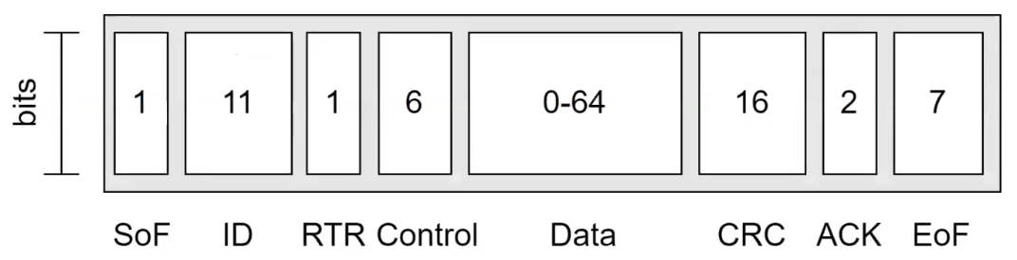

* **Start of Frame (SoF)**: dominant 0 to tell the other a node wants to talk.
* **ID**: frame identifier. *The lower the ID, the higher the priority*. **It is not an identifier of the sender** 🡪 not so important in broadcast communications like the CAN bus one, we do not need to know who the sender is.
* **Remote Transmission Request (RTR)**: indicates whether a node sends data or requests data from another node.
* **Control**: contains the Identifier Extension Bit (IEB) which is dominant 0 for 11 bits. It also contains the 4 bit Data Length Code (DLC) that specifies the length of the data bytes to be transmitted (0 to 8 bytes) 🡪 it tells us how much data we can transmit with this frame.
* **Data**: payload in common network terminology. CAN signals that can be extracted and decoded for information.
* **CRC**: check for data integrity. Not used for security purposes but only to check whether the received packet is the correct one (e.g. “if I send a command to brake, I want the car brakes”).
* **ACK**: indicates whether a node has acknowledged and received data correctly.
* **End of Frame (EoF)**: end of the CAN frame.

**VALIDITY OF THE CAN FRAME**

CAN frames need to satisfy certain conditions to be valid. If a node detects its transmission of an erroneous message, it takes actions accordingly. This is the **CAN bus error handling**, and **each node has its own error counter and state**. The state is in the set {active, passive, bus off} depending on the counter value.

An ECU transmits with certain voltage values to define the message to send, and the ECU can communicate these values to be sure that on the other part everything received has no errors. In this way it is possible to understand if the error originates from the sender or not.

Counters are **Transmit Error Counter (TEC)** and **Receive Error Counter (REC)** for each node:

* TEC = TEC + 8 if an error occurs during transmission (ECU fault)
* REC = REC + 1 if an error in the reception (not ECU fault)

TEC increases faster than REC because when the error originates from the transmitter node there might be some problem on that ECU, and it is better to signal it to avoid further errors. **Success decreases the counter by one in both cases**.

In CAN bus transmissions we can have five types of errors checked by CAN controller:

1. **Bit error**: occurs when an ECU, after comparing its transmitted bits with those on the CAN bus detects a mismatch (errors in converting bits to voltage values and vice versa).
2. **Stuff error**: after transmitting five consecutive same polarity-bits, the ECU sends an opposite bit to maintain soft synchronization. An error occurs if stuffing does not happen.
3. **CRC error**: computed one different from the received one (hashing code comparison).
4. **Form error**: if a fixed-form bit field (e.g. EoF) has a bit error the ECU raises a form error.
5. **ACK error**: when a node receives a frame it responds with a dominant bit in the ACK frame. If none respond, then ACK error.

When an error is detected, there are two types of error flags that can be transmitted on the bus:

1. **Active Error Flag**: six dominant bits – transmitted by a node, that is in error state error active, detecting an error on the network.
2. **Passive Error Flag**: six recessive bits – transmitted by a node, that is in error state error passive, detecting an active error frame on the network.

These error flags are transmitted to report the other nodes that the message transmitted on the CAN bus contains an error. Note: the error transmission violates the bit stuffing rule but with this method when a node receives 6 consecutive bits of the same polarity it can recognize that message is an error message because the bit stuffing rule does not permit 6 consecutive bits of the same polarity.



When an ECU transitions to the bus off mode it means that something serious is happening. *Limp home* state: to prevent accidents but still allow the driver to reach a safe place, the ECU in bus off usually runs with predefined parameters and reduced functionality. To return to error active mode, a reset or 128 occurrences of 11 consecutive recessive bits is needed.

**BUS ARBITRATION**

It refers to the process by which nodes get a share of the bus resources to transmit. CAN arbitration protocol is both **priority-based** and **non-preemptive**. The media access protocol alternates contention and transmission phases.

Non-preemptive: a message cannot be preempted by a higher priority one if this was queued after transmission began.

**Time is divided into slots, each with a length sufficient for a message to go back and forth in the whole bus**. A node wishing to transmit checks whether the channel is idle.

If bus is idle, ECU waits the next slot and starts a contention phase by transmitting a SoF bit.

All other nodes wishing to transmit send their ID. The CAN controller compares its output with the actual bus level at the end of each bit cycle.



S1 immediately loses, it begins with a recessive bit. Proceed with S2 and S3 bit comparison and S2 wins the arbitration at the 7th bit.

After the node that wins the competition terminates its transmission with an EoF, there should be new transmissions. The CAN bus uses a 3 bit inter-frame symbols to separate packets. After this, the bus becomes idle again and arbitration shall commence again.

## **3.2 CAN bus access and attacks**

To access CAN bus, you need to connect to the On Board Diagnostic (OBD) port. Basically, all cars nowadays use the OBD-II standard port. It is usually located near the driver’s or passenger’s seat. To talk with the CAN bus you need a converter, such as in the figure. This converts CAN bus data to something readable via a USB port.

**Attacker Model**

* Attacker can physically and remotely compromise more than one in-vehicle ECU in different means.
* The attacker objective is to manipulate or impair in-vehicle functions.
* Two means:
  + inject (attack) messages with a spoofed ID.
  + stop/suspend message transmission of the compromised ECU.
* Furthermore, ECUs can be **weakly** or **fully** compromised. Weakly compromised means an attacker cannot inject any fabricated message.

**Fabrication Attack**

* Requires a compromised ECU as a strong attacker to fabricate and inject messages with forged ID, DLC, and data.
* Objective: override any periodic messages sent by a legitimate safety-critical ECU so that the receiving ECU gets distracted or become inoperable.



**Suspension Attack**

* Requires a single weekly compromised ECU.
* Objective: stop/suspend the weakly compromised ECU’s message transmission, thus preventing the propagation of info to other ECUs.
* Detrimental also for ECUs that rely on the reception of such messages.



**Masquerade Attack**

* Need to compromise two ECUs, one as strong and the other as weak.
* Objective: manipulate an ECU while shielding the fact that an ECU is compromised.
* The attacker first monitors the traffic of the weak ECU.
* Once obtained the transmission period, stop the weak and use the strong instead.



The bus-off attack is a **denial-of-service attack** that exploits how ECUs access the bus.

The error handling mechanism of CAN bus forces ECUs that measure a certain number of errors to go bus-off 🡺 **the attacker exploits this feature to iteratively isolate ECUs**. Injecting attack messages, the adversary forces the TEC of an uncompromised/healthy victim ECU to continuously increase. Eventually, the attacker forces the error confinement to force the victim or even the entire network to shut down.

**Bus-Off Attack: Adversary Model**

* The attacker can compromise an in-vehicle ECU either physically or remotely to gain its control.
* We do not require the adversary to reverse engineer messages or checksums to be able to deliver the attack. In fact, messages have different structures depending on the manufacturer, but this is not central in bus-off attacks.
* Once the ECU is compromised, the attacker can inject messages with any ID, DLC and data on the CAN bus.

### **3.2.1 The BUS-OFF attack**

Suppose that a victim V periodically sends a message M. The attacker can hence deliver a successful bus-off attack if all the following conditions are satisfied:

1. C1: Using the same ID 🡪 in this way there is no winner and both ECUs have the same priority, this can cause an error, what we want to exploit.
2. C2: **Transmitting at the same time as M** (the tricky part of the attack). If the attacker transmission is not aligned with victim transmission the attack fails.
3. C3: Having at least a bit that is dominant in the attack message while being recessive in M (all preceding bits are equal).

The first step for an attacker is to observe and listen the channel to collect IDs and observe the **messages periodicity**, then it is possible to plan the attack using the gathered information.



**Phase 1: Victim in Error-Active**

* Both adversary and victim start in error-active mode, and the attacker targets one of the victim’s periodical messages.
* The attacker sends the malicious message and the victim’s TEC increases.
* The attacker’s TEC also increases, due to the stuff or bit errors triggered at the adversary node.
* Both nodes automatically retransmit the failed message.
* Thanks to the automatic retransmission, **the attacker brings the victim to *error-passive* by sending a single message**.



Note an important difference here: the victim’s error counter increases due to failed transmission of packet while attacker has an error due to the victim’s active error flag. So, the **victim and the attacker TEC increases in different times and for different reasons** 🡪 fundamental for the success of the attack.

**Phase 1 to 2**

* After 16 retransmissions, both victim’s and attacker’s TEC = 128 🡪 error-passive.
* As a consequence, the victim attempts the delivery of a passive error flag with 6 recessive bits.
* The passive error transmitted by the victim cannot override what is in the CAN bus, so the attacker successfully transmits its message and return to error active(attacker’s TEC = TEC -1).
* Due to the successful transmission, the adversary does not go to error-passive.



* TEC of victim and attacker differ mainly due to the time difference.

**Phase 2: Victim Error-Passive**

* Once the scheduled interval of the target message is elapsed, V retransmits M again.
* At the same time, the adversary reinjects malicious M.
* Since the victim is in error-passive, the attacker’s TEC decreases by 1, whereas the victim’s increases by 7 (+8 -1) thus maintaining the error-passive.
* The attacker iterates until the victim’s TEC > 255, i.e., bus.



**Important note**: remember that CAN ID do not contain actual information on the transmitter. The ID contains information that define the time interval and priority of messages. The attacker should hit low-value IDs (dominant) to disconnect possibly safety-critical ECUs.

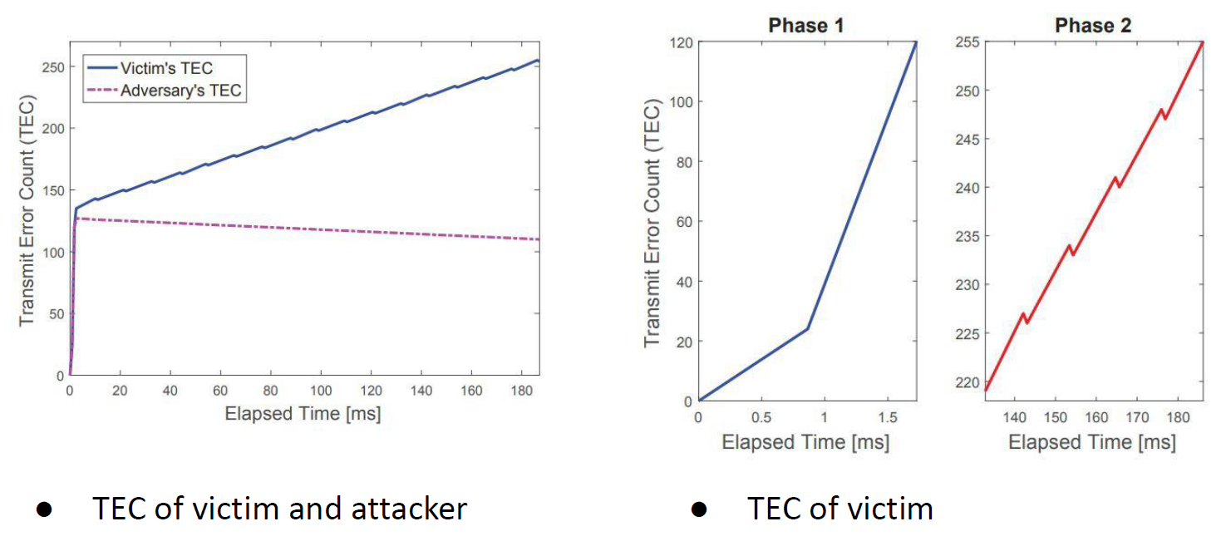

**Where to modify frames?**

* In order to satisfy C3, the attacker needs to have a dominant bit where the victim has a recessive one. All preceding bits are equal.
* Since IDs should be the same (C1), the dominant bit should be either in control or data fields.
* CRC and ACK are set by the CAN controller and cannot be altered by the attacker.
* As CAN messages usually have at least one and non-zero data values, modify either DLC or data values to all 0s.
* Given that DLC is constant over that for each CAN ID, the attacker can learn the value and modify the DLC accordingly.

**DIFFICULTIES OF THE BUS-OFF ATTACK**

**ECUs cannot acquire the IDs of all received messages**. Only of those that pass through its message filter. We can distinguish hence between receivedmessage (that we only see and read the content) and accepted message (messages that contains some information related of what we have to do, some physical operations for instance).

The attacker can only read the ID from accepted messages, and he can create only messages with the same ID depends on the filter of the victim ECU 🡪 if there is no filter then done, but filters can be remotely manipulated.

Another problem of the bus-off attack is that we need **precise synchronization**, so if we don’t transmit the malicious packet as soon as the victim is transmitting its packet then the attack is not going to work.

We can achieve the synchronization without taking care about the exact time of the victim’s transmission: **all messages and priorities are periodic, and we can exploit this to infer when a certain message is going to be transmitted** (preceded message). Usually when a packet’s transmission in the CAN bus ends, we wait for 3 bit-time before starting the transmission.

Non-Empty Message Filter

* The compromised ECU only accepts messages with a certain (range of) ID. This however does not represent a restriction for the attacker in compromising it.
* The attacker can directly modify the message filter of the compromised ECU via software commands.
* For some controllers, the configuration mode can be triggered via user instruction through the Serial Peripheral Interface.

Transmission Synchronization

* Knowing everything about ID and how to modify the message, the attacker needs to know when to send it.
* Precise synchronization is essential iteratively for the success of the attack.
* If there is as little as one bit de-synch, there would be no two arbitration winners and attack fails.
* The attacker may leverage the periodicity of CAN frames and send a message every T (estimated by observing the traffic) seconds.

**PRECEDED ID**

Although CAN messages are periodic, jitter (time variation on sending messages) may affect the effectiveness of the attack. To overcome this issue the attacker can exploit the fact that nodes which have either lost arbitration or had new messages buffered while the bus was busy attempt to transmit their messages as soon as the bus becomes idle.

Given a node with ID M, we define its preceded ID as the ID of the message that was transmitted immediately before the one the attacker is targeting.

Since the order of message transmission is determined by the priority of the IDs, and IDs are fixed, the preceded ID provides a reliable indicator for the attacker. By knowing the ID of the message that comes right before the victim's message, the attacker can better predict when the target message will start 🡪 Transmit time = 3 bits after the completion of the message with preceded ID.

If the target message has no preceded ID, the attacker can create one and send both the preceded ID and the attack message.

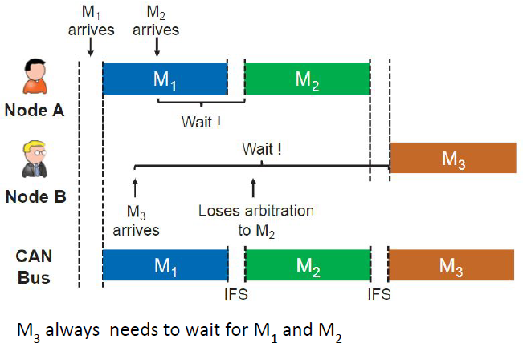

In the above figure we have:

* **Node A** sends messages M1​ and M2​, where M1has the highest priority.
* **Node B** wants to send M3, but it has lower priority compared to M1 and M2​. Hence, M3​ loses arbitration to both M1​ and M2​ and must wait until the bus is free.
* The message M3​ can only be transmitted after both M1​ and M2​ have completed their transmission.

The attacker can therefore leverage the CAN bus buffer messages order to get the message that will be sent right before the target one (M3), so M2, and get the preceded ID. In this way, the attacker can predict when M3 will be sent knowing that M3​ will be transmitted shortly after M2, the attacker can synchronize the attack by monitoring for the end of M2​. Specifically, the attacker transmits their message approximately **3 bits** after the completion of M2​. This gives them the opportunity to initiate a bus-off attack at the right moment.

Now we will focus on how an attacker can predict the exam transmission time by considering how jitter may affect the synchronization.

The injection timing, quantity, and content of fabricated preceded ID messages is fundamental for success. Regarding timing, it is fundamental to inject the message right before the target one and we still have the problem with jitter over periodicity. The only source of randomness is jitter, which follows a Gaussian distribution with zero mean and sigma standard deviation. The successive times at which the attacker receives the victim message can be expressed as:

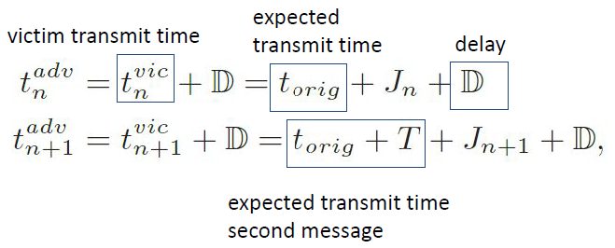

where Jn is the jitter random variable. We can then compute the next victim’s transmit time as

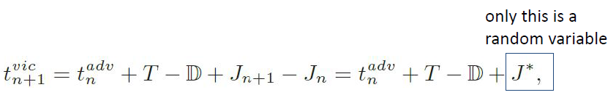

For fabrication of the preceded ID, the attacker has to start the transmission of its preceded ID messages(s) before the target and make the bus busy until it becomes sure that the attack and target messages would synchronize.

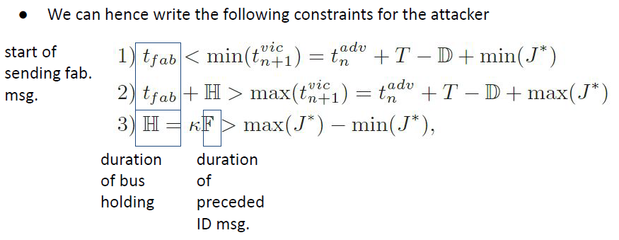

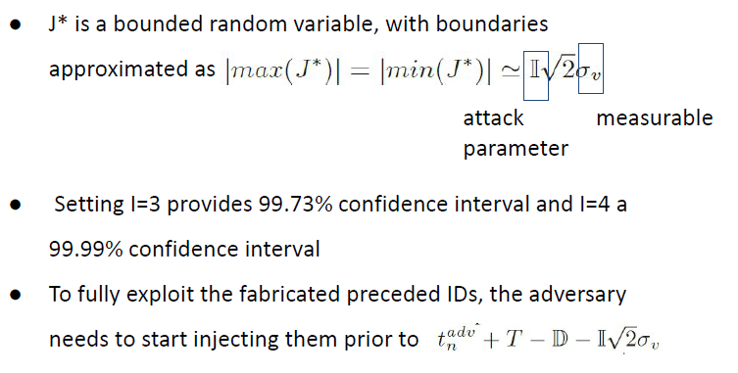

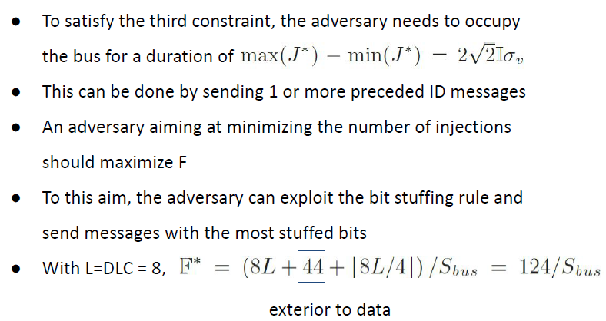

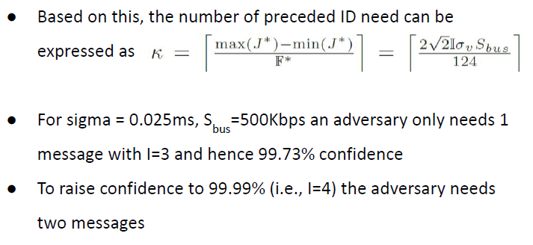

Content of Preceding ID Messages

* The adversary needs to decide which ID to use for fabricating the preceded ID messages.
* If only one preceded ID is needed, the attacker can use the next seemingly free ID.
* To be as elusive as possible, such ID can be changed at every attack attempt choosing among the least frequently sent on the bus.
* If two preceded IDs are needed, the adversary can choose one from the pool as before, but carefully select the second one to have higher priority than the target one.

Preventing Bus-Off Attacks

* The defence mechanism can leverage two features of the bus-off.
* **F1 (in phase 1)**: at least two consecutive errors occur during the transmission of frames. Thus, we watch for consecutive error frames with an active error flag.
* **F2 (in phase 2)**: at the time when the error-passive victim’s TEC increases, a message with the same ID will be successfully transmitted by some ECU on the bus.

### **3.2.2 WeepingCAN attack**

The bus-off attack is easily detectable by a good intrusion detection system (the malicious message is always the same). **WeepingCAN** is a variation of the original bus-off attack, stealthier than the original one and more difficult to identify.

Differences:

* The attacker disables the automatic retransmission of the attack message with the same ID as the victim.
* The attacker causes recessive bit errors.
* The attacker does not fabricate preceded ID messages.
* The attacker randomizes bit errors. Bits are changed randomly.

The attack message has the victim’s ID, bit-time, and prefix bits until a random position where the victim is dominant, but the attacker is recessive. As for the original bus-off, both attacker and victim have TEC = 0 at the beginning. The goal of weepingCAN is to **avoid exhibiting temporal differences due to the error state transition**.

**Attack Cycle**:

* The attacker synchronized with the victim using the same approach of the original bus-off.
* The attacker however disables its retransmission of the packet when errors occur.
* The attacker sends the attack message with the same ID and timing as the victim’s message but injects a **random bit error** at some point, causing both the attacker and victim to detect a transmission error.
* The attacker’s CAN controller sends an error-active flag due to the bit error in the attacker’s packet, which increases both attacker’s and victim’s TEC by 8.
* Since the attacker has disabled retransmission, the victim successfully retransmits its original message without further interference, decreasing its TEC by 1.
* Victim and attacker decrease TEC for other transmissions.

**Disabling retransmission allows to remove an easily detectable feature**, i.e., the consecutive retransmissions of the same packet. The attack is now composed by an active error + successful retransmission. Two ways to avoid retransmissions:

* Disable automatic retransmissions for all messages (via control register): the attacker writes to a control register that the ECU should never retransmit, neither with arbitration.
* Abort transmission on transmit error (via interrupt): most CAN controllers can raise an interrupt in transmitting errors and allows to abort retransmission in input handler.

**Recessive Injection**:

* The attacker injects a recessive bit when the victim “contains” a dominant bit.
* The attacker increases its TEC by 8 and sends an error active flag.
* The victim increases its TEC, then successfully retransmits (TEC = TEC - 1).
* The attacker must identify additional messages it can transmit to keep its TEC lower than that of the victim (otherwise could go bus off!).
* For every attack message the attacker sends, it must transmit at least one additional successful message to keep its TEC in check. Meanwhile, the victim should transmit fewer than seven other messages in the same time frame; otherwise, its TEC may recover and surpass the attacker's TEC.

**Basic attack strategy**:

* Suppose that the attacker and victim both have a single message they can send.
* Suppose A sends its message **five times more frequently** than the victim sends its message.
* Thus, for every attack message, A transmits 5 messages while V transmits 1 → TECA=3, TECV=7.
* V can be forced to error passive with 19 attack messages.
* A needs to be careful not to reach error passive before V goes bus-off!
* A can decide to skip some injections if its TEC is increasing faster than the V’s TEC. Meanwhile it can transmit some successful messages to decrease its TEC.

**Randomized bit position**

The second feature making bus-off identifiable is the presence of successive messages over the passive error flags of the victim. Furthermore, the attacker may always use the same packet for the attack. Therefore, it might be good for the attacker to have the possibility to **randomize packets**.

In particular, to randomize the position of the error bit. The DLC of most messages is a fixed constant that can be discovered by offline analysis of a CAN trace. The number of dominant bits in DLCs vary between 1 and 3, so the entropy is low 🡪 bad! A clever attacker may inject recessive error in the data field.

The data field often encodes a number that does not change quickly because of physical constraints or an event identifier that comes from a limited set of events. If A can identify a deterministic pattern, it can inject error in the data.

**What About Bit Flipping?**

* The idea of injecting errors via controlling CAN frames requires synchronization with the victim and carefully crafting attack frames.
* In the end, the whole purpose of the attacker is to flip some bits on the can BUS to lead the victim ECU to bus off.
* With minimum 32 injected fake frames (or bits?) we can force an ECU to bus off.
* If the attacker can gain control over the bus, they can just set arbitrary bits and cause errors.

**Silently Disabling ECUs**

* Suppose we include an IDS in our CAN bus that can detect arbitrary IDs appearing on the bus.
* It contains a whitelist of all arbitration IDs the ECUs on the bus are programmed to transmit.
* Such a whitelist allows us to detect but flip attackers attempting to cheat the arbitration process or transmit never seen before message (needed for preceded ID).

**Attacker Model**

* A *stealthy* attacker is able to read and write on the bus, with the goal of disabling and spoofing ECUs without being detected.
* Flipping bits is a non-precise technology, so the attacker has a chance from 0-100% of flipping bits 0→1 and 0-100% of flipping 1→0.
* Remember that 0 is dominant, so if anyone is transmitting a 0 the 0 wins.
* We make no assumption about the attack vector, as long as it can flip bits.
* We can also consider a blind attacker, which has no read access to the bus, only write.

**Stealthy Bus-Off**

* The original bus-off attack produces errors on the bus by performing a single 1 to 0 flip.
* Each attack increments the error counter by 8 → doing it 32 times over 32 messages forces the victim to bus-off.
* We want to design an attacker with the same objective but that does not produce errors on the bus.
* We also assume that attacker can arbitrarily flip bits rather than needing to win the arbitration process. Here we want to do something different from the standard bus off attack: we want to transmit erroneous bits not only in CAN frames but also on other transmissions as error flags.
* Main idea: when a CAN error frame is interrupted, it produces another error frame incrementing its TEC by 8 every time it is interrupted.
* This means that an attacker able to flip bits can force to victim to bus-off with a single message by flipping 32 bits.
* Once the victim is in bus-off, it will stop sending error frames regardless of the fact that any of them have actually been delivered to the bus.
* We need to ensure that no receive errors are produced and ensure the rest of the bus processes eventually sent malicious messages (spoofing the victim).

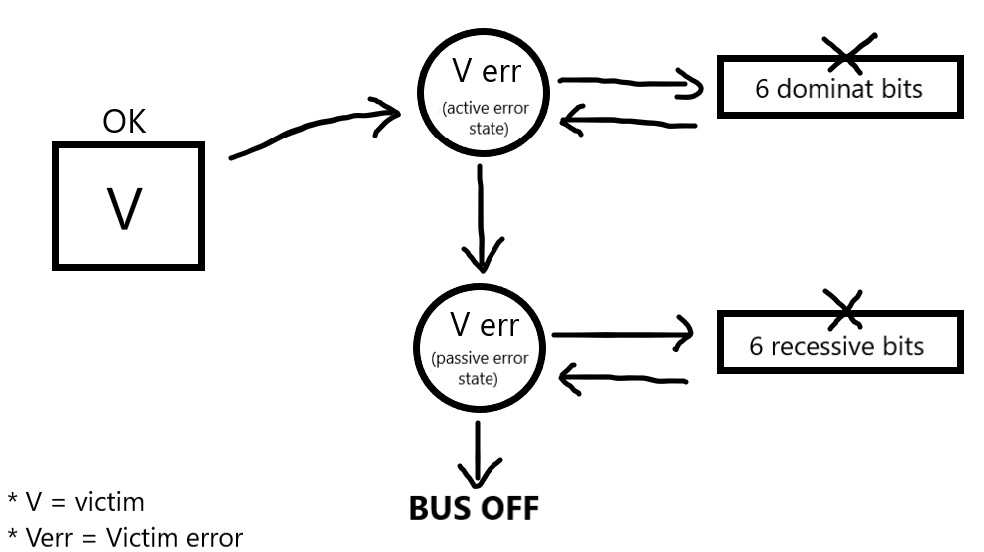

The above schema explains the main goal of this alternative weepingCAN approach where the attacker causes errors during error flag transmissions (changing bits in the error flag and so violating bit stuffing rule) that lead the victim initially in error active mode, then in error passive and finally in bus off state.

**Probabilistic Attacker**

* Flipping individual bits on a serial bus is inherently a hard problem, particularly changing the dominant state to a recessive state.
* The attacker hence must be able to:
  + successfully complete a CAN packet (11 flips in a row – EOF, IFS,delim)
  + successfully interrupt an error frame (at least 1 bit flip in 6)
  + transmit a known arbitration ID (for blind attackers)

**Interrupting an Error Frame**

* The ability to interrupt an error frame represents the ability of the attacker to continue transmitting a message without letting an error frame complete and have the victim message be dropped.
* This translates into flipping at least one every 6 bits.
* First caveat: ensure that receiver errors (RCR, ACK, stuffing, frma echeck) do not occur.
* Second caveat: interrupting another ECU attempting to transmit a message.
* Both of them are avoidable by having the ECU in bus-off by the arbitration.

# **4. Keyless Car Security**

**PHYSICAL KEYS**

At the beginning, there were ignition systems. Ignition switch is the first step to get a car to start. Turning the key sends a signal. This signal starts the ignition system and ignites the fuel vapor. This system has a critical flaw: **you can generate this signal in many ways** if you have physical access to the car and without using the original keys.

The first solution involving a cyber-component to enforce security is the ***immobilizer***. The first generation of immobilizers used a small chip embedded into the head of the car key. When the driver inserts the key into the cylinder, the chip emits a code/serial number that can be received by the antenna inside the cylinder. If the code matches the one the car expects, then ignition starts.

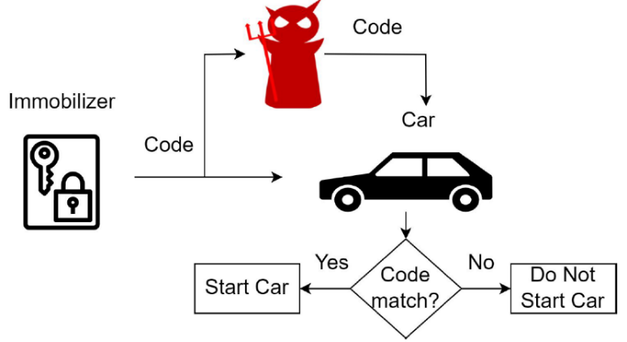**PROBLEM**: the immobilizer always transmits the same code. An attacker with an eavesdropping equipment **can easily record the code and later replay it when stealing the car**.

Immobilizers of cars such as Ford, Toyota, and Nissan were based on **Digital Signature Transponders** (**DSTs**), stronger mechanisms. The DST is a tiny RFID chip that, among the others, is enabled with a cypher F() and a 40-bit secret key. The DST and the car both share a copy of the private key K.

IDEA: The car and the DST share secret, and we can use the key K to decrypt this information.

Initially the car sends a 40-bit challenge to the key. The DST encrypts the challenge sent by the car thanks to K and sent it back to the car 🡪 now the car knows K (symmetric key) and it uses K to decrypt the information received by DST (the challenge) and if this information matches, we’ve done.

**PROBLEM**: the challenge generated by the car is not temporary, so we cannot know if the challenge has been generated now or in the past. An attacker can capture this value and replay it since the challenge is always the same.

**Cloning attack**: there is another a huge problem with the key length, i.e., 40 bits. An attacker might send a challenge and record a response from a car and try all the 1.1 trillion possible key combinations to infer the private keys. Huge number but requires few hours on a FPGA. This led to **DST+** mechanism: now both DST+ and the car expects the right challenge as response to start the engine.



## **4.1 Replay attack**

An evolution of keys is **Passive Keyless Entry Systems** (**PKESs**). It does not require interaction with the user 🡪 there isn’t any button to be pressed (“hand free experience”), an evolution of RKE. **The car not only checks for the presence of a legitimate code but checks also where the key is**. It uses a low-frequency RFID channel to check if the key is in remote distance (up to 100 m), outside the car (1-2 m from the door handle), or inside the car. Only in the last case the engine starts.

**A different threat model envisions having no direct access to the car’s key**. Still, keys use wireless communications to talk with the car and execute a challenge response algorithm. So, how do you steal a car in a minute exploiting this technology and why would this work?



We define the **replay attack** a special type of man in the middle attack, where a non-legitimate device establishes a communication between two non-proximal legitimate devices.

When relaying signals, we need to care only about the physical layer. We do not need to interpret the signal, modify it, infer keys, … We just need to demodulate the signal, amplify it if needed, transmit it as digital information using RF, and modulate it near the victim tag (we take care about the radio waves, but we don’t want to change their shape we just want to increase their amplitude if we need more power in the signal).

Note: this type of attack adds some delay to communication, so we must be sure that the introduced delay is within an accepted range by the application under attack.

**IMPLEMENTATION OVER CABLE**



Two loop antennas connected via a cable that replays the low frequency signal between them. One antenna communicates with the car and the other one with the key. **The car and the key think they are closed so the generated command is accepted**. Basic idea: the two antennas capture the signals generated by the car and the key.

**IMPLEMENTATION OVER THE AIR**

Cables may bring suspicions so, let’s just remove them. The replay system is now composed by two parts, an emitter and a receiver:

* The **emitter** captures the low frequency signal and upconverts it to 2.5 GHz, amplifies it, and transmits it over the air.
* The **receiver** downconverts the signal back to low freq., it amplifies it agains and sends it to the loop antenna.

Note: in this implementation we need to take more care about the wireless communication and the loss of information.



The main advantage of replay attack is that it is not needed to modify the packets/signals (no need to break cryptographic locks), it is enough to capture them.

**How to estimate the distance between the keys and the car**:

* Distance bounding denotes a class of protocols where the prover measures an upper bound on its distance to another entity.
* We implement RF distance bounding to verify the mutual proximity of the car and the key.
* The distance bound is obtained from a rapid exchange of messages.
* The verifier sends a challenge to the prover.
* Upon reception of the response, the verifier measures the communication round trip time to obtain an estimate of the distance.
* Summary: it is not possible to estimate the distance using the transmitting and receiving power because BOH. Time is used instead of power.

## **4.2 Rolling Codes**

**Remote Keyless Entry (RKE)** relies on unidirectional data transmission from the remote control (in the car key) to the vehicle. **The key is hence active, and upon pressing a button transmits signals** in one of the bands 315 MHz, 433 MHz, or 868 MHz (depending on the country). RKE systems enable the user to comfortably lock and unlock the vehicle from a distance and can be used to switch on and off the anti-theft alarm when present.

The first generation of RKE used no cryptography, solely relied on a fix-code signal. However, this makes replay attacks super easy. The next generation of RKE is named after **rolling code systems**.

**Rolling codes use cryptography and a counter value that is increased at every button press**. They use a conjunction of the counter and other signals as input to the cypher, and the car checks this information to assess the validity of the signal.

Then follows the type of data that we sent with RKEs systems.



* **Preamble**: is fixed and it’s used by the car to detect the presence of messages.
* **Start**: used to start a conversation/information transfer.
* **Payload**, formed by unique identifier (id of the key), rolling counter value, pressed button. There’s also the time information about when the key generated the packet.
* **Checksum**.

Authentication in Rolling Codes:

* **Implicit authentication**: the entire payload is symmetrically encrypted, and the receiver checks the UID and if the counter is in its validity window (if there is a correspondence between the car’s and key’s counter).
* **Explicit authentication**: the sender computes some sort of message authentication code over the data payload and appends it to the packet.

**Payload structure**



The grey part is the encrypted part. The payload is encrypted using a proprietary block cipher. We assume that such a **cypher is the AUT64** (as found in many cars from the VolksWagen group).

Note: the key element in rolling codes is synchronization between the car and the keys.

Both the car and remote are synchronized to an initial number (e.g., PRNG seed) 🡪 pairing a remote. It usually relies on some configuration, such as pressing a button or a master key. Once the remote and the car are synchronized, they use an algorithm to choose an initial random number **x** (to be less affected by possible attacks) and transform it to the next number in the sequence (**x+1**) 🡪 not necessarily the following number.

**The following key press will take the result of the previous keypress as the input**. If a single remote press is intercepted there is no way to determine the next code expected by the receiver (due to encryption).

Note: the difference between the button of the key and the car is that when you press the button of the key **the key’s counter always increases but the car’s counter increases just when it receives a valid message**.

If we start the counter from 0 and we increase the next counter value +1 is easy for the attacker (replay attack) to predict the next number related to pressing the key button BUT choosing a random initial number and encrypting the counter is not possible for the attacker to predict the value.

Devices not only store the next code that needs to be transmitted, but a significant number of them (e.g., 255). This is fundamental to have the process working even if in case of **erroneous keypresses that increase the counter only on the key side** 🡪 we can recover the right value.

As soon as a button keypress that is valid is received, the list is updated to be x iterations from that keypress = [1..255] 🡪 [2..256]. However, if the number of keypresses is too large, there is no way to catch up on sync.

There are few well-known manufacturers providing rolling code based RKE. Microchip Technology provides Classic, Advances, and Ultimate KeeLoq with publicly available documentation and data sheets. Companies like NXP, Omron, and TI provide proprietary solutions.

## **4.3 RollJam/RollBack attack**

How can we attack systems based on Rolling Codes? As an attacker, we would like the receiver not to be able to receive any of the radio transmissions from the remote. To achieve this, **we can jam the communication between the key and the car**.

This is a technique used by thieves to have drivers not to close their cars in the parking lot 🡪 when the owner of the car presses the key button to close his car there’s **a jamming that blocks the signal and the car doesn’t receive the signal from the key**, so the owner goes away thinking he closes the car, and the thief steals the car.

Note that we can use a transmitter on a similar frequency, as receivers have large windows for detecting signals (to account for temperature changes and flat batteries).

**Remote jamming works, but the person walking away from the car may notice that it did not lock** (no noise). We want to develop a technique that is indistinguishable from the standard interaction between car and owner. We integrate jamming and replay attack in the RollJam attack. We want to jam the signal, capture it, and somehow replay it as a legitimate communication between key and car.



While the signal is jammed, we can use the same window to capture the first legitimate message that the key sent to the car. This is possible because the jamming is not in the exact same frequency of the signal. **A thief can store the signal and use it later 🡪 the car doesn’t receive anything (its counter doesn’t increase), so the captured signal (current+1) is still valid**.

When someone cannot get a remote to work, the instinctive reaction is to press the remote again. As soon as this happens, we can get a second (successive) instance of a legitimate transmission.

**We can replay the first signal to lock the car so the owner goes away and then we can use the second captured signal to unlock the car**.

**This attack works only in key fob with lock/unlock functionalities in the same button**.

**RollJam problems**:

* **Many modern cars use different frequencies (different buttons) for lock and unlock**.
* If the attacker only monitors the frequency of the unlock button, then they will only be able to unlock the car.
* It requires the legitimate owner to send a legitimate lock, before being able to perform the unlock, given that lock and unlock use the same rolling code.
* Solution: permanently jam the lock frequency such that the user will need to manually lock the car.

Again, RollJam requires the jammer to be always there. Although rolling codes have been designed to prevent replay attacks, there are still chances that replay might work. We said that there may be some synchronization issues between key and car for which resynchronization is needed 🡺 let’s exploit this mechanism to evade the security provided by rolling codes.



1. The attacker places the RollBack-device near the target car.
2. When the victims comes back to their car, they will try to unlock it via the key fob sending *SendV(Siunlock)*
3. RollBack-device:

* Capture the signal
* Jam the frequency band to prevent reception

1. The victim assumes lousy reception and presses the same button again, sending *SendV(Si+1unlock)*
2. The RollBack-device captures the signal, but let the car receive it 🡪 the victim unlocks and drives away (no doubts).

By design, the two codes captured by the attacker are no longer valid. The victim can lock and unlock their car at will. However, we have also seen that resync requires two consecutive packets. This means that the attacker can replay the two previously captured packets at any time and get access to the car (???).

## **4.4 AUT64**



Doing the math, the effective key size of AUT64 is 91.55 bit. Finding the key via exhaustive search is not practical. However, the problem is that this RKE system uses a global master key which is independent from the vehicle or remote control. We can use the master key to generate new keys.

This means that **the** **same key is stored in millions of ECUs and RKE remotes, without any key diversification**. The sole means by which the vehicle determines if a rolling code is valid is hence by whitelisting certain UIDs and checking if the counter is within the validity window.

**RKE based on Hitag2 Cipher**



The cipher consists of a 48-bit Linear Feedback Shift Register and a non-linear filter function f.

Each clock cycle, twenty bits of the LFSR are input to f to generate a bit of the keystream.

The LFSR is then shifted one bit to the left, using the feedback polynomial to generate a new bit on the right.





**Rolling Code on Hitag2**

* During the authentication protocol, the internal state of the stream cipher is initialized.
* The internal state consists of the 32-bits UID concatenated with the first 16 bits of the key k.
* The counter ctr is incremented and iv = ctr || btn is XORed with the last 32 bits of the key and shifted into the LFSR.
* For this point, the next 32 bits of the keystream (output by the cipher ks) are sent as a proof of knowledge of the secret k.

**RKE Based on Hitag2 Cipher**

* The next 32 bits of keystream, which are output by the cipher ks, are sent as proof of knowledge of the secret key k.
* L is the feedback function from the LFSR (Linear Feedback Shift Register) that generates a bit.



**CORRELATION ATTACK ON HITAG2**

The purpose of the attacker is to retrieve the key. It requires a minimum of four rolling codes, but it would be faster and more precise by having more traces.

Rolling codes may have an arbitrary counter value, i.e., non consecutive. However, this is good as it increases correlation. We denote as <UID, ivj, ksj>, j = 0,...,n-1, n>3, n authentication traces.

1. The adversary first guesses a 16-bit window corresponding to LFSR stream bits a32,..,. a47 = k0,...,k15.
2. Together with UID, this gives the adversary a0, …, a47, which is constant over traces.
3. The adversary can hence compute b0 = f(a0, … , a47).
4. The adversary shifts this 16-bit window to the left of the LFSR, until bits a32, .. , a47 are on the very left of the LFSR, i.e., the point where the cipher starts outputting ks.
5. The adversary computes a correlation score for this guess
6. The window determines 8 input bits x0, …, x7 to the filter function f20, while the remaining 12 inputs remain unknown.
7. The correlation is taken as the ratio of those 212 input values x8, …, x19 that produce the correct keystream bit ks0.
8. Shifting the window further to the left, the adversary can perform tests on multiple keystream bits (ks0,..., ks15).
9. The adversary assigns this guess the average score over all traces.
10. So far this scoring computation is independent of the value iv as it happens before iv gets to have any influence on it.
11. The adversary sorts guesses based on their score and stores them in a table, discarding guesses with lowest score if needed.
12. Experiments show that 400, 000 guesses are usually sufficient.
13. For each guess in the table, the adversary goes back to Step (1) and proceeds as before, except that she will now extend the window size by one guessing the next LFSR stream bit (a48, … , a51).
14. The power of this attack comes from using the window on the right of the LFSR to compute the necessary keystream bits to correct the internal state.



# **5. Autonomous Vehicles**

An autonomous vehicle (AV) is **a vehicle capable of sensing the surrounding environment and take actions without human intervention**. These kinds of vehicles need a lot of sensors, include thermographic cameras, GPS, inertial measurement units, etc. The sensors’ output is used as input for a controller which creates a model to identify the most appropriate navigation path.

Note: when we talk about an autonomous vehicle, it doesn’t refer just to cars but also to drones, robots in some factory, etc.

Autonomous vehicles use different types of sensors to perceive the environment (for instance to detect obstacles) and monitor their own physical parameters:

* Cameras
* LiDAR
* RADAR
* SONAR
* IMU
* GNSS

**Sensor fusion techniques** are used to reduce measurement uncertainties due to noise 🡪 a specific class of algorithms that controls the output from sensors (maybe a sensor doesn’t work well).

**PLANNING PHASE** (the main goal of AV)

Using the data obtained from the perception system, the vehicle performs behaviour planning. The optimal behaviour needs to be decided by predicting states of the ego vehicle as well as other objects in the surrounding. Based on the planned behaviour, generate an optimal trajectory. The entire process is called **motion planning**.

**SAE LEVELS OF AUTOMATION**

The Society of Automotive Engineers (SAE) defined 6 levels of driving automation:

* **Level 0**: no automation, manual control.
* **Level 1**: driver assistance with monitoring functionalities (e.g., cruise control).
* **Level 2**: partial automation with the car taking autonomous actions such as steering and acceleration, but the human can always take back the control.
* L**evel 3**: conditional automation, where the vehicle can perform most of the driving task, but human override is still required.
* **Level 4**: high automation where the vehicle performs all driving tasks under specific circumstances and in geofenced areas. Human override is still an option.
* **Level 5**: full automation with the vehicle performing all driving tasks in all conditions. No human attention or interaction is required.

**There are several limitations and barriers that could impede adoption of AVs**, including: the need for sufficient consumer demand, assurance of data security, protection against cyberattacks, social distrust, and the development of economically viable AV technologies.

## **5.1 Control systems**

**Cruise Control** (CC) is a system that **automatically controls the speed of a motor vehicle**. It is a system that automatically **uses error-sensing negative feedback to correct the throttle of the car and maintain a constant speed**.

CC is a simple implementation of a control system that, in control theory, is called **proportional-integral-derivative (PID) controller**.

**Control Theory** is a field of engineering and applied math that deals with the control of dynamical systems. The objective is to develop a controller, a device that acts on the system to achieve a desired state.

**The controller monitors the process via a *process variable* and compares it with a *reference* or *set point*** (the input given to the controller 🡪 target, in the case of CC = the speed). **The difference between these values is called the error signal**.

*Example of a possible scenario*: if we want to maintain a certain distance from the car above, we communicate the distance reference value to the controller, it computes the error signal and do some operations to minimize the error in order to reach the given distance value.

### **5.1.1 Types of controllers**

**OPEN LOOP (FEEDFORWARD) CONTROLLER**



We provide a reference signal to the controller; it implements a function which computes an output that instruct the system on what it has to do to reach the target. At this point the process computes an output which is the current system value.

For instance, a boiler that needs to heat the water for a given amount of time.

**CLOSED LOOP (FEEDBACK) CONTROLLER**



Compares a value that is given by the process with the reference input. The difference from the previous one is that **the process’ output is returned to the controller to adjust as much as possible the current system value** **in order to reach the reference input**. For instance, a car’s cruise control or a thermostat.

A control system for an autonomous vehicle is broken down in two fundamental components:

* **Longitudinal control** (speed up/slow down + brake): control of the longitudinal motion of the vehicle.
* **Lateral control** (left/right steer): control the lateral dynamics of the vehicles.

**Kinematics is the study of motion of a system disregarding the forces (wind, etc) that govern it**.

Can be employed in situations wherein kinematics relations are able to sufficiently approximate the actual system dynamics. Valid only for systems that do not perform aggressive manoeuvres at lower speeds 🡪 driving slowly and making smooth turns.

We however start from them to make things simpler.

**BICYCLE MODEL**

Model to capture vehicle dynamics under normal driving conditions. Strike a good balance between simplicity and accuracy → widely adopted.

**The idea is to define a vehicle state and see how it evolves over time based on the previous state and current control inputs 🡪 defining its behaviour**. Let the vehicle state q comprise the x,y coordinates of location, heading angle theta, and velocity v:



(complete example on the slide)

**PID CONTROLLER**



It is a control loop mechanism using feedback to apply continuously modulated control.

**It continuously computes an error as the difference between a desired setpoint and a measured process variable. Based on the error value, it applies a correction** **based on** **proportional (P), integral (I), and derivative (D) terms**.

Based on the type of error computed, the **controller applies a correction**:

* **Proportional (P) term**: the proportional term is directly proportional to the current error (the difference between the desired setpoint and the actual process variable).
* **Integral (I) term**: the integral term considers the accumulated error over time.
* **Derivative (D) term**: the derivative term considers the rate of change of the error. It predicts future error based on the rate of error change and applies a corrective action to counteract sudden changes in the process variable.
* Kp, Ki and Kd determine the magnitude of the correction.





### **5.1.2 Adaptive Cruise Control (ACC)**

Adaptive Cruise Control (ACC) is a system that automatically controls the speed of a motor vehicle by integrating sensing capabilities on the vehicle [SAE Level 1].

The vehicle uses a radar/LiDar/laser to compute the distance from a car in the front. This distance is reported to the controller, which acts on the speed to maintain a minimum safety distance.

*Scenario*: assume we have two cars, one in the front (lead) and one in the back. We assume that the one in the back (ego vehicle) has ACC. Ego uses a radar to measure the distance to the lead vehicle. The lead car is supposed to be driving in the same lane. Ego also uses the radar to measure the relative speed between the two cars.



**First mode**: the ego vehicle should drive at a driver’s specified speed as long as it maintains a safe distance with the lead vehicle.

**Second mode**: the space between the two vehicles is controlled (by changing the ego vehicle’s speed) so that the two vehicles do not get closer than a safe distance.

According to real-time measurements, **either working modes can be enabled by the ACC system**.

To determine the operating mode, the ACC applies the following rules:

🡪 If relative distance is >= safe distance, then use speed control (first) mode to track the driver set velocity.

🡪 If relative distance is < than safe distance, then the space control (second) mode is active and keep track of the distance.

We explore two different attack scenarios in which we assume the attacker can compromise in some way the ACC unit 🡪 two scenarios:

1. **The attacker remains dormant** and monitors the measured distance to the front vehicle. At the times this distance is at its lowest (presumably near the minimum safe distance), it creates a spike (a very high signal) in the control signal and makes the vehicle accelerate. This could similarly happen when the front vehicle suddenly brakes and the compromised ACC refuses to reduce the speed.
2. Unlike the first scenario **the attacker does not hide for the attack**. Trivially lowers the ACC’s reference distance. During the times ACC is in mode 2 and tries to maintain the safe distance, it is practically following a false reference. Since this difference is trivial and not noticeable to the driver, this attack remains covert or stealth.

### **5.1.3 Cooperative Adaptive Cruise Control (CACC)**

Cooperative Adaptive Cruise Control (CACC) is **a system that automatically controls the speed of a motor vehicle by integrating sensing capabilities on the vehicle and communication capabilities with other vehicles**. It uses Vehicle-to-Everything (V2X) communication. In addition to what ACC does, **CACC uses the preceding vehicle’s acceleration in a feed-forward loop**. This info passes via the Cooperative Awareness Messages 🡪 we are creating a communication with other vehicles: a vehicle communicates its status to the other ones.



**Perception Phase**:

* Get information from on-board sensors and include them in CAN data.
* The Wireless Safety Unit (WSU) provides i) data transmitted by other CAVs in the CACC system through V2V communications, ii) data collected by GPS with wider area augmentation system differential corrections (e.g., vehicle position assigned in the CACC system).
* Information derived from on-board sensors such as Lidar, odometer and flag signals will also be received and included on the CAN bus data structure.

**Planning Phase**:

* Includes the high-level controller (longitudinal control algorithms).
* The controller is usually connected and instructs the vehicle via the CAN bus.
* Very similar to ACC.

**Actuation Phase**:

* Execute target reference command transmitted from the planning phase.
* Low-level controller converts the target speed commands into throttle and brake actions.

The vehicle dynamics is calculated by the vehicle controller and controller acts only on its vehicle. In particular, we often use longitudinal control, **we write the sum of the forces acting on the vehicle and use them to maintain the same longitudinal speed of the other vehicles in a CACC system** while keeping a fixed longitudinal inter-vehicle distance.

CACC technology allows CAVs to form vehicle platoons with shorter inter-vehicle distances.

**MODEL OF CACC**







**ATTACK STRATEGIES**

An attacker can cause a series of abnormal behaviours in CACC system, in particular referring to the platooning case. The attacker may either be an external actor or an inner vehicle/byzantine node.

1. **Reduced headway attack**: a car ignores the recommended  headway speed that guarantees string stability and follows closer. This attack would likely be implemented by a driver who wants to increase fuel savings by decreasing draft or a driver who manually drives with extremely small headways.
2. **Joining without radar**: a car attempts to become part of a platoon without having the necessary radar, or other distancing equipment. A driver who does not want to buy a new vehicle but retrofits a car with DSRC which, unlike radar, does not require per vehicle tuning. The reaction of the car is uniquely based on the feedforward information which is dangerous in case of communication problems (e.g., congestion). The attacker control strategy is hence .
3. **Mis-report Attack**: The attacker misinforms the vehicle that is following to increase the following car’s headway or to cause a change in the following car’s behaviour. The attacker mounting this attack could either follow the prescribed control law or choose an alternative control law. Assuming the attacker misreporting only its behaviour, then . This is motivated by wanting to increase the following distance of the preceding car.
4. **Collision Induction Attack**: the attacker broadcasts an acceleration profile indicating that they are speeding up which causes the following vehicle to accelerate. The attacker starts to aggressively brake which causes the error between the attacker and following car to quickly increase. Very similar to attacks that could be mounted in the current highway system. If a driver was to jam on their breaks during rush hour while being tailgated, the vehicle would likely be rear ended.

***Summary***



**How do we detect and defend against these attacks?**

We can describe our CACC system with a double integrator model with a lag constant nu for each car:







**MODEL BASED DETECTION**

Every car model the expected behaviour of the vehicle directly in front of them. Vehicles then compare the calculated expected behaviour with the observed behaviour. The car is then able to detect both malicious and benign abnormalities. Once abnormal behaviour is detected, the car switches from operating in a cooperative platoon framework to a radar only based adaptive cruise control framework where it is safe even if the preceding car is mounting an attack.









The modeling technique is based on double integrator and can be made complicate at wish. Considering tradeoffs in accuracy, calculation cost, and time for calculation. Improvements that could be considered in the modeling include capturing non-linear behavior of the vehicles drivetrain and using terrain mapping to predict variation.

**THRESHOLDING**

Once we have the prediction model, we can predict whether the error is acceptable or not.

We indicate the measured values as , also we assume we can compute acceleration and velocity. However, we cannot measure the error since we do not have a line of sight with cars further than a single hop.



**DIFFERENT METHODOLOGY**

Model predictive control can be implemented in multiple ways. In the previous example, each vehicle implements the model of the preceding vehicle. However, we can model more complex systems. For instance, it could be possible for vehicle i to simulate the entire platoon up to vehicle i-1.

Slide 61/107

# **6. Drones Security and Privacy**

**Unmanned Aerial Vehicles** (UAVs) are flying devices without any crew or pilot on board. They come in different shapes and size, and can reach different altitudes.

**OPERATING MODE**

* UAVs may be operated by pilots located on the ground
* Remotely Piloted Aircraft Systems (RPAS)
* Formally, “a set of configurable elements consisting of a remotely piloted aircraft, its control station, the command and control links and any other system elements required during flight operation”.
* UAVs may be autonomous and coordinate with other drones to deliver a common objective.
* Fleet of UAVs.
* Need to communicate with other fleets to avoid crashes.

**Structure of a drone**

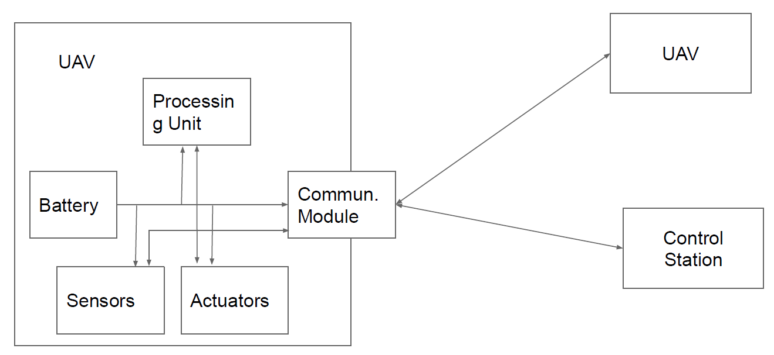

Drones are characterized by:

* multiple modules to acquire and process data;
* communication module as enabler.

UAVs employ control loops possibly with sensor feedback.

**APPLICATIONS**

* UAVs have been firstly proposed for military applications.
* Seventeen countries armed UAVs, and more than 100 countries use UAVs in military capacity.
* Civil applications are instead more recent.
* Thanks to their high adaptability, UAVs find applications in many different fields
  + Infrastructure
  + Transport
  + Media and Entertainment
  + Telecommunication
  + Agriculture
  + Search and Rescue

A drone ecosystem is composed by six unique targets:

1. Drone hardware: CPU, sensors, firmware.
2. Drone chassis and package: all non-electronic devices.
3. Ground control station: may be fixed or mobile.
4. First-Person View (FPV) channel: control channel via common communication protocols.
5. Pilot: person remotely controlling the drone.
6. Cloud services: some drone send telemetry of flight information to a cloud server if needed.

**ATTACKER MODEL**

Attacker aim: disrupt the legitimate task of flying a drone.

Attackers may be both civilian or military. Although military may have sophisticated equipments (e.g., cannons or predator birds), a civilian may still be able to impact on the drone. We consider a civilian that has access to equipments that can be purchased at a moderate cost (Software-Defined Radio, Computer, Commercial lasers, Butterfly net, Magnets).

An attacker may be of three types:

1. With direct physical access → access the drone or the GCS to modify the firmware or replace hardware parts.
2. Physically proximate → send, modify, and replay radio transmissions in order to hijack a drone.
3. Distant adversary → resides on the Internet and applies attacks against servers, drones, the GCS.

The impact of the attack can be measured according to the CIA triad

* Confidentiality: attack that reveals information about drone, pilot, telemetry or collected data.
* Integrity: attack that modifies the information delivered to or collected by the drone, GCS, cloud server or pilot.
* Availability: attack that causes the pilot to lose control of the drone due to forced landing, crash or hijacking.

**Drone hardware attacks**:

* Find vulnerabilities in the devices or software used by the drone
* Attack to the compass
  + Use a magnetic field to fool the compass and either hijack or prevent take off
* Attack on the stabilizing algorithm via camera sensor
  + Drones use a camera to collect images and stabilize the flight
  + To detect movements, UAVs use optical flow
  + Features can be modified by projecting laser beams on the ground, or projecting images on the ground
  + The drone will follow the projected features

**OPTICAL FLOW**

Optical flow is the pattern of apparent motion of objects, surfaces, and edges (basically, everything from which we can extract simple features) in a visual scene caused by the relative motion between an observer and the scene. Optical flow uses a sequence of successive images to allow for the estimation of motion. It tries to calculate the motion between two image frames which are taken at a predefined rate at every voxel position.

UAVs use a downward facing optical flow camera. They collect images and use the estimation to stabilize the flight. It can detect whether the drone is drifting by comparing successive

frames of the ground below. The sensor system will attempt to infer if the ground plane image has moved by a relative offset . If so, the system assume that the ground is stationary and the drone has drifted.

Optical flow first requires a feature detection algorithm to identify regions of the ground plane easy to track. These features are then provided as input to the optical flow algorithm. It then identifies the location of these features in successive images and uses the difference to compute the displacement. Classic configuration: use the Shi-Tomasi corner detection algorithm for feature detection and the Lucas-Kanade method to compute the optical flow.

**Shi-Tomasi Corner Detection**

Basic idea: use the derivative of the image to detect whether there is a sudden change of color in one direction. If only in direction, then an edge is detected. If in two directions, then a corner is detected. It is generally used because efficient, compared to more sophisticated but slower feature detectors (SURF, SIFT).

**Lucas-Kanade Optical Flow**

Assumes that the difference between two consecutive frames is small and approximately constant within some neighbourhood. This assumption is arranged for UAVs considering a combination of sufficiently high framerate and sufficiently low resolution.

For each corner pixel p returned by the feature detector, let us define a local window of n neighbourhood pixels *qi* for .

For each *i* let 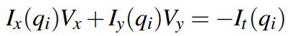 , where I denote the image matrix, pedix denotes partial derivative, and V the velocity or motion along a coordinate → estimate V via Least Squares.

Build system:



Matrix form *Av = b*

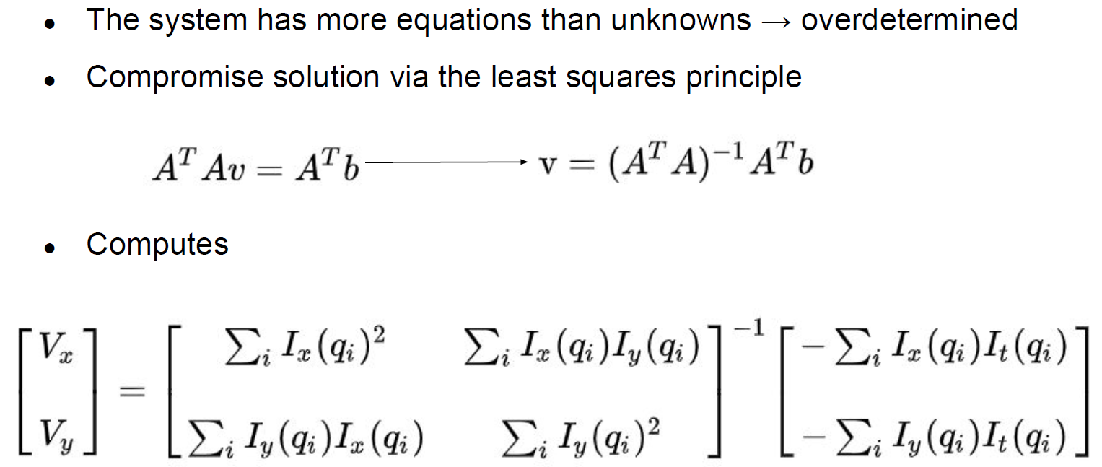

**ATTACKER REQUIREMENTS**

A successful attack to sensors needs three requirements.

1. Environment influence: the adversary can alter the physical phenomenon that the system measures (alter pixel values).
2. Plausible input: create an input to the sensor that will actually be used by the system as valid input.
3. Meaningful response: the attacker can induce a behavior on the UAV representing the control the attacker has over it.

1) **Environment Influence on Optical Flow**

* The adversary must be able to alter or obscure the ground plane to alter the pixel values reported by the optical flow camera.
* Onerous example: cover part of the area with feature-rich pattern.
* More concrete example: project features on the ground via laser/light beams.
* In the first case, the attacker can use a battery operated projector loading images e.g., from a USB stick.
* In the second case, use an array of laser elements to create features.

2) **Plausible Input to Optical Flow**

* The basic idea of optical flow is to instruct the UAV to compensate a drift by moving of the same amount in the opposite direction.
* The system assumes the image on the ground to be stationary, so it interprets feature motion along a vector as a movement in the opposite direction.
* By moving the ground feature, the attacker can control the movement of the drone.

3) **Meaningful Response to Optical Flow**

* The attacker’s goal is to project a sharp gradient onto the ground so that the feature detection algorithm will pick up the light as a corner.
* Since the Lucas-Kanade-based optical flow computes a final displacement based on the average displacement of each feature, the attacker needs to generate a large number of corners.
* In practice, the attacker can simply sweep their projected light across the ground plane.

Most UAVs are enabled with the **Return to Home** (RTH) functionality. The UAV records its location of departure, and in case of emergency it will automatically fly back to home. Emergency includes low battery or loss of the control signal for more than 3 seconds.

**CAPTURING DRONES**

Most UAVs rely on the Global Navigation Satellite System (GNSS) for positioning (e.g., Europe’s Galileo). However, this system has the main issue of not being authenticated. We can hence spoof the GNSS signal and control the location of the drone However, the drone is controlled by its pilot.

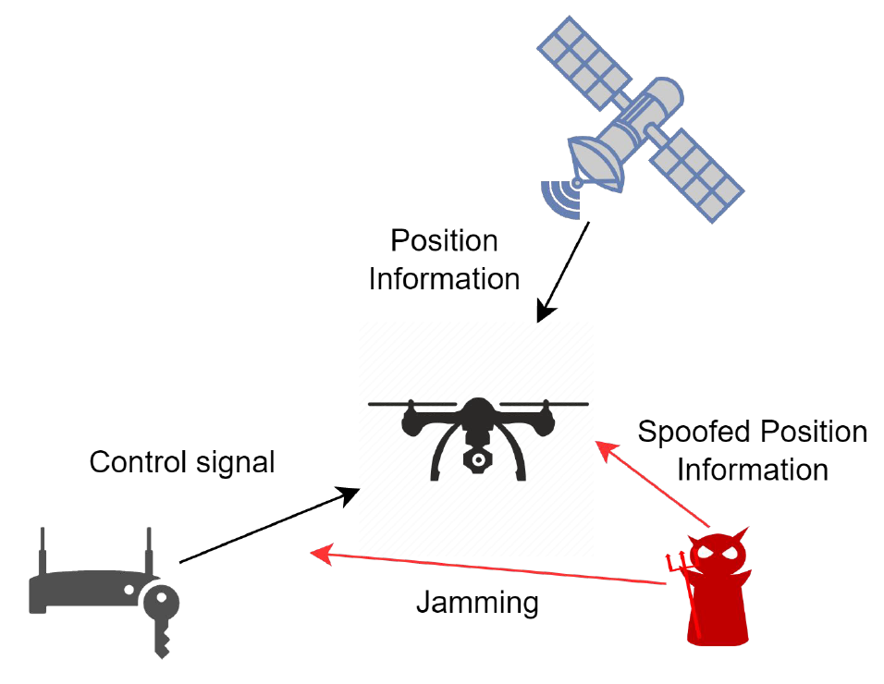

When jamming the signal for enough time, the drone enters the RTH mode and starts to fly back to the home location. With the help of the GPS module and the on-board compass, it can derive a trajectory based on its current location S and the home location H. The attacker aims at sending spoofed location information to capture the drone in the minimum time by bringing it to a controlled location D. To achieve the shortest capturing time, the attacker may want the

UAV to fly along the straight line SD. However, the drone has a pre-recorded H and will try to return there. If only one could spoof an arbitrary location to the UAV, then the UAV will change its direction immediately to any desired angle. For instance, given a location S’ such that S’H || SD, then the UAV will fly to D along SD. However, GPS accepts only physics-reasonable coordinates.

**Greedy Algorithm for UAV Capture**

Constraint: the maximum location change speed of GPS spoofing is Vs.

Idea: to minimize the capture time, the UAV trajectory shall be spoofed such that it points towards D as soon as possible.

* Loiter mode: the UAV tries to hold its position S by correcting any drift. We exploit this feature to have the drone gradually moving to D.
* An ideal spoofing trajectory is the one starting from the horizontal line a, where the arriving point is exactly above H.
* Besides spoofing, the UAV will always point towards the direction of H tanks to its compass.
* Whenever it believes it is on the left side of S1’, it moves closer to H horizontally.
* After passing S1, the UAV direction will turn left until it points precisely at D.
* Denoting S2’ as the turning point in the spoofed trajectory and its corresponding point in the actual trajectory as S2, S2’H || S2D.
* The UAV, convinced to be taking the spoofed trajectory S2’H, will fly along the straight line S2D until it reaches D.
* How to determine the spoofed trajectory S1’S2’ such that its actual trajectory becomes S1S2 and S2’H becomes parallel with S2D at the earliest time?
* Greedy algorithm to compute S2’.
* At the spoofed location S1’, the next spoofed point Sx’ is such that S1Sx’ is perpendicular to S1D.
* If SxD || Sx’H, done.
* Otherwise, repeat.



**GPS Failsafe**

GPS systems may occasionally drop the signal or suffer from glitches, i.e., provide significantly inaccurate position information. The GPS failsafe is mechanism to provide safety to the drone in case of GPS signal loss or glitches. In this case, the drone may either land or switch to a manual control. To protect against glitches, the drone has a short memory of GPS position and compares the new measurement with the old one (you can use Kalman filter also in this case).

We can classify consumer grade drones based on their behavior after failsafe mode

1. First type: switch from the failsafe mode to positioning mode which utilizes GPS.
2. Second type: resume autopilot just before loss-of-lock.
3. Third type: maintain GPS failsafe even though GPS is available and wait until a pilot gives a new command.

## **6.1 Safe Hijacking**

We want to develop an anti-drone system such that, as soon as we detect the drone, we do not simply interrupt the control channel and have the drone to hover over a sensitive area.

To carry out a mission that evades RC jamming by anti-drone solutions, terrorists will operate drones in autopilot mode based on GPS and will not rely on a remote controller. Therefore, spoofing GPS might be a solution to safely remove drones from an area they should not be into.

**Soft GPS Spoofing**

* The spoofing signal is aligned with the authentic GPS signal.
* The operation is not interrupted and the victim gradually locks to the spoofed GPS signals in three steps.

**Hard GPS Spoofing**

* Soft spoofing has some requirements to satisfy to avoid losing the lock.
* When one of the requirements is not satisfied, we call this signal as hard GPS spoofing.
* It initially acts like a jamming signal and the victim may lose its lock on the authentic signal.
* The spoofing signal is stronger, thus the victim will reconnect to the spoofed signal.

**Strategy A**

* It deals with type 1 drones.
* The drone is trying to maintain its original position.
* The attacker spoofs the target drone’s GPS position as if the drone is moving in a certain direction.
* The target drone generates speed in the opposite direction, so the drone moves in that direction in the real world.

**Strategy B**

* It deals with type 2 drones.
* Based on the drone’s characteristic that control their body according to their path-following algorithm (e.g., in RTH).
* If the GPS position is manipulated as the drone deviates from the path, then it will move in a different direction from the original direction to return to the track.
* The hijacker can determine the hijacking direction and calculate the corresponding fake location.

**Strategy C**

* It deals with type 3 drones.
* Since they need to wait for a pilot command, manipulation of GPS signal is not effective.
* Therefore, we want to hijack them without losing the connection with the GPS (soft GPS spoofing).
* However, it might be complicated to move the drone if it uses a combination of GPS and IMU sensors to determine its location.

**The 3DR Solo Case**

* 3DR Solo does not have a fallback mechanism when losing connection with the GPS.
* It is complicated to hijack, because it uses both GPS and IMU for
* localization
* It has a complicated path-following algorithm that uses Intermediate Target Position (ITP), necessitating moving the spoofed GPS location accordingly to safely control the behavior of the target drone
* Good case study for strategy C!

**PATH FOLLOWING ALGORITHM**

* The drone uses an Extended Kalman Filter algorithm to estimate various parameters, such as velocity, position, and magnetic filed by fusing the IMU’s output with GPS measurements.
* The EKF algorithm starts by predicting its position and velocity by using the IMU’s output only.
* IMUs have inherent errors → periodically compare its predictions with the GPS values and correct based on errors.

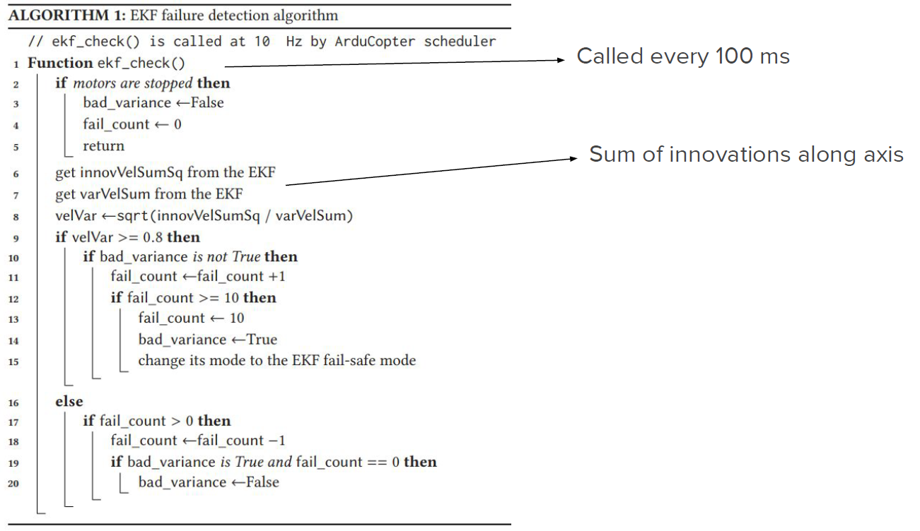

* During flight the drone might deviate from the track because of external influences such as wind.
* The path following algorithm is what prevent the drone from completely deviating from its mission.
* The ArduCopter path following algorithm is based on the ITP position.
* ArduCopter periodically advances the ITP along the track in small increments and causes the drone body to move to the ITP.



**SAFE HIJACKING STRATEGY**



* ITP remains unchanged if the drone is in Zone 1.
* Advances slightly forward along the track if in Zone 2 or 3.
* From the attacker’s point of view, the ITP can be estimated to be the physical location of the drone immediately prior to GPS spoofing.
* If the drone mistakenly determines that it has deviated from the track owing to GPS spoofing, then it will move in the direction away from the manipulated location to the ITP.
* The path following algorithm uses a *leash length*, i.e., a minimum distance from the current position to the main path.
* The attacker can exploit this distance to hijack the drone’s location.

**INITIAL FAKE LOCATION**

* The ITP is fixed or only slightly changed when the GPS location deviates from the main track by more than the leash length
* We can hence say that the physical location of the drone immediately before hijacking is an approximation of the updated ITP
* The attacker hence derive the possible coordinates of the initial fake location from the approximated ITP and the intended hijack direction
* We assume the attacker begins hijacking at the physical location pinit = (p1, p2, p3)
* Objective: move the drone to ptarget
* Hijacking direction = line between pinit and ptarget
* The drone will try to move to the ITP (approximately pinit) if its GPS location deviates from the track more than the leash length
* The direction from the initial fake location ainit = (a1, a2, a3) to the ITP should be the same as the hijacking direction

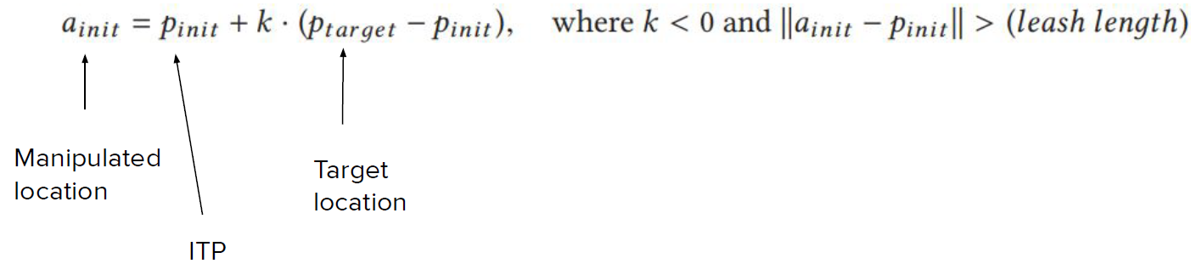

* The equation is the vector form of the parametric equation of a line
* Thus, ainit lies on the line that passes from pinot in the direction from target to pinot
* In addition, the distance between pinot and ainit should be higher than the leash length

**ADAPTIVE SPOOFING**

* The fail_count value will increase by one if the GPS location of the drone jumps to ainit because the GPS velocity and that measured by IMUs is not consistent.
* Therefore, the GPS velocity must be changed adaptively to be similar to the motion of the drone body to avoid triggering the failsafe mode.
* It makes the GPS location approach the drone’s original track to within the leash length, but we can prevent a change in the ITP by manipulating the GPS location to ainit again.
* The hijacker repeats the process until the drone reaches the safe target location
* The EKF failure count increases by one for each jump, but it will decrease to zero if the GPS velocity is consistent of that of the IMUs
* We define as t’ the current time, and as delta the GPS update period
* We update the current fake location as



**Flight Attitude Control**

* A drone needs a controller able to adjust the horizontal speed at a rotor level.
* Indeed multiple rotors are not always exactly the same and the center of mass cannot always be ensured.
* A flight attitude controller is hence implemented at a software level.
* Compute the proper control signal for multiple rotors based on the data from Inertial Measurement Units (IMU), including gyroscopes.

**ATTACKS TO UAV’S GYROSCOPE**

* An IMU is an electronic device using a combination of accelerometers, gyroscopes, and sometimes magnetometers to measure a body’s specific force.
* In a UAV, an IMU measures the orientation, rotation, and acceleration.
* Micro-Electro-Mechanical Systems (MEMS) gyroscopes are used to make flight control modules small.

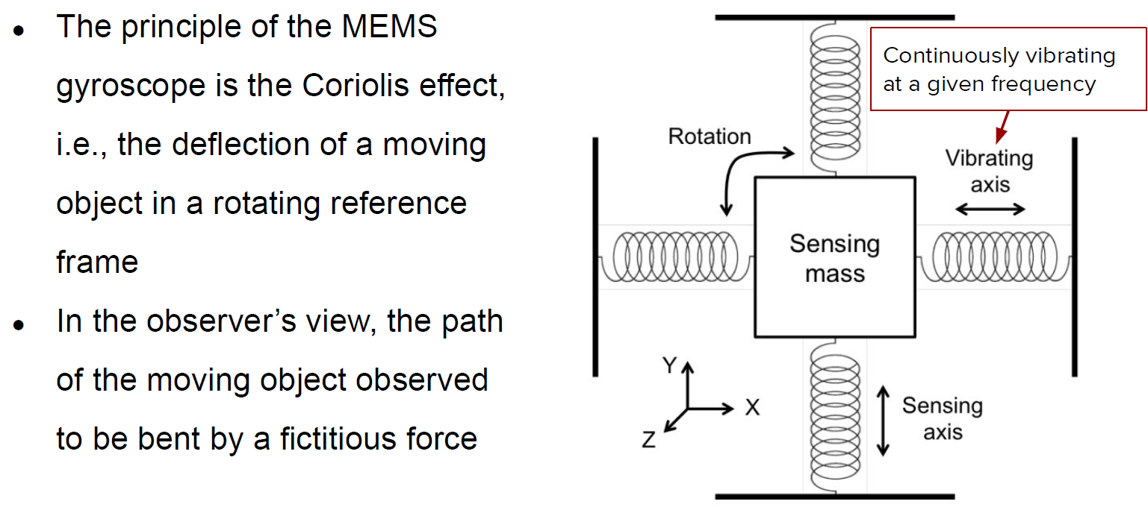

**Acoustic Noise Effect**

* MEMS gyroscopes are highly vulnerable to harsh acoustic noise.
* Such noise cause accuracy degradation, thus providing wrong results.
* A MEMS gyroscope has a resonant frequency related to the physical characteristics of its structure.
* Due to this resonance, if met, the gyroscope generates unexpected outputs that cause system malfunctioning.
* Usually, such frequencies should be ultrasound (above 20kHz).
* The sensitivity to noise can be exploited by an attacker.

**Setup**

* To effectively attack MEMS with audio, we need their resonant frequencies.
* A simple and reliable way, is exhaustive search → scan with single tone sound over a chosen frequency band.
* Use a consumer grade speaker connected to a laptop and placed 10 cm above the top of the target gyroscope.
* Generate single tone noises at frequencies from 100 Hz to 30 kHz at intervals of 100 Hz.

**Sound Source**

* A common noise measurement unit for the loudness of sound is the Sound Pressure Level (SPL).
* Another important property is the Total Harmonic Distortion plus Noise (THD+N), i.e., the ratio of the power of the harmonics and noise components to that of a fundamental component (in %).
* Sound source = tweeter.

**Noise Effect on MEMS**

* Gyroscopes fixed on a stable frame in an anechoic chamber.
* In the absence of noise, the variance of the measurements should be zero → difference in standard deviation as a criterion for the resonance of the gyroscope.



**Attack Design**

* The attacker, in order to design a good strategy, needs to understand what the drone is doing.
* Static analysis of the controller code to understand the reaction of sensor and actuators to noise.
* Usually drones can support different gyroscope implementations, however the main software routing is the same for all of them.

Software Analysis

* The main processor reads the raw data from the gyroscope’s registers through an I2C interface, along with the control data provided by the user.
* Raw data for each axis is stored in two 8-bit register → main inputs of the controller, which uses a PID logic to instruct rotors as follows.
  + P is proportional to the present output of the gyroscope, and if the present output is abnormally large the control from the transmitter can be ignored.
* Such raw data are them main inputs of the controller, which uses a PID logic to instruct rotors as follows.
  + I is proportional to the accumulated error between the output from the transmitter and the gyroscope, which can be ignored because usually its gain is very small.
  + D is proportional to the changes between the present output values and the gyroscope.
* Throughout the whole process the gyroscope data is not checked.

**Experiment**

* Attach a small bluetooth speaker above the target system gyroscope at a distance of 10 cm to serve as attacking source.
* The sound noise is turned on while the target drones were stably maintained in the air.
* To observe the status of the drone before, during, and after the attack, the speaker is turned off, on, and off again every 10 seconds.

# **7. Industrial Systems Security**

An **industrial control system** (ICS) is a broad class of automation systems used to provide control and monitoring functionality in manufacturing and industrial facilities. It is an aggregate of various system types:

* Process Control Systems (PCS)
* Distributed Control System (DCS)
* Supervisory Control and Data Acquisition (SCADA)
* Safety Instrumented Systems (SIS)

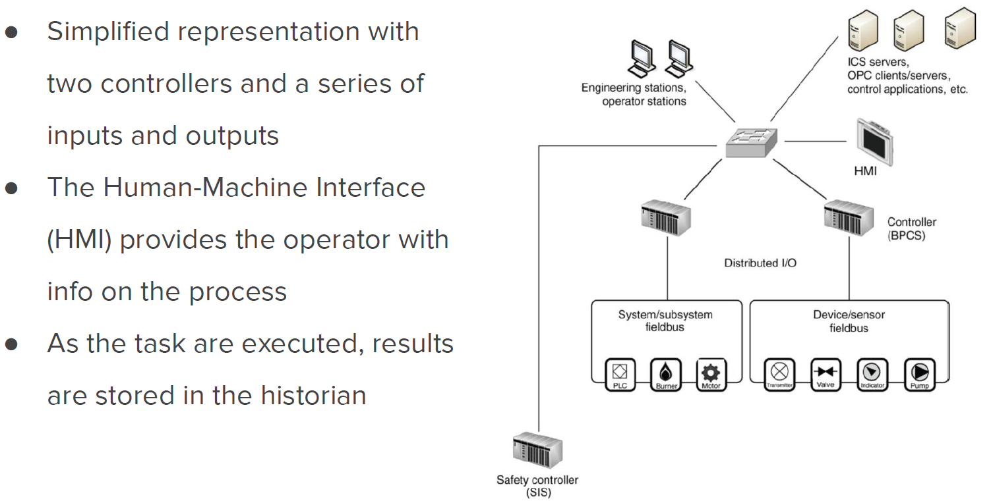

**Zones and Enclaves**

* These terms refer to closed groups of assets, or a function group of devices, services, and applications that make up a larger system.
* A zone describes a special network that is created to expose a subset of resources to a larger, untrusted network.
* This is often referred to as demilitarized zone.
* Used when enterprises want to place external-facing services, like web servers, email servers, B2B portals on the Internet while still securing their more trusted business networks.



**Common Recommendations**

* Identifying what systems need to be protected.
* Separating the systems logically into functional groups.
* Implementing a defense- in- depth strategy around each system or group.
* Controlling access into and between each group.
* Monitoring activities that occur within and between groups.
* Limiting the actions that can be executed within and between groups.

**Supervisory Control and Data Acquisition**

* Supervisory Control and Data Acquisition (SCADA) is a control system architecture comprising computers, networked data applications, and graphical user interfaces for high-level supervision of machines and processes.
* It also covers sensing and automation devices to interface with process plants or machineries.
* The operator can monitor the process and issues process commands via the SCADA computer system.
* Real-time control is performed by networked modules (controllers).
* SCADA can perform supervisory operations over a variety of other proprietary devices at different levels.
  + **Level 0:** field devices.
  + **Level 1:** industrialized input/output for direct control (PLCs/RTUs).
  + **Level 2:** supervisory computers aggregating information and provide the operator control screens (plant supervision → HMI).
  + **Level 3:** production control level that monitors production and target.
  + **Level 4:** production scheduling level.

Let’s see the components used in **industrial networks** and the role they play. Two main groups:

1. **Field components**, such as sensors, actuators, motor drives, gauges.
2. **Control system components**, such as programmable logic controllers, remote terminal units, intelligent electronic devices.

**PROGRAMMABLE LOGIC CONTROLLER**

* A Programmable Logic Controller (PLC) is a specialized industrial computer used to automate functions within manufacturing facilities.
* They are typically hardened, making them suitable for deployment in production environments.
* May be specialized for specific industrial uses with multiple specialized inputs and outputs.
* They do not use common operating systems, but rely on specific application programs that allow the PLC to function automatically generating output actions in response to specific inputs.



* They usually control real time processes, so they are designed for simple efficiency.
* Processing overhead and delay in the execution of the PLC functioning may impair a whole production process.
* The logic of PLCs is implemented via a standardized set of languages given by IEC-61131-3.
* Among them, we find Ladder Logics/Ladder Diagrams.
* The working principle of PLC can be understood as a cyclic scanning method, i.e., the scan cycle.
* The cycle goes on until the PLC is in run Mode.



* Part 3 of IET 61131 deals with basic software architecture and programming languages for PLCs.
* We have both graphical and textual programming languages:
  + graphical: Visual PL or block coding is a PL that lets users create programs by manipulating grèahical elements;
  + textual: classical languages you always used.

**LADDER LOGIC**

* Gets its name from the legacy methods of implementing discrete logic via electromechanical relays.
* Can be thought of as a set of connections between inputs (relay contacts) and outputs (relay coils).
* It defines a path consisting of logic steps that need to be fulfilled to allow for reaching the end.
* If one of the conditions is false, then the overall path is false and hence the output remains “de-energized”.
* The PLC applies this ladder logic by looking at inputs from discrete devices that are connected to the manufacturing equipment.
* It uses a thresholder to decide whether the input is true or false.
* Performs a desired output functions based on the state of these inputs.
* The outputs are connected to manufacturing equipment, such as actuators and motor drives.
* Can be thought of a rule-based language rather than a procedural
* language
* A “rung” in the ladder represents a rule.
* When executed in a PLC, these rules are executed sequentially by a software in a continuous loop or scan.
* By executing these loops at a high peace (many times per second), we achieve the effect of simultaneous and immediate execution.
* The language itself is a set of connections between logical checkers (contacts) and actuators (cols)
* If a path can be traced between the input and output through asserted contacts, the rung is true and the output coil storage bit is asserted (1)
* **Rung inputs:** checkers or contacts
  + -[ ]- : normally open contact, closed when its input is energized
  + -[\]- : normally closed contact
* **Rung outputs:** actuators (coils)
  + -( )- : normally inactive coil, energyzed when the rung is closed
  + -(\)- : normally active coil

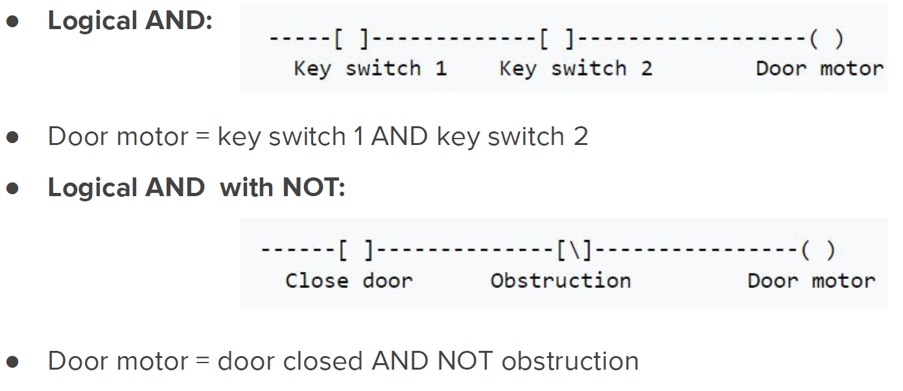

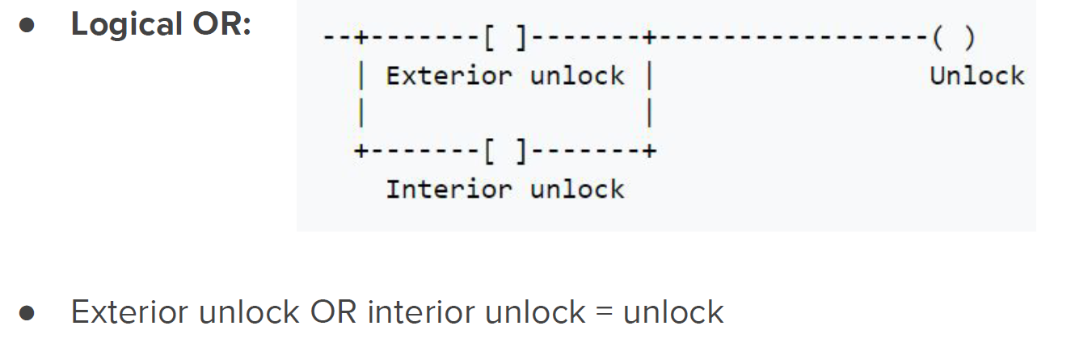

**INDUSTRIAL STOP/START**

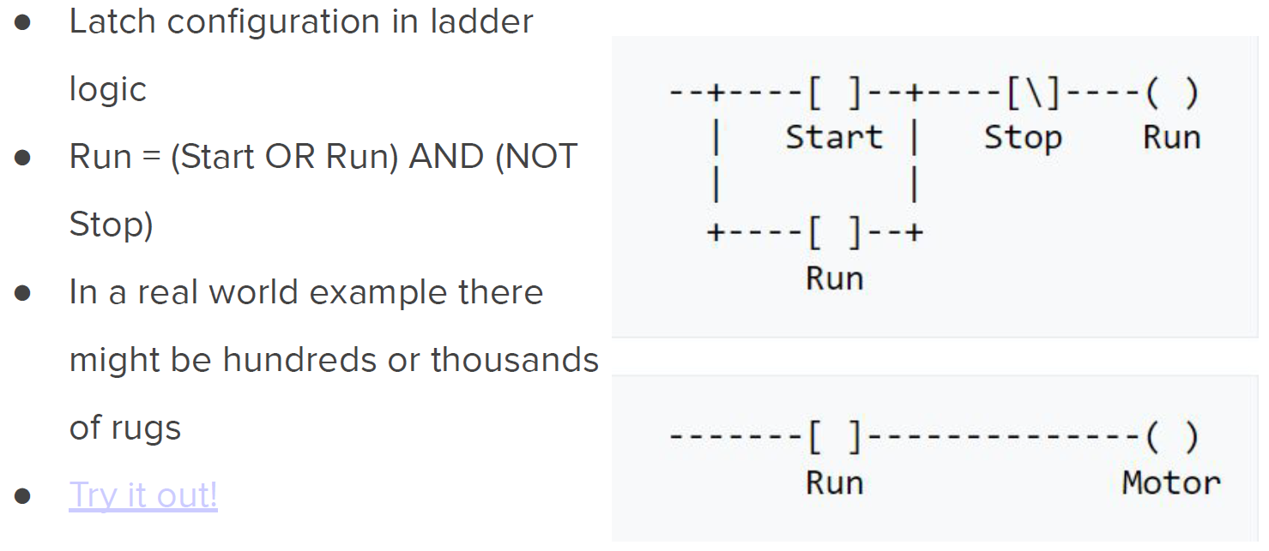

**REMOTE TERMINAL UNITS**

* A Remote Terminal Unit (RTU) monitors the field parameters and send this data back to a central monitoring station (e.g., an ICS server, a centrally located PLC, or HMI).
* RTUs typically reside in substations along a pipeline or some other remote location where there may not have easy access to electricity.
* They usually include communication capabilities, e.g., via modem, cellular data connections, radio or other wide area communication technology.
* Their communication bandwidth is generally limited.
* In order to maximize the information transmitted they use protocols supporting *report by exception* or other *publish-subscribe* mechanism.

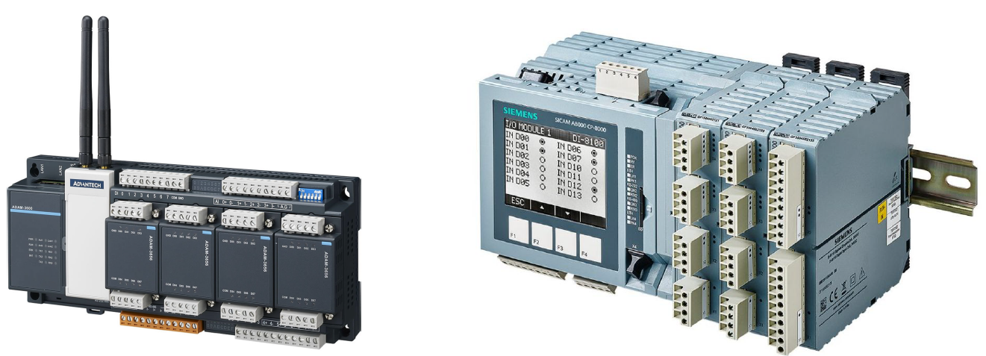

* An RTU is basically the interface between the physical world and the distributed control/SCADA system.
* They usually support the IEC 61131-3 programming standard for PLCs.
* It can monitor inputs of different types:
  + Digital: to acquire two state real-world information, usually accomplished by using an isolated voltage or current source to sense the position of a remote contact at the RTU side.
  + Analog: can monitor analog inputs of different types (current, voltage).
* Can also receive analog inputs from other on-field devices.
* It can produce outputs of different types:
  + Digital: may drive high current capacity relays to a digital output board to switch on or off on-field devices, may drive a sensitive logic input in an electronic PLC using a sensitive 5V input.
  + Analog: may be included in control devices that require varying quantities.
* They are usually capable of executing simple programs autonomously without involving the host computers of the distributed control system or SCADA.

**HUMAN-MACHINE INTERFACE**

* They provide the means for operators to interact with PLCs, RTUs, and IEDs.
* They replace manually activated switches, dials, and other electrical controls with graphical representations of the digital controls used to sense and influence the process.
* They allow the operator to start and stop cycles, adjust set points and perform other functions to adjust and interact with the control process.
* The HMI is at the top level near the human operator.



* The figure shows how it is integrated in the overall (up to now) system.
* The human interact with the HMI via a console, which however does not require authentication.
* They are hence deployed in physically strong security areas.
* The HMI uses software that may come in two forms.
* The first runs on operating systems such as Windows 11 and are capable of performing a variety of functions.
* The other form combines an industrial hardened computer, local touch panel, and typically utilize embedded operating systems.
* In this case, they are usually programmed with a separate computedand associated engineering software.
* The HMI shows the process instead of the logic behind it.
* Since they provide supervisory data as well as control, user access control should be part of the ICS.
* The HMI interacts with an ICS and hence with one or more controllers.

**Data Historian**

* It is a specialized software system that collects point values, alarm events, batch records, and other information from industrial devices and systems and stores them in a purpose-built database.
* Data that are historized and stored is referred to as *tags*, and car represent almost anything.
* Information used by both industrial operations and business management is often replicated across industrial and business networks and stored in data historians → security risk due to zones.

**Control Processes**

* Control process is a general terms used to define large automated process within an industrial operation.
* To manufacture a product or generate electricity, it might be necessary to use many control processes, each comprising one or more control loops.
* Examples: one process might be to inject an ingredient into a mixer utilizing a control loop that opens a valve in response to volume measurements within the mixer, temperature, and other conditions.



**SAFETY INSTRUMENTED SYSTEMS**

A risk management strategy should include different layers of protection to prevent a manufacturing environment to reach an unsafe operating condition. Safety Instrumented Systems (SIS) are deployed as part of a comprehensive risk management strategy. The basic process control systems is responsible for discrete and continuous control necessary for normal operations. In the event of an abnormal situation, the SIS takes over the control.

**Risks of SISs**

* There are risks originating within the SIS relating to cyber incidents.
* The prevention of the SIS from properly performing its control functions can allow the plant to transition into a dangerous state.
* Since the SIS operationally overrides the BPCS and its ability to control the plant, the SIS can also be used maliciously to cause unintentional equipment or plant shutdowns.
* To prevent this situations, we need to isolate the SIS to the greatest possible extent from other basic control assets.

**SIS Isolation**

* SIS programming is not usually allowed in operational mode.
* Highly authorized applications like SIS programming tools and SIS engineering workstations can be removed from ICS networks until they are required.
* SIS systems must be periodically tested to guarantee their functionality.
* This also includes cyber security assessments.

**INDUSTRIAL NETWORKING**

* An industrial network is any network that supports the interconnectivity of and communication between devices that make up or support an ICS.
* They may be local-area switched networks as common with Distributed Control Systems.
* They may be wide-area routed networks more typical of SCADA architectures.
* Most are Ethernet and IP-based and consist of both wired and wireless connectivity.
* Availability is prioritized over data integrity and confidentiality.
* Therefore, there is a great use of real-time protocols, UDP transport, and fault-tolerant networks interconnecting endpoints and servers.
* Bandwidth and latency are extremely important, because the applications and protocols in use support real-time operations that depend on deterministic communication often with precise timing requirements.
* Ubiquitous connectivity might not be something we want to achieve.
* The ICS requirements dictate the topology of the networks.
* High reliability and resiliency dictates the use of ring or mesh network topologies.
* Real-time operations and low latency require the minimization of switching and routing hops.

 

* Five sessions require 20 paths to be traversed.
* It is therefore necessary to minimize latency wherever possible to maintain real-time and deterministic communications.
* Therefore, we need to use switching unless traversing a functional boundary.
* We also need to use low level (Ethernet) firewalls and prefer a bridged mode, i.e., avoid relying on IP routing.
* As we go lower into the control environment, functionality becomes more specialized.
* Introduction of open and/or proprietary protocols in either their native form or adapted to work over Ethernet.
* Figure below: Fieldbus.



**Wireless Network**

* Wireless networks are bound by the same design principles as wired networks.
* However, they are more difficult to physically contain because they are bound by the range of the radio wave propagation from an access point rather than by physical cables and network interfaces.
* Any device that is equipped with an appropriate receiver and is within the range of a wireless access point can physically receive wireless signals.
* There is no sure way to prevent this physical (wireless) access.
* While it is possible to block transmissions by using jammers or signal-absorbing materials, these measures are costly and rarely implemented.
* Typically conduct thorough radio frequency surveys in order to not only place antennas in optimal locations, but also prevent unnecessary transmission of signals into untrusted and unrestricted areas.



**NETWORK SEGMENTATION**

* “Segmentation” pertains to the division of networks (network segmentation) or zones (zone segmentation) into smaller units.
* Important for many reasons, including network performance considerations and cyber security.
* Segmentation typically occurs at Layer 3 (the network layer) by a network device providing routing functions.
* The router blocks broadcasts, enabling a large flat Ethernet network to be broken up into discrete Ethernet segments.
* Segmentation provides an inherent degree of access control at each demarcation point
* Should be used to support zone segmentation whenever possible.
* Results in hierarchical networks, such that communication between two networks might require traversal of several networks.
* Just because a segmented network architecture supports communication flows between segments, it does not mean that this traffic should be allowed between segments.



**Physical vs Logical Segmentation**

* Physical segmentation refers to the use of two separate physical network devices (both passive and active components) to perform the isolation between networks.
* Logical segmentation refers to the use of logical functions within a single network device to achieve essentially the same result.
* Physical separation of systems (“air gap” separation) is still widely used in industrial networks when talking about the coexistence of basic process control and safety systems overseeing the same process.

**Creating zones from segment**

* Each industrial architecture is unique, not because of the selection of equipment, but how each system is deployed in a particular environment and how each system is integrated with other ancillary systems.
* A safety level applied to each system so that appropriate measures can be in place to ensure that each system performs as intended without unintentional consequences or interactions between systems.
* Assets at a particular site are grouped based on their relative security requirements or security level.

**Identifying zones**

* One of the biggest challenge is the creation of a set of base requirements to determine whether a certain asset should be in a certain zone.
* These goals can be broken down into categories
  + Based on communications and interactions
  + Physical access to assets
* Zones based on network connectivity are rather easy to understand.

**BASED ON CONTROL LOOPS**

…

**BASED ON PLANT**

…

There are many highly specialized protocols used for industrial automation and control. Since they are designed for efficiency, many of them usually forgo any feature or function that is not absolutely necessary. Many of them have been adapted to run on top of Ethernet and IP. Two categories:

1. Fieldbus: commonly found in process and control.
2. Backend: commonly deployed on or above supervisory networks, and are used to provide efficient system-to-system communication.

**MODBUS**

* Modbus is an application layer messaging protocol, meaning that it operates at **Layer 7** of the OSI model.
* It was designed in 1979 to enable process controllers to communicate with real-time computers.
* It remains one of the most popular protocols used in ICS architectures.
* It has been widely adopted as a de-facto standard, freely distributed, and well-supported by the Modbus Organization.
* It has been enhanced over the years into several distinct variants.
* It is based on a request/reply methodology allowing for efficient communications between interconnected assets.
* Extremely simple devices such as motors and sensors use Modbus to communicate with more complex computers.
* Therefore, message generation, transmission, and receipt all require very little processing overhead.
* It makes it a suitable protocol from PLCs and RTUs to communicate data to supervisory ICS.



* It is a request/response protocol using three distinct protocol data units
  + Modbus Request
  + Modbus Response
  + Modbus Exception Response
* Up to 32 devices can be connected on a single RS-485 serial link, requiring each device being assigned a unique address.
* A command is addressed to a specific modbus address.
* While other devices may receive the message, only the addressed device will respond.

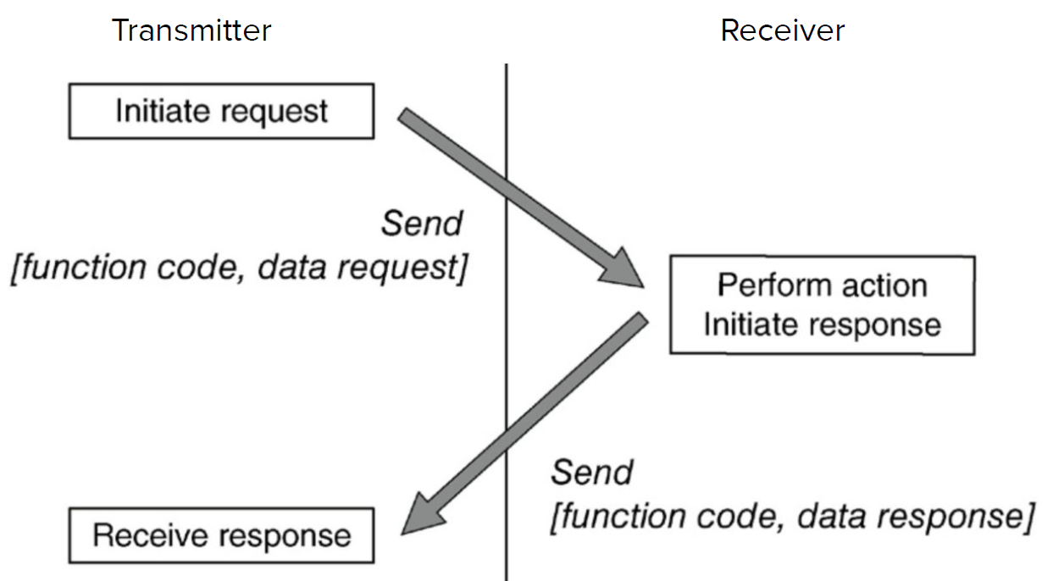

* A “transaction” begins with the transmission of an initial Function Code and a Data Request within a Request PDU.
* If there are no errors, the receiver will respond with a Function Code and Data Response within a Response PDU.
* If there are errors, the device will respond with an Exception Function Code and Exception Code within a Modbus Exception Response.



* Function Codes used in Modbus are divided into three categories and provide the device vendor with some flexibility in how they implement the protocol.
* Function codes in the range of 01–64, 73–99, and 111–127 are defined as “Public” and are validated by the Modbus-IDA community and are guaranteed unique.
* “User-Defined” function codes in the range 65–72 and 100–110 are provided to allow a particular vendor to implement functionality to suit their particular device and application.
* “User-Defined” function codes in the range 65–72 and 100–110 are provided to allow a particular vendor to implement functionality to suit their particular device and application.
* Function Codes and Data Requests can be used to perform a wide range of commands.
* E.g., Read the value of a single register, Write a value to a single register, Read a block of values from a group of registers, Obtain device diagnostic data.

**Where do we use MODBUS?** Modbus is typically deployed between PLCs (client) and HMIs (server). Modbus devices may also take the role of server in some communications, while being client in other communications.



**Security concerns**

* Modbus presents several security issues.
* It **lacks authentication**: sessions only require the use of a valid Modbus address, function code, and associated data.
* The data must contain the values of legitimate registers or coils contained in the slave device, or the message will be rejected.
* This requires additional information of the target in order to provide a valid message, which however can be obtained via e.g., traffic analysis.
* Possibility for man-in-the-middle and replay-like attacks.
* It **lacks encryption:** Commands and addresses are transmitted in clear text and can therefore be easily captured and spoofed or replayed due to the lack of encryption.
* Communications to/from a Modbus device can also disclose significant information pertaining to the configuration and use of the device.
* It **lacks message checksum:** a command can easily be spoofed by building up the Modbus/TCP ADU with the desired parameters, as the checksum is generated at the transmission layer, not the application layer.

**Security recommendations**

* Should only be used to communicate between sets of known devices.
* In this way it can be easily monitored by establishing clear network zones and by baselining acceptable behavior.
* This baseline behavior can then be used to establish access controlson the conduit into the zone via appliances that provide protocol inspecting and filtering capabilities.
* Suspicious messages: Modbus TCP packets that are of wrong size or length, function codes that force slave devices into a “listen only” mode, function codes that restart communications.

**Distributed Network Protocol**

* DNP3 was extended to work over IP via encapsulation in TCP or UDP packets in 1998, and is now applied in different industries.
* DNP3 is very reliable, while remaining efficient and well suited for real-time data transfer.
* It also utilizes several standardized data formats and supports time-stamped (and time-synchronized) data, making real-time transmissions more efficient and thus even more reliable
* A single DNP3 frame can include up to 17 CRCs.
* Variations of DNP3 support link-layer authentication.

**How DNP3 works**

* DNP3 is primarily used to send and receive messages between control system devices.
* It can also be used to send control functions, or even direct binary or analog data for direct interaction with devices, such as RTUs and IEDs.
* DNP3 provides a method to identify the remote device parameters and then use message buffers corresponding to event data classes 1 through 3 in order to identify incoming messages and compare them to known point data.
* In this way, the master station is only required to retrieve new information resulting from a point change or change event on the outstation.
* Initial communications are typically a class 0 request from the master station to an outstation, used to read all point values into the master station’s database.
* Subsequent communications will typically either be direct poll requests for a specific data class from the master station, or control or configuration requests from the master station to an outstation.

**Where we use DNP3**



**Security concerns**

* Much attention is given to the integrity of the data frame, there is no authentication or encryption inherent within DNP3.
* Some examples of realistic hacks against DNP3 include the use of MitM attacks to capture addresses, which can then be used to manipulate other system components.
* Examples: Turning off unsolicited reporting to suppress alarms, Spoofing unsolicited responses to the master station to falsify events, Performing a DoS attack through the injection of broadcasts.

**Secure DNP3**

* Secure DNP3 is a DNP3 variant that adds authentication to the response/request process
* Authentication is issued as a challenge by the receiving device.
* A challenge condition occurs upon session initiation, after a preset period of time, or upon a “critical” request, such as write.
* Authentication occurs using a unique session key that is hashed together with message data from the sender and from the challenger.
* In this way, it is very difficult to perform data manipulation or code injection, or to spoof or otherwise hijack the protocol.

## **7.1 Attacks and Detection in ICS**

**Vulnerabilities of ICS**

* The major distinction of control systems with respect to other IT systems is the interaction with the physical world.
* While measures for IT systems may be good for IT systems, they might not be sufficient for ICS.
* It is important not only to protect information, but also to protect estimation and control algorithms and how they impact the physical world.

**Risk Assessment**

* Risk management = shifting the odds in your favor by finding the alternative that minimizes the impact of certain events.
* The best well-known metric is the average loss 
* Multiply the loss implied by event i by the probability that event i occurs.
* There are also other measures, for instance the variance of the losses.
* 
* However, this is important over long periods of time so not very suitable for our case, average loss is more than enough.

**ATTACK MODEL**

* We focus on attacks on sensor networks and their effect on process control.
* In our case, *pi* denotes the likelihood that an attacker will compromise sensor i, and *Li* denotes the loss associated with that particular compromise.
* We assume that the likelihood is the same for all sensors, and we focus on the estimate of the potential loss.
* Let’s consider a network of p sensors with measurement vector 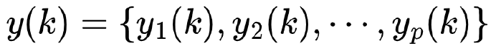
* All sensors have a dynamic range that defines the domain of y for all k.
* I.e., 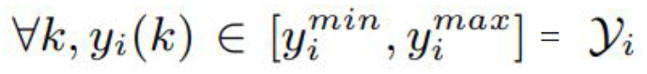
* We assume each sensor has a unique identity protected by a cryptographic key.
* Let  denote the received measurement by the controller at time k.
* Based on these measurements, the control system defines control actions to maintain certain operational goals.
* We assume that attacked signals lie within 
* If the malicious value is outside the legitimate range, it can be simply detected by fault-tolerant algorithms.
* Let  denote the attack duration.
* Given attack signal , the general model for the observed signal.



* This model can be used to represent two types of attacks.
* **Integrity attacks**: in this case the attacker compromises the senor and the value it reports, therefore  can be some arbitrary non-zero value.
* **DoS attack**: the controller will notice the lack of new measurements and will react accordingly. An intuitive response is the use of the last received valid signal.

**Experiments**

* Controllers are not stupid…
* Let’s see what effect these attack might have on an industrial process and decide which attack has the most impact.
* Tennessee-Eastman process control system (TE-PCS) and multi-loop PI control.
* Chemical process introduced for education purposes and for benchmarking.

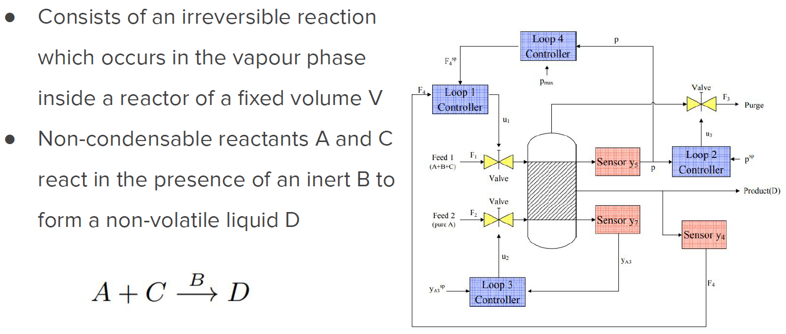

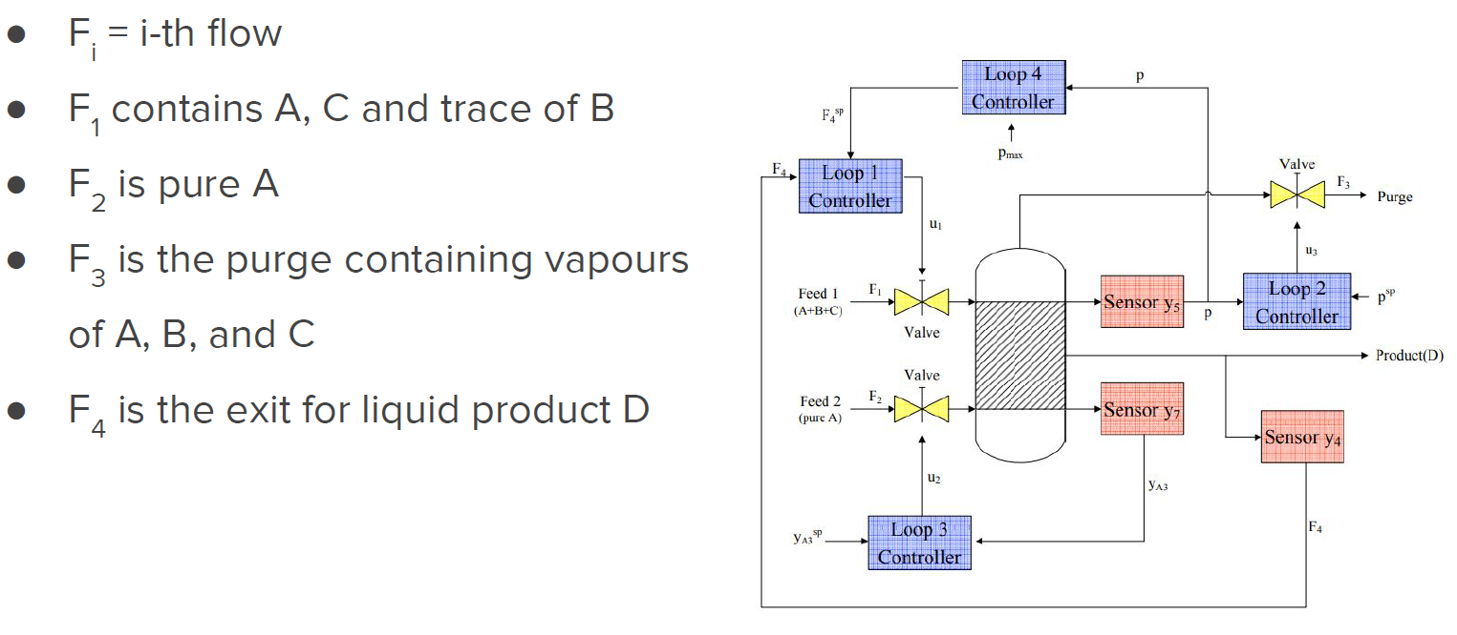

**Control Objectives**

* Regulate the rate  of production of product D at a set point 
* Maintain the operating pressure of the reactor P below the shutdown limit (safety).
* Minimize C, the operating cost, that is a linear function of the purge loss of A and C relative to the production rate of D 
* Where  and  denote the respective fractions of A and C in the purge, the vs are given constants.

**Input variables**

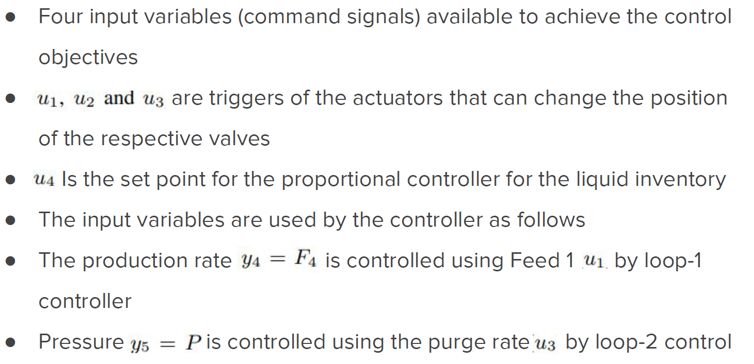

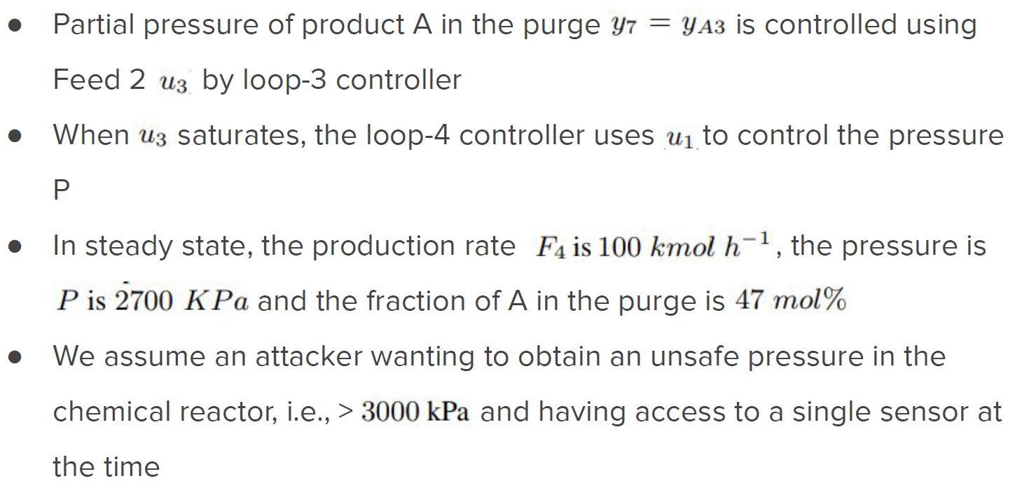

**ATTACKING TE-PCS**

* We assume an attacker wanting to obtain an unsafe pressure in the chemical reactor, i.e., > 3000 kPa and has access to a single sensor at the time.
* We also assume that *Li* > *Lj* when an attack i can drive the system to an unsafe state and an attack j cannot.
* Spoiler: the most effective attacks are max/min attacks, i.e., when  or , although not all of them can drive the system to un unsafe state.
* By attacking a sensor we expect the controller to respond with incorrect control signals: by pushing  from t=0, to 30 the controller believes there is a large amount of component A in the tank.
* However, the controller can bring back the system to the steady state when the attack finishes.
* Furthermore, the pressure never reaches the critical 3000 kPa value.



* By launching attack  the attacker turns down the purge valve to increase the pressure and prevent the liquid products from accumulating.
* The pressure of the tank keeps increasing past 3000 kPa and the system operates in an unsafe state.
* However, it takes about 20 hours to cause an explosion.
* This delay (slow-dynamics) gives human system operators enough time to observe the unusual phenomenon and take proper action.



* Detecting attacks to control systems can be formulated as an anomaly-based intrusion detection.
* Instead of modelling traffic or software behavior, we model the physical system.
* If we know how the output sequence of the physical system should react to the control input sequence, then any attack to the sensor data can be potentially detected by comparing the expected output with the received signal.
* **Needs**: model of the system and anomaly detection algorithm.

**System Model**

* Developing a model for the system under analysis is not trivial.
* First principles model: derived from the laws of physics.
* Empirical input and output data: learn the model.
* To facilitate this task, most industrial control vendors provide identification packages, i.e., tools to develop models from physical data.
* The most common models are linear systems, which model dynamics that are linear in state x and control u 
* Assuming that the system is monitored by a sensor network of p senrs, we obtain the measurement sequence from the observation equation.
* 
* These values represents the estimated measurements collected by the sensor, and C is the output matrix 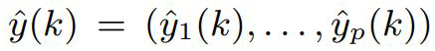

**Detection Methods**

* Sequential detection theory: methodology to detect anomalies in real-time without considering a fixed measurement time, but relying on an online-chosen detection time
* Problem formulations of this kind are called optimal stopping problems
* Two such problems formulation are sequential detection (sequential hypothesis testing) and quickest detection (change detection)
* Reference to this type of problems:
  + T. Kailath and H. V. Poor. Detection of stochastic processes.
  + IEEE Transactions on Information Theory, 44(6):2230–2258, October 1998

**Optimal Stopping Problems**

* Let us consider a given time series sequence 
* Goal: determine the minimum number N of samples to observe before making a decision on one of two hypothesis: *H0*, i.e., normal behavior or *H1*, i.e., attack.
* Sequential detection strategy: we assume that the time series originated from either the normal or attack hypothesis and we want to decide on the hypothesis in the minimum amount of time.
* Change detection: the sequence originated from the normal hypothesis and changed to the other. We want to detect this change ASAP.

**Sequential Detection**

* *False alarm probability*: detect an attack when there is none.
* *Missed detection probability*: probability of not detecting an attack.
* Goal: Given fixed false alarm and detection probability, minimize the number of observations needed to make a decision.
* Solution given by the Sequential Probability Ratio Test (SPRT).
* Also referred to as Threshold Random Walk (TRW) in security papers and used to detect portscans, worms, and botnets.

**Sequential Detection: SPRT**

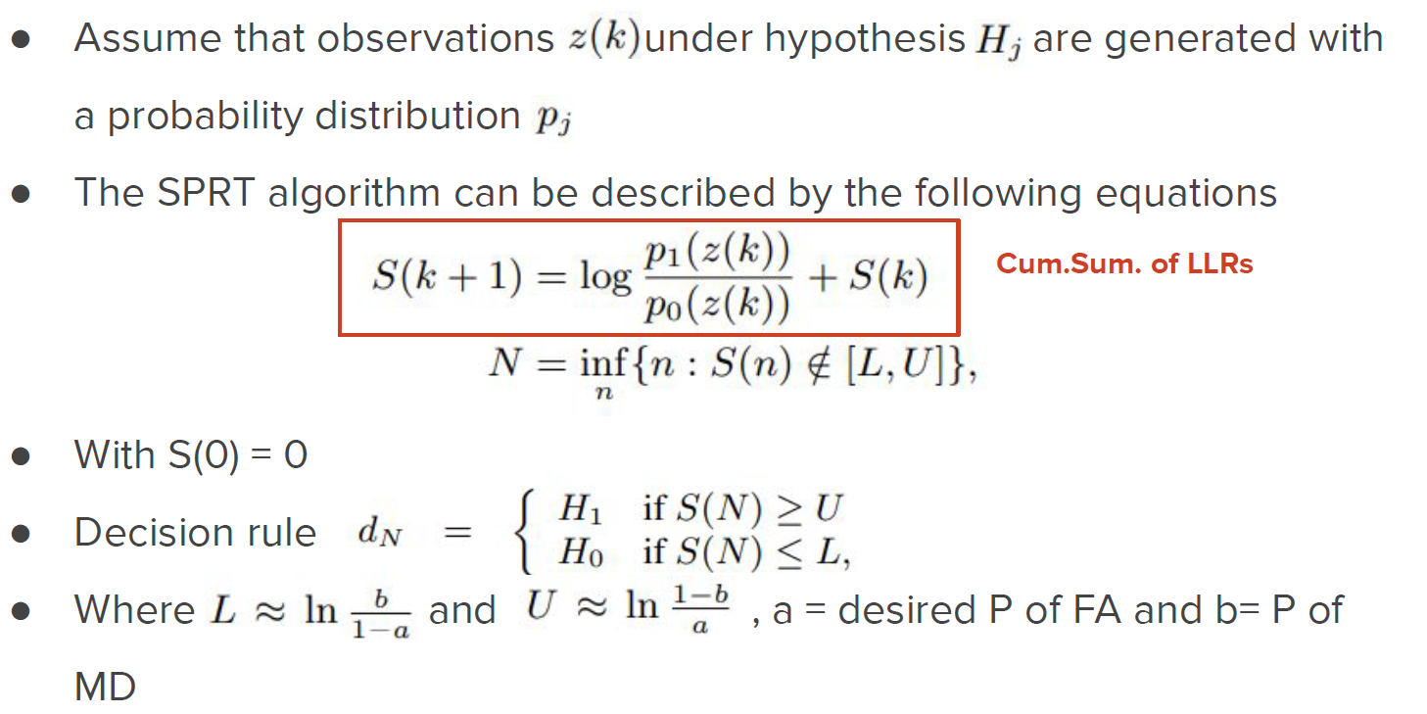

**Change Detection**

* Detect a possible change in the generation problem at an unknown change point *ks*
* CUSUM and Shiryaev-Roberts statistics are the two most commonly used algorithms for change detection.
* Given a fixed false alarm rate, CUSUM aims at minimizing the time N > *ks* for which the test stops and decides that a change has occurred.
* Very similar to SPRT.

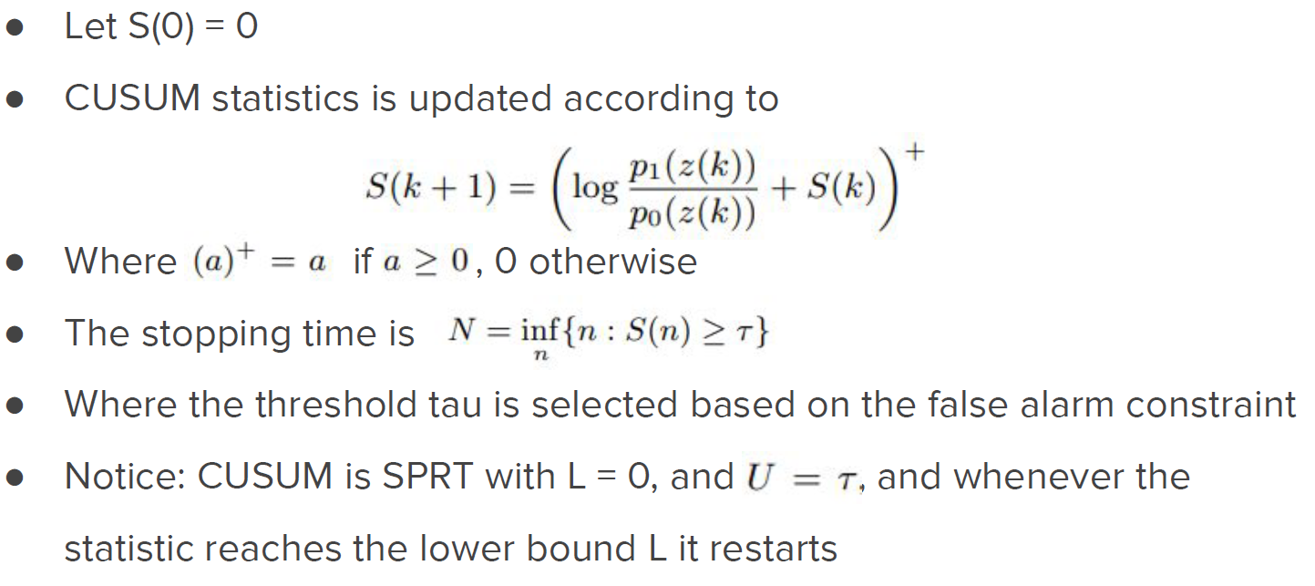

**Detecting Compromised Sensors**

* In general, we do not know the probability distribution for an attack
* The attacker can indeed select arbitrary and non-stationary sequence, hence assuming a fixed probability limits our detection capabilities
* We hence use ideas from nonparametric statistics
* We do not assume a parametric distribution for *pj*, j = {0, 1}
* We place mild constraints on the observation sequence

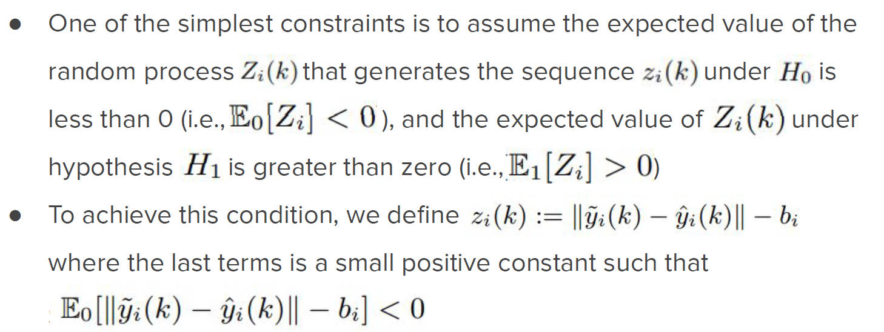

**Selecting b**

* To select the value bi for each sensor, we need to estimate the expected value of the distance between the linear model estimate and the sensor measurement (i.e., without attack), respectively.
* Run experiments to estimate probabilities.



**Detecting Compromised Sensors**

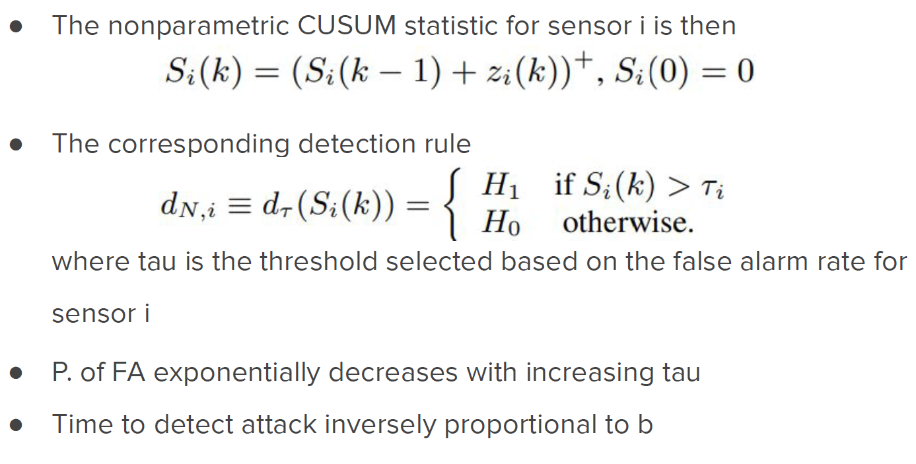

**Computing tau**

* Run the system many times without attacks and count how many times the system detects ana attack.
* In general we would like to select tau as high as possible to avoid false alarms.
* This however increases the detection time.



**Stealthy Attacks**

* Sometimes attackers are able to adapt to the system and develop solutions to evade detection schemes.
* We now consider an attacker aware of the existence and working principle of our detection system.
* We assume the attacker knows: the exact linear model that we use (i.e., matrices A, B, and C), the parameters tau and b, and the control command signals.
* Goal: raise the pressure in the tank without being detected (i.e., keeping the controlled statistics below threshold tau).

**Surge Attacks**

* The attacker tries to maximize the damage as soon as possible
* However, when the statistics reaches the threshold it stays at the threshold level for the remaining time of the attack
* Means 
* To do this, the attacker needs to solve 

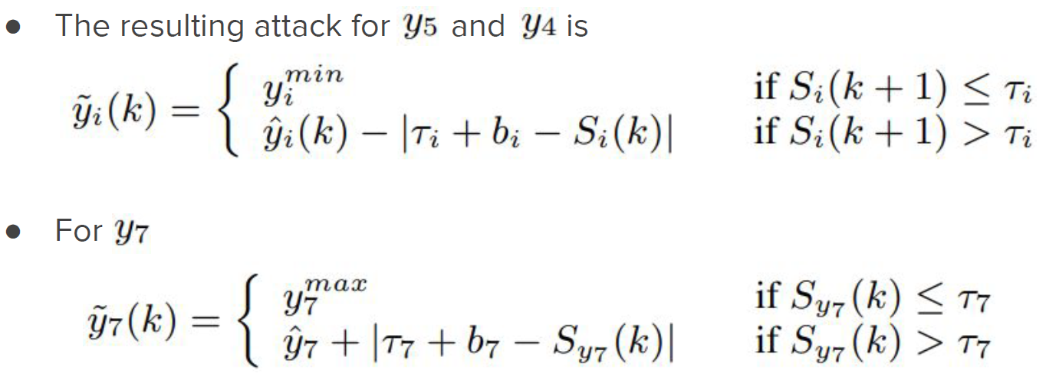

**Bias Attacks**

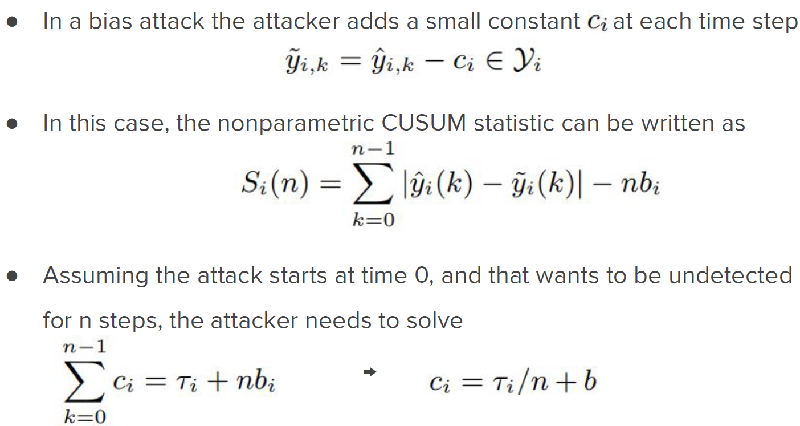

* This attack creates a bias of  for each attacked signal
* If an attacker wants to maximize the damage, the attacker needs to select the smallest n
* Since , it is reduced to an impulse attack
* If the attacker wants to attack for a long time, then n will be very large
* If n is large, the bias is smaller

**Geometric Attacks**

* The attacker wants to drift the value very slowly at the beginning and maximize the damage at the end.
* Combine slow initial drift of the bias attack with a surge attack at the end to cause maximum damage.
* Given , the attack is 
* We need to find alpha and beta such that 

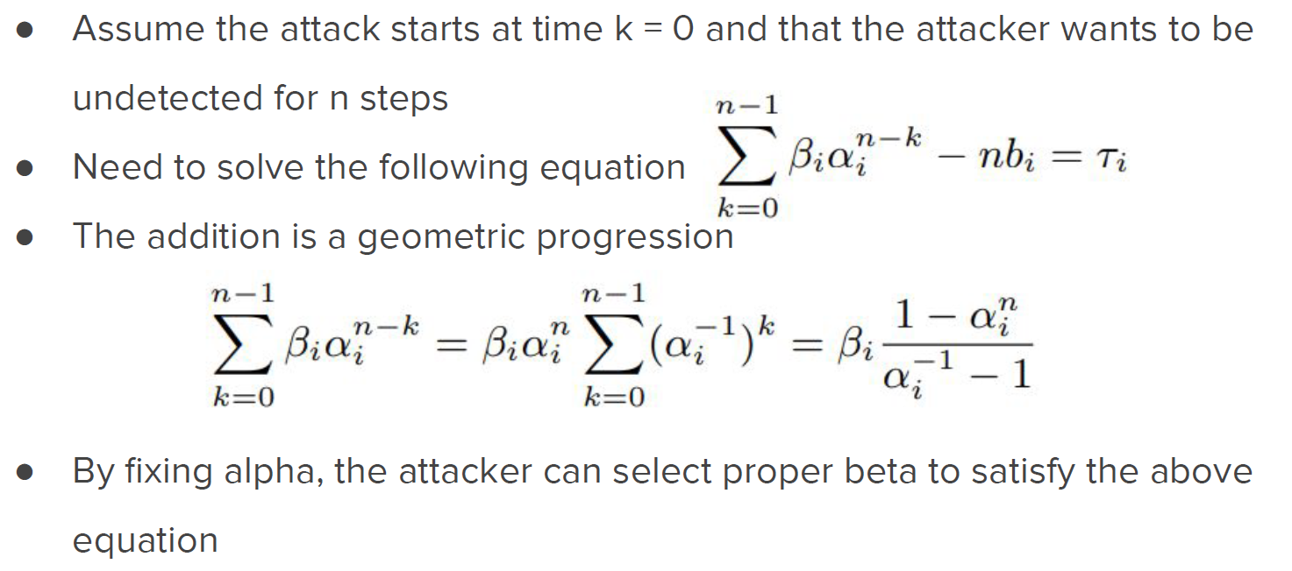

**Detectability**

* The value tau impacts on how good we are in detecting attacks.
* Thus, a relevant information is the percentage of successful stealthy attacks for different values of tau.
* Paramterization of threshold as 
* Success of geometric stealthy attack in bringing pressure above 3000kPa.
* Attack undetected.



**Safety**

* Although attack may go undetected, they usually do not impact on the safety.
* The most successful attack is the geometric one.



### **7.1.1 Honeypot**

Stuxnet was the first example of a cyberattack against an ICSs, but not the only one. In 2017 Triton malware was able to disable safety instrumented systems in a Saudi Arabian petrochemical plant. In 2017, WannaCry ransomware took down a car manufacturing factory

in Japan.

To effectively protect ICSs it is necessary to develop new methods for attack detection and mitigation. Firewalls and anti-virus solutions are reactive and require updates in order to detect/prevent new forms of malicious traffic. Zero-day exploits can consequently penetrate networks and infect systems while being undetected. Bring your own device makes it hard to define clear security perimeters.

**Honeypots**

* A solution aiming at mitigating novel (potentially unknown) attacks is via honeypots.
* Honeypots are systems with no inherent purpose rather than capturing attacks either on the internet of within a networks.
* Generally, they do not receive any legitimate traffic.
* Many different types of honeypots, ranging from emulating specific services (e.g., SSH) to fully fledged systems with multiple running services.
* Proactive approach to security: adversaries are encouraged to attack these systems to reveal valuable threat intelligence.
* This gives indication on new vulnerabilities and associated exploits.
* Broader view of offensive tactics and techniques.
* In 2020, honeypots helped in identifying four zero-day vulnerabilities in ICS, proving their effectiveness.

**Legal Caveat**

* Entrapment: defense to criminal charges when it is established that the agent or official originated the idea of the crime and induced the accused to engage in it.
* Other experts consider honeypots not only unethical, but a disadvantage to the computer world since they are “building the better hacker”.
* However, pretty useful, nah?

Honeypots Types

* Honeypots can be either virtual or physical and are designed to be exploitable.
* Virtual: install and simulate hosts on the network from different operating systems and simulate the whole TCP/IP stack. More frequent modality.
* Physical: real machines with their own IP addresses simulating the behaviors modeled by the system. Higher price for purchasing and maintenance, so less frequent.
* Research honeypots: facing the internet and deployed to gather information for research purposes.
* Production honeypots: usually not directly accessible and deployed inside an organizational network.
* Need to be configured with care to avoid the entrapment problem.
* When compromised, they can generate alerts, deceive the attacker by diverting exploitation efforts away from the system.

**Honeynets**

* A honeynet can be defined as two or more honeypots implemented on a system.
* More specifically, it is a high interaction honeypot system of generation I, II, and III.
* Usually, although using multiple honeypots in a system, the literature talks about honeypots.
* Generation I: first appeared in 1999 with the goal of capturing actions from the black-hat community. It consists of a firewall supported by an IDS at front and a honeypot in the back. They can capture in-depth information and capture unknown attacks. However, they can easily be detected by attackers.
* Generation II as developed in 2002 and had an honeynet sensor that serves the purpose of the IDS and of the firewall in Generation I.
* The sensor works like a bridge, so it is more difficult for attackers to detect it.
* Generation III was developed in 2004 and had the same architecture as Generation II.
* However, it has improved deployment and management capabilities.

**Two types**

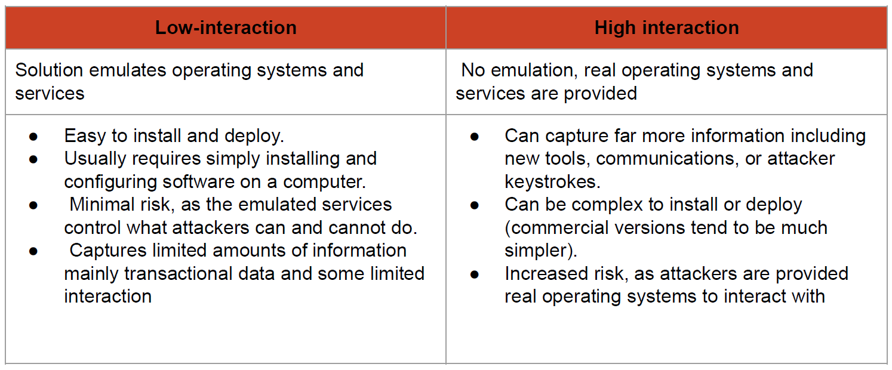

**The First ICS Honeypot**

* The first honeynet for SCADA ICS was proposed by Cisco Systems’ SCADA HoneyNet Project in 2004.
* It is based on an open-source honeypot framework Honeyd.
* It is a low interaction honeynet that supports the simulation of Modbus/TCP, FTP, Telnet, and HTTP services running on a PLC.
* We need to simulate various entry points so that when the attacker encounters a perimeter device will be presented the same network as a SCADA network.
* Router connected to Internet, Direct serial device, HMIs,...

**Digital Bond SCADA HoneyNet**

* The second honeynet for ICSs was proposed by Digital Bond in 2006 under the name of SCADA HoneyNet.
* Two virtual machines
  + one simulates a PLC with Modbus/TCP, FTP, Telnet, HTTP, and SNP services;
  + one is a Generation III Honeywall, i.e., a honeynet that monitors and controls the honeypot traffic and attacker interactions.
* From the attacker’s perspective, the target is simply an internet facing machine.
* The attacker can launch an nmap and discover open ports and services.
* Furthermore, the attacker can type an URL (e.g., <http://bld-control.iac.iastate.edu>) to find the homepage for Schneider.
* Electric Modicon Modbus/TCP and get for instance diagnostic information.
* From the administrator’s perspective, the attacker only reaches a second NIC on the physical machine hosting both the Honeywall and the Target VMs.
* The honeywall bridge bridges the adversary with the target VM logging activities as it does so.
* The administrator can manage the honeynet locally or remotely via a properly configured NIC.

**Conpot**

* Conpot is one of the most famous ICS honeypots that have been used by researchers.
* Open-source low-interaction honeypot developed under the Honeynet Project ([Link](https://github.com/mushorg/conpot) to the Conpot project).
* It supports various industrial protocols including IEC 60870-5, Building Automation and Control Network, Ethernet/IP, Modbus, S7Comm and others such as HTTP, FTP, SNMP and TFTP.
* It comes with templates for Siemens S7 PLCs, Guardian AST tank monitoring systems, and Kamstrup 382 smart meters.

**Nmap-ping Conpot**

* Let’s use the Nmap scanner to see what Conpot exposes
  + nmap -A -v [IP Address]
  + nmap -A -v -Pn [IP Address]
  + nmap -A -v -Pn -p- [IP Address]
* The flag -A results in Nmap turning on version detection and other advanced and aggressive features (according to docs).
* Very intrusive and readily detected but provides a good representation on what to expect (if executed on a standard machine).
* The Pn results in Nmpa to suppress pings when conducting scans to determine if a host is up.
* Virtual machines are up and reject pings.
* -p to conduct the scan over the whole port range 0-65535.
* -v for version detection (although -A already does that).
* Scanning with the -v and -A flags resulted in no results from the Guardian AST, IPMI, and Kampstrup smart meter.
* Pings are rejected.
* However, port 22 (ssh) is revealed, an attacker might get suspicious!



* By suppressing pings we get way more results!
* However, most of these ports are not SCADA ports.
* E.g., 514 is for system logging → Ubuntu services are still there.



* Scanning all ports shows we see open ports in the dynamic range 49152-65536, so questionable.



**Shodan**

* Engine for detecting everything on the internet.
* It works for ICS, databases, network infrastructures.
* [A lot of crazy info](https://exposure.shodan.io/#/IT)
* Shodan is a search engine that lest its users search for various types of servers (webcams, routers, PLCs,..) connected to the internet using a variety of filters.
* Mostly collects data on web servers (HTTP/HTTPS 80, 8080, 443, 8443), FTP (port 21), SHH (port 22), SNMP (port 161), ..
* Shodan can help us identify ICS connected to the internet.
* [However](https://www.shodan.io/search?query=PLC)
* We also use Shodan data to analyze Conpot to understand which port is open.
* Shodan scans the entire IPV4 internet address space and can indicate what can be seen by third party entities.



**Conpot**

* Many Conpot-based honeypots have been developed.
  + Additional functions and subfunctions support for S7comm.
  + Dynamic HMI for the evaluation of threats to ICS.
  + High-fidelity ICS protocol simulations, data capture, and analysis.
  + Implementation on real-life resource constrained devices (e.g., Arduino or RaspberryPi).

**Realistic Honeypot**

* There have also been realizations of realistic Honeypots, such as the one by Trend Micro.
* The goal was to develop a honeypot that appeared so real not even a well-trained control systems engineer would be able to tell it is a fake.
* Decide services and ports to expose, keeping them to a minimum number to prevent honeypot to be identified as such.
* Made up company history: employee names, working phone numbers, email addresses.

**Layout plan**



**Undetectable Honeypot**

* We want attackers to be able to use Shodan-based -like system to flag our honeypot as such.
* To this aim, we can use a real ICS hardware and a mixture of physical hosts and hardened VMs.

**ICS Hardware**

* For PLCs from Siemens s7, Allen-Bradly MicroLogix, Omron CP1L.
* Chosen for their popularity in the control system markets from around the world.
* Each brand uses different protocols, thus providing more info on possible attacks.
* Each PLC is loaded with logic and performed specific tasks together running the facility.
* Use of incremental functions through logic to vary the feedback of values.

**Machines and HMIs**

* Three VMs and one physical machine.
* The three VMs include an HMI to control the factory, a robotic workstation to control a palletizer, and an engineering workstation to program the PLC.
* The physical machine is a file server for the factory.
* To mimic a realistic manufacturing environment, create an HMI to quickly identify the states of virtual actors.
* Expose the HMI through Virtual Network Computing without access control.

**Robotic Workstation**

* Industrial robots are key components of smart manufacturing.
* To build a realistic system, we need to include them and their corresponding engineering workstation.
* Include robotics workstations that would be used by engineers to graphically write the automation logic.
* Install the programming environment on a VM.
* The rendered 3D digital twin of the robot is visible by VNC scans.

**Luring Attackers**

* One of the main goal of an honeypot is to be attacked.
* Start open specific ports.
* No password required for NVC.
* A month later, misconfigure VNC to allow remote inputs.
* Act like a victim infected by malware and upload items to online antivirus aggregation service including networks diagrams.
* Posts on Pastebin.

**Neural Network-Based Honeypot**

* To avoid being detected, an honeypot should be able to reflect changes in the physical process of the ICS.
* For instance, the honeypot should send different response messages for the same request at different times.
* Neural networks can be used to simulate this process and generate responses that match a particular ICS scenario.
* Three types of entities:
  + Industrial agent: transmits physical process parameters from ICSs to the server via storage media.
  + Server: undertakes honeypot configuration, data storage, and data visualization task. Furthermore, forecasts the physical process data.
  + Honeypot node: opens the default port 502 of the Modbus protocol.
* The chosen protocol should not be encrypted so that we can easily determine from the protocol specification the definition of each field, data conversion rules, and physical parameter storage locations.

**System Initialization**

* The server receives the physical process parameters (sensors or actuators measurements) generated within a certain period from the industrial agent.
* Loads them as input data into the time series forecast model.
* These values are converted and stored in the honeypot configuration file together with a timestamp.
* Attackers can trigger the transition of the honeypot state by accessing these storage blocks.

**Generate Response Messages**

* The honeypot can reply to all request messages using the Modbus protocol.
* However, only when the attacker attempts to read or write the storage block will the honeypot response message contain payloads.
* For each request message, the honeypot node first locates the timestamp in the storage block configuration file.
* The timestamp is given by the difference between the current time and the first arrival time.

**Malicious Traffic Detection**

* The server is in charge of detecting malicious traffic.
* First, the server completes the pretraining of the malicious traffic detection model using the attack data obtained by the honeypot.
* Every hour, the Tshark on the honeypot node saves the captured malicious traffic as a Pcap file and sends it to the server.
* The server will preprocess the traffic data, then feed it into the pretrained model M2 and display the detection result.

**Sequence Forecast Model**



### **7.1.2 Stuxnet**

There are many examples of things that can go wrong in an ICS:

* **Computer-based accidents**
  + A whole nuclear power plant was forced into emergency shutdown for 48 hours after an operator installed a software update on the business network used to monitor chemical and diagnostic data.
* **Non-targeted attacks**
  + Incidents caused by the same attacks that any other internet-connected PC may suffer, such as worms infecting computers, or controllers sending spam messages.
* **Targeted attacks**
  + The attacker knows that the target is a control system and hence tailors the attack strategy with the aim of damaging the physical system under control.
  + Although physical attacks were already famous, cyber-attacks are nowadays more and more exploited as they are cheap, they have long range, and are easy to replicate and coordinate.
  + There have been many attacks, however none of them has shown the actual vulnerabilities of control systems as Stuxnet did.

**Stuxnet**

* Stuxnet is a malicious computer worm first discovered in 2010 that targets Supervisory Control and Data Acquisition (SCADA) systems.
* It is the first concrete example of a cyberweapon.
* It specifically targets PLCs.
* It exploited four zero-day flaws.
* Targets machines using Windows OS, then Siemens Step7 Software, and finally the PLCs.
* Compromised PLCs, collecting information on industrial systems and causing the fast-spinning centrifuges to tear themselves apart.

**ATTACK SCENARIO**

* As each PLC is configured in a unique manner, the attackers would first need the ICS’s schematics (stoel from an insider or retrieved by an early version).
* Once having that, the attacker can develop the latest version of Stuxnet.
* In Stuxnet the attacker’s malicious binaries container driver files that needed to be digitally signed. The attackers compromised two digital certificates to achieve it (stole them).
* To infect their target, Stuxnet would need to be introduced into the target environment → infect a willing or unwilling party.
* The original infection may have been introduced by removable drive.
* Once Stuxnet had infected a computer within the organization it began to spread in search of Field PGs, which are typical Windows computers but used to program PLCs.
* Since most of these computers are non-networked, Stuxnet would first try to spread to other computers on the LAN through a zero-day vulnerability.
* While attackers could control Stuxnet with a command and control server, the key computer was unlikely to have outbound internet access.
* All functionalities required to sabotage a system were directly embedded in the Stuxnet executable.
* Updates to the executable would be propagated throughout the facility through a peer-to-peer method established by Stuxnet.
* When Stuxnet finally found a suitable computer, one that ran Step 7, it would then modify the code on the PLC.

**STUXNET ARCHITECTURE**

* The heart of Stuxnet consists of a large .dll file that contains many different exports and resources.
* Stuxnet also contains two encrypted configuration blocks.
* The dropper component of Stuxnet is a wrapper program that contains all of the above components stored inside itself in the “stub” section.
* When executed, the wrapper extracts the .dll file from the stub section, maps it into memory as a module, and calls one of the exports.
* During the execution, Stuxnet runs predefined actions.
* The original stub section is continuously passed around between different processes and functions as a parameter to the main payload.
  + A pointer to the original stub section is passed to the export as a parameter.
  + This export in turn will extract the .dll file from the stub section, which was passed as a parameter, map it into memory and call another different export from inside the mapped .dll file.
  + The pointer to the original stub section is again passed as a parameter.
* Stuxnet also uses an alternative way to call exports besides loading the .dll file into memory and directly calling the export.
* The alternative is to read an executable template from its own resources, populate the template with appropriate data, such as which .dll file to load and which export to call, and then to inject this newly populated executable into another process and execute it.
* The newly populated executable template will load the original .dll file and call whatever export the template was populated with.



**Injection Technique**

* Whenever an export is called, Stuxnet typically injects the entire DLL into another process and then just calls the particular export.
* When injecting into a trusted process, Stuxnet may keep the injected code in the trusted process or instruct the trusted process to inject the code into another currently running process.
* The trusted process consists of a set of default Windows processes and a variety of security products (Kaspersky, McAfee, Symantec,..).
* In addition, the registry is searched for indicators that the following programs are installed (KAV v6 or v9, McAfee, Trend PcCillin).
* If one of the above security product processes are detected, version information of the main image is extracted.
* Based on the version number, the target process of injection will be determined or the injection process will fail if the threat considers the security product non-bypassable.

**Behavior Blocking Bypass**

* Stuxnet uses a special method to load DLLs and be able to bypass behavior-blocking and host intrusion-protection that monitor LoadLibrary calls.
* Stuxnet calls LoadLibrary with a specially crafted file name that does not exist on disk and normally causes LoadLibrary to fail.
* The filenames used have the pattern of KERNEL32.DLL.ASLR.[HEXADECIMAL] or SHELL32.DLL.ASLR. [HEXADECIMAL], where the variable [HEXADECIMAL]is a hexadecimal value.

**Distribution and Target Determination**

* Stuxnet is bigger and more complex than conventional worms.
* However, the attackers relied on local distribution via USB stick and local networks.
* While Stuxnet infected any Windows PC on its path, it only targeted Siemens’ controllers.
* The infection from PC to controller happens via Ethernet, Profibus, or Siemens’ proprietary protocol.
* It uses a complex process of fingerprinting to ensure that it is on target.
* Fingerprinting includes model number, configuration details, downloading the program code of the controller.
* If match, then Stuxnet drops rogue code to the controller.
* The rogue driver DLL contained three controller code sets: two (infection A and B) destined to a Siemens 315 controller, and one (infection C) to a 417 controller.
* The latter is more complicated and four times the size of the former.
* 417 is Siemens’ top-of-the-line product.

**Controller Hijacking**

* The rogue code was logically structured in a set of subfunctions.
* The attackers’ goal was to get any of these functions called.
* Stuxnet achieved this goal by injecting code into an executive loop.
* Both 315 and 417 attack codes used the main cycle for this purpose, the 315 also used the 100-ms times (interrupt handler).
* Stuxnet only occasionally takes over the main code and normal behavior.
* Whenever an export is called, Stuxnet typically injects the entire DLL into another process and then just calls the particular export.
* The trusted process consists of a set of default Windows processes and a variety of security products (Kaspersky KAV, Mcafee, AntiVir, BitDefender, Etrust).
* In addition, the registry is searched for indicators that the following programs are installed (KAV v6 to v9, McAfee, Trend PcCillin).
* If one is detected, version information of the main image is extracted, and decision is made on whether is possible or not to infect.

**Removable Drive Propagation**

* One of the main propagation methods Stuxnet uses is to copy itself to inserted removable drives.
* ICS are commonly programmed via Windows computers that are non-networked and operations usually exchange data using removable drives.
* Stuxnet used two methods to spread to and from removable drives.
  + vulnerability that allowed auto-execution when viewing the removable drive
  + using an autorun.inf file

**LNK Vulnerability (CVE-2010-2568)**

* The removable-drive copying is implemented by exports 1, 19, and 32.
* Export 19 must be called by other code and then it performs the copying routine immediately.
* Exports 1 and 32 both register routines to wait until a removable drive is inserted.
* Exports 1 and 32 both register routines to wait until a removable drive is inserted.
* If called from Export 1 or 32, Stuxnet will first verify it is running within services.exe, and determines which version of Windows it is running on.
* It creates a new hidden window with the class name ‘AFX64c313’ that
  + waits for a removable drive to be inserted (via the WM_DEVICECHANGE message)
  + verifies it contains a logical volume (has a type of DBT_DEVTYP_VOLUME)
  + is a removable drive (has a drive type of DEVICE_REMOVABLE)
* It created a list of .lnk files that contain an exploit that will automatically execute a .tmp when viewing the folder and hook kernel APIs.

**USB Execution Flow**



**MODIFYNG PLCs**

* the end goal of Stuxnet is to infect specific types of Simatic programmable logic controller (PLC) devices.
* PLC devices are loaded with blocks of code and data written using a variety of languages, such as STL or SCL.
* The compiled code is an assembly called MC7.
* To access a PLC, one needs a specific software (e.g., WinCC/Step 7).
* With this software installed, the programmer can connect to the PLC with a data cable and access the memory contents, reconfigure it, download a program onto it, or debug previously loaded code.
* Step 7 uses a library file called s7otbxdx.dll to perform the actual communication with the PLC (block exchange).
* Stuxnet aims at replacing the s7otbxdx.dll file responsible of handling PLC block exchange between a programming device and the PLC.
* By replacing this file, Stuxnet can
  + Monitor PLC blocks being written to and read from the PLC
  + Infect a PLC by inserting its own blocks and replacing or infecting existing blocks
  + Mask the fact that a PLC is infected

 

* Stuxnet renames the original s7otbxdx.dll file to s7otbxsx.dll
* It then replaces the original .dll file with its own version.
* It can now intercept any call that is made to access the PLC from any software package.
* Stuxnet’s s7otbxdx.dll file contains all potential exports of the original .dll file.
* The majority of these exports are simply forwarded to the real .dll file.
* The trick is in 16 non-forwarded but intercepted exports, where intercepted exports are the routines to read, write, and enumerate code blocks on the PLC, among others.
* By intercepting these requests, Stuxnet can modify the data sent to or returned from the PLC without the operator of the PLC realizing it.
* Thanks to these routines, Stuxnet is able to hide the malicious code on the PLC.
* Types of blocks:
  + Data blocks contain program-specific data, such as numbers, structures.
  + System Data Blocks (SDB) contain information about how the PLC is configured.
  + Organization blocks are the entry point of programs cyclically executed by the CPU.

**Attack Behavior**

* The attacks were triggered by complex timer and process conditions.
* Initial state: attack code just stays put and let the legitimate controller code do its thing.
* Strike time: take over control without the legitimate controller noticing.
* For the 315 attack, execution of legitimate code simply halted during the strike condition.
* 417 attack implemented a man-in-the-middle attack on the controller, intercepting the interaction between the legitimate control program and physical I/O.
* Similar to a computer application that does not directly access any physical interface registers of an I/O chip (such as Ethernet, USB, or serial), but would use data from the driver’s buffer Providing the legitimate program code with a fake process image.
* The fake data that the 417 attack code fed to the legitimate controller program was recorded from real, unsuspicious inputs.
* Stuxnet replayed prerecorded input to the legitimate code during the attack.

**Infection Thread A and B**

* This thread runs the infection routine every 15 minutes.
* Check if PLC type is 6ES7-315-2 via API call.
* The SDB blocks are checked to determine whether the PLC should be infected (check whether it is using Profibus identification numbers 7050h and 9500h, i.e., frequency converters).
* The DP_RECV block (used to receive Profibus frames) is copied to FC1869, and then replaced by a malicious block embedded in Stuxnet.
* The malicious blocks of the selected infection sequence are written to the PLC.
* Organization Block (OB) 1 is infected so that the malicious code sequence is executed at the start of a cycle.
  + Increase the size of the original block
  + Write malicious code to the beginning of the block
  + Insert the original OB1 code after the malicious code
* OB35 is also infected. It acts as a watchdog, and on certain conditions, it can stop the execution of OB1.

**BEHAVIOR OF INFECTED PLC BY A/B**

* DP_RECV is the name of a standard function block used by network coprocessors, used to receive Porfibus network frames.
* The infection of a 315-2 is organized as follows.
* The replaced DP_RECV block (referred to as DP_RECV monitor) is meant to monitor data sent by the frequency converter drives to the 315-2 CPU via Profibus.
* Up to 6 CP 342-5 Profibus communication modules are supported.
* The addresses of the CP 342-5 modules are recorded.
* Frames sent over Profibus are inspected. They are expected to have a specific format.
* Each frame should
  + have 31 records - one for each slave - of either 28 or 32 bytes as the format differs slightly for the two different frequency converter drives.
  + Some fields are stored.
* The other blocks implement a finite state machine
* In state 1 fields recorded by the DP_RECV monitor are examined to determine if the target system is in a particular state of operation. When enough fields match simple criteria, a transition to state 2 occurs.
* In state 2 a timer is started. Transitioning to state 3 occurs after two hours have elapsed.
* In states 3 and 4, semi-fixed network frames are generated and sent on the Profibus to DP slaves
* The content partially depends on what DP_REECV monitor has recorded
* State 5 initiates a reset of various variables used by the infection sequence before transitioning to state 1. Transitioning to state 0 may also occur in case of errors.
* In state 0, a 5-hour timer is started



* The initial state is 1 and transitioning to state 2 can take a fair amount of time.
* The code specifically monitors for records within the frames sent from the frequency converter drives that contain the current operating frequency (speed of device being controlled) → referred to as PD1.
* Frequency values can be represented in Hz or deciHz, and are in the range 807-1210 Hz.
* If value(PD1) > 1210, the code assumes is represented in deciHz and adjusts all frequency values by a factor of 10.
* The data in the frames are instructions for the frequency converter drives.
* E.g., one of the frames contains records that change the maximum frequency (the speed at which the motor will operate).
* The frequency converter drives consist of parameters, which can be remotely configured via Profibus.
* Thus, one can write new values to these parameters changing the behavior of the device.
* For sequence A, the maximum frequency is set to 1410 Hz in sequence.
* 1a, then set to 2 Hz in sequence 2a, and then set to 1064 Hz in sequence 2b.
* The normal operating frequency at this time is supposed to be between 807 Hz and 1210 Hz.
* Thus, Stuxnet sabotages the system by slowing down or speeding up the motor to different rates at different times.
* When a network send (done through the DP_SEND primitive) error occurs, up to two more attempts to resend the frame will be made.
* During states 3 and 4, the execution of the original code in OB1 and OB35 is temporarily halted by Stuxnet.
* Likely used to prevent interference from the normal mode of operation while Stuxnet sends its own frames.
* short-circuits, used to transition directly through states 0 and 1 to state 3, were planned and implemented.
* However, they appear to be disabled, which means the wait period for the transition from 1 to 2 cannot be avoided.
* When reaching states 3 and 4, the original PLC code is halted and the malicious PLC code begins sending frames of data based on the recorded values during the DP_RECV monitor phase.
* The purpose of sending the frames is to change the behavior of the frequency converter drives.
* Each record sent changes a configuration, such as the maximum frequency on the frequency converter drive.

**Summary**

* The PLC is infected
* Frequency converter slaves send records to their CP342-5 master, building a frame of 31 records The CPU records the CP-342-5 addresses
* The frames are examined and the fields are recorded
* After approximately 13 days, enough events have been recorded, showing the system has been operating between 807 Hz and 1210 Hz
* The infected PLC generates and sends sequence 1 to its frequency converter drives, setting the frequency to 1410Hz
* Normal operation resumes
* After approximately 27 days, enough events have been recorded
* The infected PLC generates and sends sequence 1 to its frequency converter drives, setting the frequency to 1410Hz
* Normal operation resumes
* After approximately 27 days, enough events have been recorded
* The infected PLC generates and sends sequence 2 to its frequency converter drives, setting the frequency initially to 2Hz and then 1064Hz.

# **8. IoT Security and Privacy**

An **Internet of Things** (IoT) describes a group of physical devices equipped with sensing, processing, and communication capabilities able to exchange information with each other over the Internet or other communication networks. It is a result of development in different fields, including embedded devices, sensor networks, automation, and control systems.

**IoT Taxonomy**



**IoT Architecture**

* An IoT system consist of three main layers: i) devices, ii) edge gateway, iii) cloud.
* Devices are the things, i.e., those devices equipped with sensors and actuators that collect data and report it to the gateway.
* Gateway is a data aggregation system to pre-process data, securing connectivity to cloud, the event hub, and sometimes fog computing.
* Cloud contains the applications built using microservices, storage, event queuing, and messaging systems.

**Network Architecture**

* We expect IoT networks to comprise a huge number of devices.
* We use IETF IPv6 over Low-Power Wireless Personal Area Network (6LoWPAN).
* Usually operates on top of IEEE 802.15.4 defined for low rate – PAN.
* For industrial networks, we have IPv6 over TSCH model of IEEE 802.15.4e (6TiSCH).
* Data transport is provided by IETF Constrained Application Protocol (CoAP), ZeroMQ, and MQTT.

**IEEE 802.15.4**

* Low Rate PAN standard specifying lower protocol layers (physical and MAC).
* Addressing uses a 64 bit node ID and 16 bit net ID.
* Basic channel access mode is carrier-sense multiple access with collision avoidance (CSMA/CA).
* Check whether channel is occupied, if not send a RTS packet and wait for CTS.
* If CTS received, send packet.
* Uses data packets and ack packets.

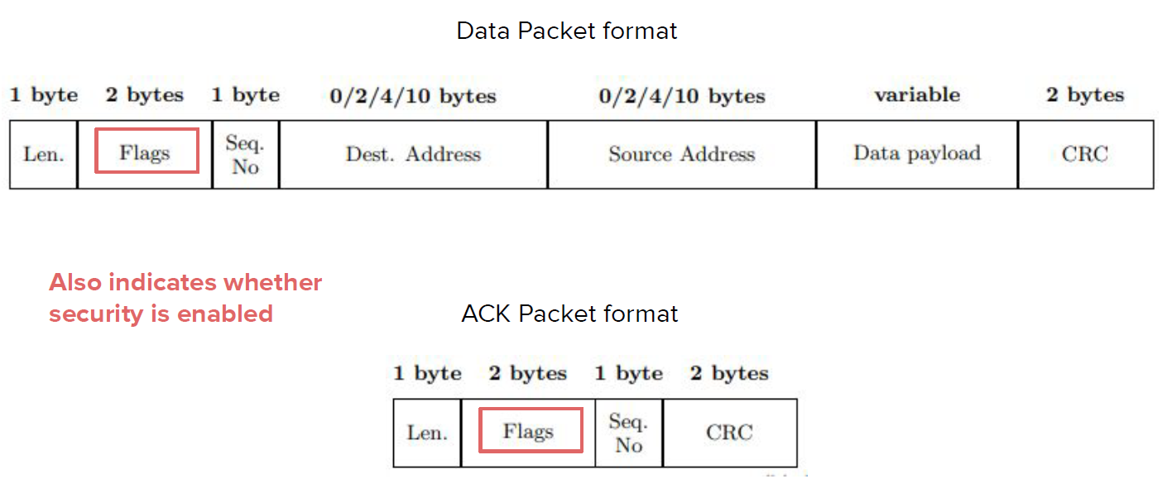

**IEEE 802.15.4 Security**

* A link layer security protocol needs to provide four basic security services: access control, message integrity, message confidentiality, and replay protection.
* In 802.15.4 security is handled at the media access control layer.
* The application specifies the security stack and sets the appropriate control parameters
* Security is not enabled by default.
* An application has a choice of *security suites* that controls the type of security protections provided for the transmitted data.
* It defines eight different security suites
  + No security
  + Encryption only (AES-CTR)
  + Authentication only (AES-CBC-MAC)
  + Encryption and authentication (AES-CCM)
* Each category that supports authentication comes into three variants depending on the size of the MAC (4, 8, or 16 bytes).

**AES-CTR**

* confidentiality protection using AES block cypher with counter mode.
* The sender breaks the cleartext packet into 16 byte blocks  and computes  where each block uses its own counter x.
* The receiver recovers the plaintext as 
* The counter, known as nonce or IV, is composed of a static flags filed, sender’s address, and three separate counters.



* The frame counter is maintained by the hardware radio and the sender increments it after encrypting each packet.
* The key counter is under application control.
* Requirement: nonce must never repeat within the lifetime of any single key and frame and key counter should prevent nonce reuse.
* The 2 bytes block counter ensures that each block will use a different nonce value.

**AES-CBC-MAC**

* Provide integrity protection via CBC-MAC algorithm.
* It can only be computed by parts having symmetric key.
* MAC protects the packet headers and data payload.



**AES-CCM**

* Provides both encryption and authentication.
* It first applies integrity protection over header and data payload using CBC-MAC.
* Encrypts data payload and MAC using AES-CTR mode.



**KEYING MODELS**

* Govern what key a node uses to communicate with another node.
* Network shared keying: single network-wide shared key. Key management becomes trivial and memory requirements are minimal.
  + However, vulnerable to insider attacks and single key compromise.
  + A single compromised node can undermine the security guarantees of the entire network.
  + If we expect nodes to be occasionally compromised or captured, not a good approach.
* Pairwise keying: limit the scope of every key
  + Each pair of nodes shares a different key.
  + Thus, if a node is compromised, only the security of communication with its pair is undermined.
  + Comes with an increased overhead.
  + Each node must store a key for every other node it communicates to.
  + Select the proper key when communicating with a node.
  + IoT nodes have limited resources.
* Group keying: compromise between pairwise and network keying.
  + A single key is shared among a set of nodes and is used on all links between any two nodes in that group.
  + Groups can be created based on locations, network topology, or similarity of function.
  + Partial resistance to node compromise and partial improved management of resources.

**Secure Group Pairing**

* IoT devices need a pairing mechanism which establishes shared cryptographic keys between devices.
* Traditional pairing methods employ a centralized approach where a user pairs each device with a trusted IoT gateway through external helper device (e.g., type a pwd on the smartphone).
* However the central gateway is a single point of failure, sometimes preventing devices from communicating → move towards decentralized networking (e.g., OpenThread).

**Context-Based Pairing**

* In order to limit as much as possible the human intervention, there is an increasing interest in context-based pairing.
* Co-located sensors establish shared keys based on the entropy extracted when they observe common events.
* Although nice, it is limited to homogeneous devices which need to have the same sensing modalities.
* Furthermore, if based on events, it might take some hours or days to have pairing.

**Zigbee**

* Zigbee is a higher layer protocol based on IEEE 802.15.4 to create PAN networks.
* It is usually leveraged for home automation, medical device data collection, and small scale projects.
* It has a range of 10-100 m in line of sight.
* Longer distances are achieved via multi-hop in a mesh network of intermediate devices.

**Zigbee Devices**

* Three type of devices in Zigbee:
* Zigbee Coordinator (ZC): root of the network tree and bridge with other networks. Only one ZC, since it is the originator of the network. Trusted node containing e.g., keys.
* Zigbee Router (ZR): act as intermediate device to pass data to other devices. They are usually mains powered to always be available.
* Zigbee End Device (ZED): minimal functionalities to talk to the parent node. Battery powered and wake up only when has something to say.

**Zigbee Security**

* Zigbee security builds on top of IEEE 802.15.4 security.
* Keys and modes we’ve seen for 802.15.4 are basic for Zigbee.
* A momentary exception exists for the addition of a previously unpaired and unconfigured device.
* We need to assume trust in the initial installation of keys.
* Within the protocol stack, we need access policies to cope with the lack of cryptographic separation between different layers.

**Security Architecture**

* Zigbee uses 128-bit keys to implement its security mechanism.
* A key can be associated to a network or to a link, acquired via pre-installation, agreement, or transport.
* There should be an initial master key obtained via a secure medium
* Establishment of link keys is based on a master key.
* Trust center: special device in the network which other services trust for the distribution of secure keys.
* Ideally, all devices will have the trust center address and initial master key.
* The security architecture is distributed to different layers

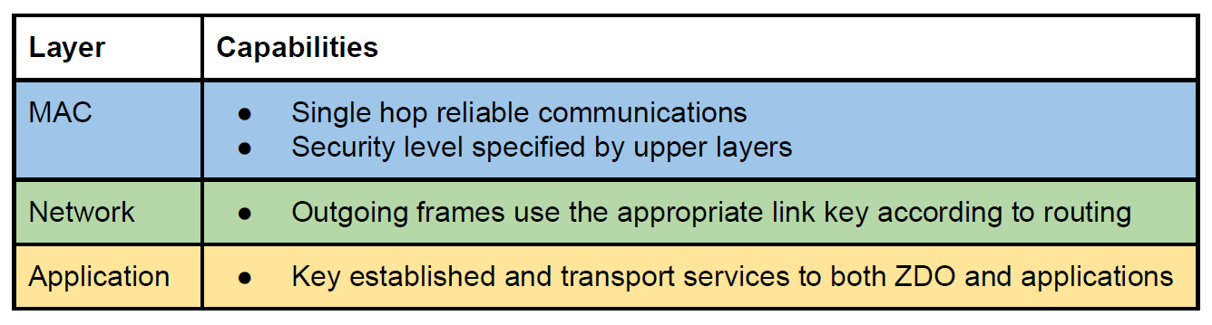

**Device Authentication**

* After joining the network, an end-device needs to exchange security information with the trust center.
* Needs to obtain the current network key from the trust center and establish a new end-to-end trust center link key.
* It consists of four steps.
* Establish the Trust Center Link Key (TCLK): each device has a pre-installed TCLK typically obtained from the device installation code.
* This key is provided to the TC through out-of-band means.
* Establish the transport key: the TC and node can derive a transport key from the TCLK.
* Distribute the network key: the TC can send to the new node the network key encrypted via transport key.
* Establish new link key: as soon as the join procedure is completed, the TC updates the TCLK of the joining device.

**LoRAWAN**

* Personal Area Networks sometimes are not sufficient for IoT purposes.
* Long Range (LoRa) is a proprietary radio communication technique.
* LoRa Wide Area Network (LoRaWAN) defines the communication protocols and system architecture to create a larger network than PAN.
* Also in this case, we consider battery powered resource constrained devices.
* It is a cloud based Medium Access Control (MAC) layer protocol.
* Manages communications between LPWAN gateways and end-node devices.

**LoRAWAN Security**

* The LoRa alliance designed security measures for LoRaWAN accounting for low power consumption, low complexity, low cost, and high scalability.
* As part of the network join procedure, a LoRaWAN end-device establishes a mutual authentication with the LoRaWAN network.
* MAC and application messaging are origin authenticated, integrity and replay protected, and encrypted.
* End-to-end encryption for application payloads.
* LoRaWAN uses AES, and each device has a unique 128 bit AES key and a globally unique identifier (EUI-64-based DevEUI).
* Allocation of EUI-64 identifiers require the assignor to have an Organizationally Unique Identifier from IEEE registration authority.
* LoRaWAN networks are identified by a 24-bit globally unique identifier assigned by the LoRa Alliance.

**Mutual Authentication**

* The Over-the-air activation (or join procedure) test whether both devices know the AppKey.
* The proof is obtained by computing an AES-CMAC(AppKey) on the device’s join request and by the backend receiver.
* CMAC is a One-Key MAC that fixes security deficiencies of CBC-MAC, i.e., the fact that the latter is secure only for fixed-length messages.
* Nevertheless, a variation of CBC-MAC.
* Two keys are derived by LoRaWAN authentication:
  + Providing integrity protection and encryption of the LoRaWAN MAC commands (NwkSKey)
  + E2E encryption of application payloads (AppSKey).
* NwkSKey is distributed to the LoRaWAN network to prove and verify packet integrity and authenticity.
* AppSKey is distributed to the application server to encrypt/decrypt the application payload.

**IoT Network Formation**

* We consider the formation of a 6TiSCH network.
* There exists a root node, called Joint Registrar/Coordinator (JRC) which periodically broadcasts Enhanced Beacon (EB) frames.
* EBs contain basic network information such as the JRC ID, duration of a timeslot, number of time slots in a slot frame, channel hopping sequence, location of the shared cell.
* Pledges are new nodes willing to join a 6TiSCH network.
* When pledges want to join the network, they start scanning until they receive a valid EB.
* When it receives an EB from an already joined node, it becomes a TSCH synchronized node.
* The channel is slotted, and is divided into control slots and shared slots.

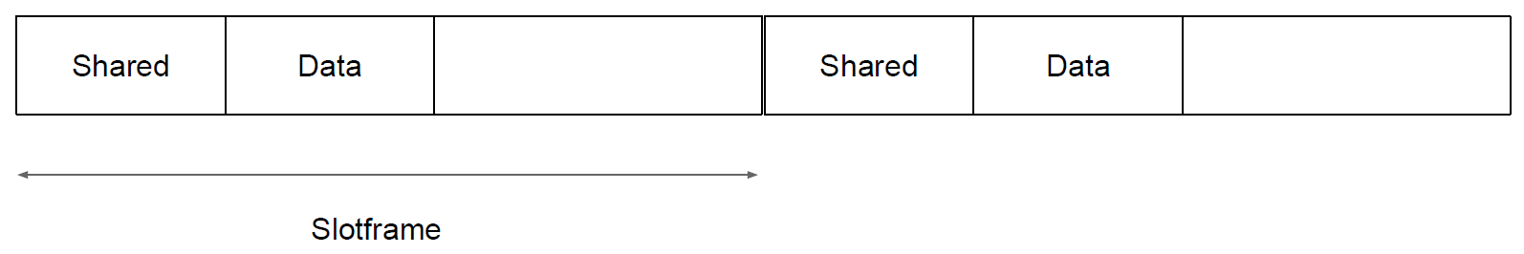

* The network is organized as a Destination Oriented Directed Acyclic Graph (DODAG).

(explain the scheme in the slides…)

**DIS Attack**

* DIS packets can be sent by arbitrary nodes to solicit the sending of DIO packets.
* DIS attack: increase the number of transmissions in DIO packets in the network.
* Goal: increase energy consumption and congest the shared slot.



**Rank Attack**

* Each node chooses its parent based on two values: the rank and objective function.
* The rank should increase going downward in the DODAG, and the role of the preferred parent selection is to select the one with the best rank.
* The objective of the attacker is to manipulate these values to affect the network topology.
* Manipulation can be performed in two ways.
  + First, the attacker changes its rank by a specific values based on its neighbors rank value.
  + Second, the adversary manipulates its rank through the use of a different objective function to deceive legitimate nodes into giving the malicious node a better rank.

**Types of Rank Attack**

* Decreased rank attack: malicious nodes advertise lower rank to other nodes resulting in many of them selecting the adversary as preferred.
* Increased rank attack: the attacker is near the routing node and advertises higher rank and worse routing metrics.
* The idea is to cause topology disruptions and delays, sa nodes will need to select further nodes as parents.

 

* Worst parent attack: the attacker advertises its tru rank but selects the worst parent for itself.Deceive nodes into connecting to the attacker and cause delays due to the worst path they unwillingly select.



**Neighboring Attack**

* In this attack, the attacker node will forward any received DIO message it gets to its neighboring nodes (no modification).
* This creates the illusion that the original sender is in the range of the neighboring nodes.
* Worst case scenario: the original sender has a good rank and adversary’s neighbors choose it as preferred parent although being out of range.
* Alone, the neighboring attack only causes a slight increase in the end-to-end delay.
* However, suitably combined with other attacks gets more dangerous.
* An adversary could launch a DIS attack to get DIO messages with better metrics, then selecting one of these messages to perform a neighbor attack, increasing the effect of such an attack.

**RPL Storing Mode**

* RPL can work in a Point-to-Point fashion, i.e., create traffic between two nodes that are not root nodes of the DODAG.
* In storing mode, each node keeps a downward routing table for its sub-DODAG and use it to forwards P2P traffic.
* In practice, traffic goes upward up to a common ancestor of sender and destination that routes the packet to the destination node.

**RPL Storing Mode Attack**

* Routing table overload: the adversary sends many bogus routes (via DAO) until the node saturates.
* Route table falsification: a malicious node advertises fake routes to other nodes that might exists but not be part of the attacker’s sub-DODAG causing packet losses or longer delays.
* All these attacks also cause resource exhaustion due to the increased overhead and repetitive repair attempts.

**Attacks Inherited from WSN**

* Wireless Sensor Networks (WSNs) are the networks from which IoT was born.
* Therefore, IoT inherited part of the routing attacks that existed in WSNs.
* Although the working principle is the same, attacks needed to adapt to the new IoT paradigm.

**Blackhole and Selective Forward**

* In a blackhole attack, a malicious node(s) will drop all packets it receives instead of forwarding them (DoS).
* To be less detectable, an attacker may decide to selectively drop packets (i.e., only forward RPL control messages) → selective forward or greyhole attacks.
* Selective-forward attacks cannot be detected nor mitigated by the self-healing mechanisms of RPL because they pass control messages.

**Sinkhole attacks**

* Malicious node(s) try to be sink for as much nodes as possible by advertising a fabricated link with better metrics.
* Sinkhole by themselves are not very powerful, they need to be combined with other attacks.
* These attacks can be performed by advertising DIOs with better metrics or having several adversaries directing all passing traffic toward another adversary.

**Wormhole attacks**

* To create this attack, two adversaries need to cooperate to create a tunnel between them and transmit traffic through it instead of the regular path.
* Three ways to create a wormhole:
  + Packet encapsulation: malicious nodes use a legitimate path between them and encapsulate packets to hide the hop count
  + Relay: deceive nodes to be neighbors
  + Out-of-band link: create links that are not part of the network

**Clone ID and Sybil attacks**

* In Clone ID attack, a malicious node(s) takes the identity of another legitimate node.
* In Sybil attacks, each malicious node takes several identities from legitimate nodes.
* With sybil attacks an attacker can submit forged information to manipulate the system, disturb the routing topology and reputation-based systems.
* Can be mitigated by adding location information and DHTs.

**Mitigation Techniques**

* To detect some of these attacks (or their declinations) there have been many proposals in terms of Intrusion Detection Systems (IDSs).
* Signature-based IDSs: use a database of signature patterns of the attacks.
* Anomaly-based IDSs: create a normal behavior profile and compare the current observations with the normal behavior.
* Specification-based: create a normal profile based on protocol specification.
* Hybrid IDSs: combine two of the aforementioned methods.

**Placement of IDSs**

* Centralized IDS: the IDS resides either on the root node or on a dedicated host and uses the traffic passing by to detect attacks.
  + In many cases, it is required that the central node of the IDS send periodic request for updates to unmonitored areas.
  + Advantage: most of the heavy works occurs inside a powerful node, usually capable of performing firewall functionalities as well.
  + On the other hand, challenging to monitor the network during the attack.
* Distributed IDS: each node will have a full IDS implementation, making it responsible for detecting attacks around it.
  + Usually nodes collaborate to increase the efficiency of the detection.
  + However, this approach consumes a lot of resources throughout the network.
  + It is usually required to optimize the IDS periodically to minimize its effects.
* Hybrid IDS placement: to get the best of both worlds
  + Central nodes with more resources are responsible for computationally intensive tasks (analyzing data, decision making)
  + Normal nodes are responsible for lightweight duties (e.g., monitoring neighbor nodes, send info about traffic passing through them, responding to requests from central nodes)
  + Requires optimization

## **8.1 IoT Authentication**

**Attack to Authentication**

* Authentication usually assumes that keys are secret and cannot be obtained by adversaries.
* Closed network, where only devices that gain a secret through a secure out-of-band channel get their secrets, it might be challenging for attackers.
* Among, the others, Zigbee is one of the protocols that has been considered to be secure due its closeness.
* There are two factors that makes it challenging to compromise Zigbee networks.
* Closed nature: Zigbee devices are equipped with a dedicated commissioning process to add new devices to the network.
* Commissioning usually requires users’ actions to enable the controller to accept joining requests (e.g., pushing a button on the controller).
* Except commissioning, the Zigbee network is closed and the controller will not process the joining request.

**Zigbee Protocol Stack**

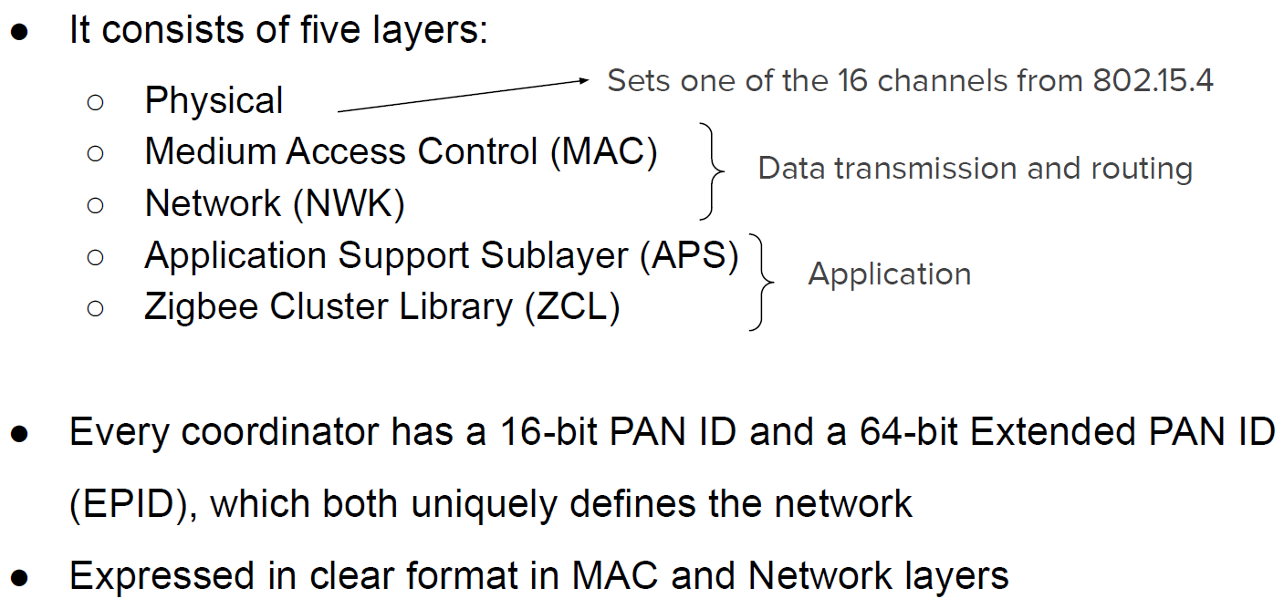

**Encryption and Authentication Recall**

* AES encryption and CCM mode of operation (authenticity and confidentiality).
* 32-bit Message Integrity Code (MIC) is calculated and appended after the encrypted payload for integrity protection.
* Brute forcing a 32-bit MIC is infeasible in terms of time consumption.
* With a packet transmission rate of 200 packets/s the brute force would take more than 248 days.

**Threat Model**

* Factors making Zigbeee networks challenging to compromise:
  + Closed network with a dedicated commissioning process to add new devices in the network (press a button on the controller).
  + Zigbee uses encryption with AES CCM. Without keys you cannot infiltrate the network.
* We now want to understand whether it is possible to still infiltrate the network.

**Attack to Authentication**

* Simplified Zigbee network with two nodes: one device, one controller.
* Attacker not authorized, not part of the network.
* Attacker sniffs publicly available Zigbee network information: MAC, net addresses, PAN ID, EPID (unencrypted in MAC and network layer headers).



**IMPERSONATION ATTACK**

* The attacker impersonates a node that is already in the target Zigbee network.
* Since the controller has the most capabilities, we focus on impersonation of the controller.
* The following attack steps can be launched at arbitrary time during the closed normal operations of Zigbee networks.
* Step 1: the attack device needs to overwrite its manufacturer-produced physical address and pretend to be the controller.
  + This controller’s address can be obtained by sniffing Zigbee packets, since the MAC address is contained in plaintext in the header.
* Step 2: The attacker further imitates the network identifiers.
  + Extracts the controller network address and network PAN ID by eavesdropping regular Zigbee packets.
  + To get EPID, the adversary broadcasts a beacon request.
  + The controller will send a beacon reply with EPID and state that the network is closed and does not accept join requests.
  + The adversary selects a target device and obtain its address via packet sniffing.
* Step 3: the attack device constructs packets and injects them into the Zigbee network.
  + The goal is to cause the target device to process forged control packets and end up in dysfunctional statuses.
  + Though Zigbee uses encryption on the network layer payload, packets crafted with specific control fields and commands can induce vulnerabilities.

**Power-on Phase**

* We now manipulate MAC packets during the power on phase.
* Every time a device boots up, it uses its manufacturer-provided MAC.
* We can simply change the code, and replace the one fetched from one of sources including non-volatile memory, flash, or random generation.

**Network Setup Phase**

* More challenging, as the adversary needs to interact with a closed network.
* During normal operations the network does not accept association requests, and authorized nodes have their roles in the network.
* A new device is not recognized and cannot play any role.
* Instead of trying to access the network, we can impersonate the controller and create a new network, as a twin of the original one.
* We exploit the Zigbee network formation to enforce network-setup manipulation.
* Network formation needs three steps from a controller.
  + Enabling the radio antenna.
  + Setting PAN ID and EPID.
  + Adding routing path of the target device without commissioning.
* To avoid the original controller to interfere with the network formation, we assume that the setup is conducted outside of the transmission range of the target Zigbee network (after needed sniffing).

**PAN ID Manipulation**

* The 16-bit PAN ID is contained in every Zigbee packet to identify the associated network.
* We aim at modifying the PAN ID of the new Zigbee network that the module (attacker) creates and make it the same as the target network.
* The PAN ID is stored in a configuration file that can hence be changed upon sniffing the target one.

**EPID Manipulation**

* Zigbee mainly uses PAN ID in regular communications, while EPID is used in commissioning or rejoining process.
* An adversary can acquire the EPIDs of the nearby Zigbee networks by simply broadcasting a beacon request.
* During network formation, we assign the EPID to the newly created network by setting the specific value.

**Routing Insertion**

* Although we now have a twin network with the proper identifiers, it does not contain any node yet.
* We need to induce the framework module to believe that a target device is associated with this new network and stand-by for communications.
* At the end of the network formation, the module will be in open mode for a couple of hundred seconds to accept new nodes to join.
* However, a device has no reason to actively sending association requests.

**Fuzzing Packets**

* Now that we created a malicious network, we can start exploring whether it is possible to send packets that cause malfunctioning.
* We first need to understand what is the structure of packets we can send without legitimate keys.
* Then we can start exploring how to randomly generate packets to find vulnerabilities.

**Semantic Exploration of Packets**

* A first approach would be to randomly put content into the generated packets and blindly test whether they cause the Zigbee network to malfunction.
* However, this is highly inefficient and results in many non valid packets.
* Two challenges that we want to address in the fuzzing process:
  + Zigbee uses encryption
  + Packets have varied length and formats according to header values

**Managing Encryption and Auth**

* With our attack, the malicious coordinator does not know the key.
* Therefore, the packets it generates cannot be accepted unless being encrypted with the proper key.
* We hence examine unencrypted fields in Zigbee packets like MAC or network headers.
* We want to transmit plaintext messages that get processed.
* To have the payload of a layer encrypted, there are three security-related fields on that layer: security enabled bit, security AUX header, and message integrity code.
* The security bit plays a decisive role: if set to 0, no security mechanism, so no AUX header, nor MIC → forged packets are processed at the receiver!
* Packets with security bit to 1 may have impact if the system has implementation flaws.
* We can develop strategies to fuzz this.
* If security bit is set to 1, use AES with CCM.
* The 128-bit AES-CCM allows generating encryption output with arbitrary length.
* AES encrypts an incremental nonce and then XOR with plaintext.
* The ciphertext maintains the same length as the plaintext.

**PACKET FORMATS**

* In addition to encryption, Zigbee has varied packet formats.
* First, the different header values cause different header lengths and consequently change the packet structure.
* Second, in the payload, commands and attribute parameters are correlated and require different lengths.
* For instance, attribute IDs have different data types to achieve various functionalities.
* We hence need to actively enumerate each individual field by sending packets and examining the format changes of captrured ones.
* Two steps for Zigbee analysis:
  + Decide the header fields to find the fuzzing locations.
  + Retrieve the fuzzing ranges of commands and parameters.
* First, every layer header has a frame control field which decides the other header fields and whether the packet contains upper layers.
* We enumerate the frame control values bit by bit to find the corresponding structure changes and later construct protocol-compliant lower layers when we fuzz the upper layers.
* Second, we focus on cluster ID, command ID, and attribute ID in different upper layers for our fuzzing.
* These fields are correlated across different layers.
* For example, different command IDs require different lengths of attribute IDs, and the cluster ID in the APS header determines the ZCL layer command ID.
* We test their minimum and maximum values to get ranges.

**Network Layer Fuzzing**

* We first configure the network layer header and payload.
* The header can use three types of address settings (mix of network and MAC addresses) and two security bit settings (0, 1).
* Network layer packets include command ID, and each command has a one byte attribute that can be fuzzed.
* There are 13 valid network commands.
* If security bit = 0, 13x28 = 3328 combinations to try.
* If security bit =1, network payload is encrypted and MIC added for integrity check.
* Since encryption preserves the content length, we prioritize cases that could bring to meaningful results.
* All network commands are 1 byte, and add another byte as attributes.
* We set random MIC values and fuzz the payload only with the length of possible commands.
* We fuzz encryption payload lengths of 8 and 16 bits → 28 + 216 = 65792 combinations.
* NWK header has 3 unencrypted bits that can be fuzzed for different packet settings.
* Total fuzzing number is 65792x23 = 526336.

**Example of Attack: Key Leakage**

* This attack cause vulnerable systems to leak security information.
* Some of the ZCL cluster ID fuzzed can cause key leakage in Zigbee networks.
* The attack packet will cause the device to send rejoin requests.
* During the rejoin process, the controller will resend the network key which is only encrypted by the default public link key.
* With the publicly known link key and the frame counter in the packet (plaintext), we are able to decrypt and retrieve the network key of the network.

### **8.1.1 Group Pairing and Key Exchange**

**Need for Keys**

* Traditional approach for key management envision a central device with authoritative capabilities handling them all.
* However, this represents a single point of failure that may compromise the overall network security.
* IoT platforms have recently been pushing towards decentralized IoT networking protocols (e.g., OpenThread).
* Past efforts at decentralized IoT device pairing include two approaches: human-in-the-loop, and context-based pairing.

**Decentralized Approaches**

* In human-in-the-loop approaches a human needs to be physically involved in the pairing process.
* For instance, the user should touch or press a button, shake two devices at the same time, enter password, or read QR codes.
* With context based pairing we can increase scalability, as the human is not needed.
* In this, co-located sensors establish shared keys based on the entropy extracted when they observe common events.

**An Example of Events**

* We consider an IoT deployment with three devices.
* Each device is equipped with either a microphone, a power meter, a temperature sensor.
* User A opens the door to go aìout, in the meanwhile user B turns on the coffee machine.
* While the coffee machine is on, user A returns and closes the door.
* User A prepares a cup of coffee for herself and turns on the heater.





**Threat Model**

* We consider an attacker aiming at eavesdropping the communication between IoT devices and learn private information about users.
* Devices are deployed within an indoor closed physical space and controlled by a common trusted entity.
* The attacker is not present within the boundaries of the indoor IoT environment and cannot access, add devices or control devices inside the network.
* The attacker has complete knowledge of the pairing protocol and has access to the communication channels.

**IoTCupid**

* We now present IoTCupid, a solution for context-based IoT device pairing.
* The first step is to process the raw time-series data collected in real-time and perform a threshold-based signal detection to separate the sensor data corresponding to events from background noise.
* The second step is to extract distinctive time-series features from the signals each sensor has detected.
* It then extends a fuzzy clustering algorithm to group independent and concurrent signals into different events.
* The clustered events are used to obtain the sequence of time intervals between consecutive events of a given type, serving as evidence of the device’s context.
* Lastly, IoT devices use their inter-event timings to authenticate each other and establish a shared group key.
* IoTCupid encodes the inter-event timings into passwords and extends a partitioned group password-based authenticated key exchange scheme for a group key establishment protocol.



* We consider devices that sense the same event as a group.
* Each subset of devices that have the same inter-event timings establishes a group key.
* IoTCupid does not require a central gateway or IoT hub, but guarantees secure ad-hoc connectivity among heterogeneous IoT devices.
* To initiate association, devices broadcast their public keys encrypted with the extracted inter-event timing for establishing group keys.

**Sensor Data Extraction**

* To extract signals corresponding to events, we first segment sensor data into multiple samples with window size ws.
* To address fluctuations during the day, we normalize the sensor readings to eliminate these fluctuations impact and capture transient changes caused by events.
* We then apply a smoothing filter by computing the exponentially weighted moving average Sw = a*Yw+(1-a)*Sw-1, where a is the weight, Yw is the sensor data and Sw-1 is the EWMA of the preceding window.

**Event Detection**

* We use a threshold-based approach to distinguish event’s influence on sensor readings from background noise.
* We use a lower threshold TL to identify peaks in sensor readings that distinguish events’ impact from background noise.
* We use an upper threshold TU to remove high amplitude noise signals.
* We consider the consecutive timestamps at which sensor values exceed TL but are blow TU as a single event.

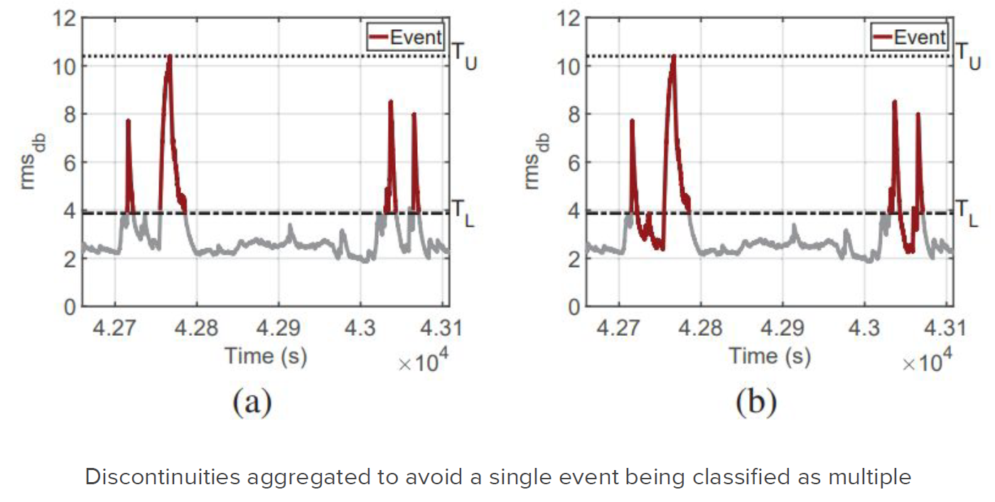

* If sensors measure continuous quantities (e.g., temperature), the previous approach is not good.
* For instance, a heater-on event occurring at time t causes a gradual increase in temperature sensor values after a delay Deltat.
* Same event at different timing may have different delays (figure below).



* To account for gradual changes and the varying delay, we leverage the rate of change in the sensor readings to detect signals corresponding to events for continuously influenced sensors.
* We first compute the derivative of the pre-processed sensor values in each window w as S’w= (Sw_ws-SW0)/ws, where ws is the window size and the terms in parentheses are recorded as the first and last sensor values in the window.
* We then apply lower and upper thresholds based on the average derivative of each sensor.
* We extract the timestamps where the absolute value of the sensor readings’ derivatives lie within the predetermined TU and TU for the sensor.



**Content Extraction**

* Context is about event clustering.
* The idea is to cluster the detected signals into different events to extract their inter-event timings.
* We do not leverage any prior information about the event types for clustering, as a single device might detect multiple events.
* As a first step, we extract time domain features (min, max,..) from the signals corresponding to events.
* To select a set of features Fmin we perform dimensionality reduction via Principal Component Analysis (PCA).

**Fuzzy C-Means Event Clustering**

* In real deployments, multiple events may occur simultaneously and produce overlapping signals.
* This implies that the signal features of simultaneous events might significantly differ from those in single events.

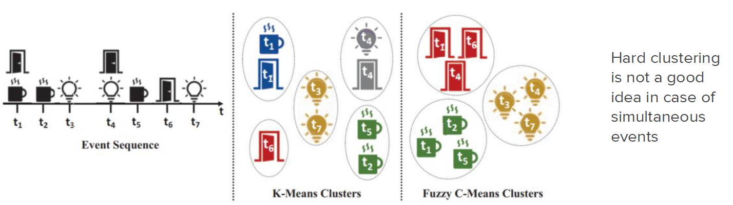

* We extend fuzzy C-Means clustering to assign the detected signals into one or more appropriate event clusters based on the extracted features.
* We partition signals into c (input parameter) clusters.
* This method allow events occurring simultaneously to belong to their appropriate cluster.

**Context Evidence Generation**

* IoTCupid generates inter-event timings for each device after clustering the detected signals into different event types.
* Each device extract inter event times of event occurrences in each cluster, and uses it as evidence in the group key establishment.
* With this, although devices may be heterogeneous, two devices detecting the same event will measure the same inter-event timings.
* Although devices might be non-synchronized, inter-event timings are…

**Challenges for Key Generation**

* Recalling that the IoT deployment might be dynamic, deriving group keys might be challenging.
* First, groups must be generated dynamically based on the devices that sense the asme event.
* Second, the protocol should support device addition and removal.
* When a device is added, it should pair with other nodes.
* When a device is removed its keys must be revoked to prevent an adversary from capturing them.
* Group keys can be generated using the secure communication channels from individual keys derived through a standard pairing protocol.
* Group Diffie-Hellman is one of them, but it requires multiple rounds.
* Furthermore, when a device is added to the IoT network, it must first individually pair with other devices to be authenticated and then participate in the group key establishment.
* NOT A GOOD OPTION.
* We could use fuzzy commitment schemes tp generate individual keys.
* The idea is to use error-correcting codes and enable verifying two evidences when they have small differences (Hamming distance < th.).
* However, these schemes are vulnerable to offline brute-force key guessing attacks.
* The adversary collects the network traffic and tries all evidences until they find the one that can decrypt the network traffic.
* To prevent offline brute-force key guessing attacks, we could use a large number of evidences (i.e., a large number of inter-arrival times).
* This is however highly inefficient, as it may take a long time to derive keys.
* Password-Authenticated Key Exchange (PAKE) protocols have been proposed to prevent offline brute-force attacks.
* We should however extend them into the group setting.

**Group PAKE**

* GPAKE enables multiple devices sharing the same evidence to derive group keys.
* The passwords of all devices that participate in the key agreement must be the same, as the scheme abort without establishing a shared key even if a single password is different.
* An adversary could leverage this limitation by joining the key agreement protocol with arbitrary evidences to deny legitimate key derivation → denial of key exchange.

**New Key Establishment Protocol**

* Objectives: dynamic group generation with computational efficiency, device addition/removal, resilience to offline brute-force and denial of key exchange attacks.
* We encode inter-event timings to be used as passwords.
* Devices then use the passwords to run a partitioned GPAKE scheme such that each subset of devices sensing the same events derives a group key.



(Look at slides for whole table explanation…)

## **8.2 Remote Attestation**

**The Software Problem**

* IoT devices have their own software and this can be compromised by malicious entities.
* It is not easy to detect attacks in on-field devices, as Stuxnet showed.
* We need solutions to attest the legitimacy of (software and hardware) components by distantly looking at them and their behavior.
* We need to account for the constrained resources of these devices.

**Remote Attestation**

* Attestation is the activity of making a claim to an appraiser about the properties of a target by supplying evidence which supports that claim.
* An attester is a party performing the attestation activity.
* An attestation protocol is a cryptographic protocol involving a target an attester, an appraiser and possibly other principals serving as trust proxies.
* Target: supply evidence that will be considered authoritative by the appraiser while respecting privacy goals of its target.
* We denote as remote attestation a protocol whereby a challenge (Chal) verifies the internal state of a device called a prover (Prov).
* This protocol is performed *remotely*, i.e., over the Internet.
* Goal: an honest Prov should create an authentication token that convinces Chal that the former is some well-defined expected state.
* If Prov has been compromised by an adversary, the authentication token must reflect this.

**Attestation Protocol**

* An attestation protocol P is comprised by the following components.
* Steup() - a probabilistic algorithm that, given a security parameter outputs a long-term key k;
* Attest(k,.) - a deterministic algorithm that, given a key k and a device state s, outputs an attestation token a.
* Verify(k,.,.) - a deterministic algorithm that, given a key k, a device state s, and an attestation token a, outputs 1 iff a corresponds to s, i.e., iff Attest(k,s) = a, and outputs 0 otherwise.
* The verifier challenges the prover with a fresh nonce (uniformly random and from a large pool).
* The prover attests its state with the key and creates a token.
* The verifier receives the token and decides whether to accept it.



**Att-Forgery Security**

* Let us define the following game
* Game 1 (Att-ForgeryChal,Prov(k)): Chall running P interacts with Prov as follows
  + Chal runs k ← Setup(1k) and outputs sChal to Prov
  + Prov is given oracles access to Attest, i.e., adaptively submit q device states and receive the corresponding token
  + Eventually Prov outputs a; the game outputs 1 iff Verify(k,s,a) = 1, i.e., iff a corresponds to s = (sChal,sProv)
* An honest node has no problem winning the previous game.
* If instead Prov has been compromised, its sProv has changed and must attempt to simulate the operation of Attest.
* We can define the following security notion for an attestation protocol.
  + *Definition*: Att-Forgery Security. An attestation protocol P = (Setup, Attest, Verify) is Att-Forgery-secure if there exists a negligible function negl such that for any probabilistic polynomial time prover Prov and sufficiently large k it holds Pr[Att-ForgeryChal Prov(k) = 1] ≤ negl(k).

**System Model**

* The central goal of attestation is to verify Prov’s state.
* Successful execution however does not guarantee that the entire Prov’s system can be trusted or that it cannot be compromised after attestation completion.
* We assume Prov to be a low end embedded device with a single thread of execution, limited storage capacity, and general complexity.
* Although valid for any device, Att-Forgery-security is stronger if the cost of the device is smaller than that of a TPM.
* Prov has the following characteristics.
  + Single memory space (no separation from kernel and user memory).
  + Single thread of execution with exception of interrupts (no direct memory access).
  + Ability to disable interrupts and force a region of code to execute automatically.
  + Availability of Read Only Memory (ROM).
  + Ability to securely cleanup (erase) memory upon device reset.
  + Hardware-based control mechanism to prevent unauthorized access to certain memory location.
* We make no assumptions about Chal.
* A malicious Chal may perform a DoS by forcing Prov to take part in the RA protocol at will.
* Malicious Chal does not learn any new information about an honest Prov by performing RA, since Chal must already know the desired state of Prov in order to verify the attestation token.
* We assume that Chal is honest.
* **Note**: Challenger is the term from crypto, verifier is the term from RA. We can use them interchangeably.

**Adversary Model**

* We assume the adversary can compromise Prov at any time.
* Once it is compromised, the adversary has control over the prover device.
* There however needs to be a key that the adversary cannot access to although being in control of the prover.
* We assume that the adversary cannot modify the hardware components of the compromised device.
* We also assume that there is a way to protect Attest against side channel attacks.

**Properties Required**

* Attest needs to have specific security properties.
* We assure there exists a secure algorithm to compute a based on the prover’s state s and a prover-specific key k (e.g., via HMAC).
* Attest must satisfy the following security properties
  + Only Attest can compute a valid token a.
  + a accurately captures s, i.e., Attest(k,s) = Attest(k,s’) with negligible probability.
* Two ways to attacker remote attestation
  + Attack 1: The adversary simulates Attest and correctly computes a.
  + Attack 2: returned a does not reflect s, i.e., escape detection.
* The key k is the only secret held by Prov, and access to k allows the adversary to simulate Attest (i.e., type 1 attack).
* Exclusive access: attest must have exclusive access to k.
* No leaks: Attest leaks no function of k other than a, i.e., after Attest completes, the entire state of Prov is statistically independent from k.
* Immutability: Attest code is immutable. This means that it needs to be executed in-place from immutable memory.
* Uninterruptibility: the attacker has no means to interrupt the execution of attest.

**Features from Properties**

* We derive a set of features that are both necessary and sufficient for remote attestation that achieve the five security properties.
* **Exclusive access to k**: in our system model, the best solution is to add a small hardware-based check that monitors the address byt and the program counter and enforces that k is only accessible when PC is within attest.
* **No leaks**: we need a way to erase all intermediate values that depend on k, except the attestation token a, when they are no longer needed.
* **Immutability**: to ensure Attest to be immutable, we place it in ROM and execute it in place. We consider it as an inexpensive way to enforce immutability.
* **Uninterruptibility**: on a platform with a single thread of execution, the adversary can still regain control after invoking Attest by scheduling an interrupt. Both Attest and instructions to enable and disable interrupts should be atomic.
* **Invocation from start**: we must enforce exclusive invocation of Attest from its very first instruction. To this aim, custom hardware is needed to enforce the logic: if the program counter is an address within the Attest code, other than the first instruction address, then the previous instruction must also be within Attest.
* This prevents the adversary to jump in the middle of attest, there is no way to enforce this without OS support.
* We hence need to monitor the Attest region and reset the device if detecting illegal behavior.

**Types of Remote Attestation**

* Remote attestation can be performed in several ways, with different requirements in terms of device capabilities, equipment, and security guarantees.
* At a high level, we can distinguish between software-based attestation and root of trust-based attestation.

**Software-Based Attestation**

* In software-based attestation, typically we use timing information to allow the verifier to assess the correctness of the firmware running on the prover.
* These approaches generally require strict timing requirements on the network, which might not always be feasible in generic IoT.
* They also generally consider a one-hop communication between verifier and prover, which makes it hard to be realized in large IoT networks.
* A Naive approach for verifying the prover’s memory content would be to challenge the prover in computing a MAC of the memory content with a verifier-provided key.
* The verifier knows the memory content of the legitimate device.
* However, an attacker could easily cheat on this.
* Indeed, the attacker could save the original memory content and move it to an empty portion of the memory or to an external device that could be accessible when needing to compute the MAC-based proof.

**Pseudo-Random Memory Traversal**

* The embedded device has a memory-content verification procedure that can be remotely activated by the verifier.
* The procedure uses a pseudorandom memory traversal.
* In particular, the challenge is used as seed for a pseudorandom number generator that generates a list of memory addresses to be checked.
* The adversary has no mean to know in advance the portion of the memory that will be checked.
* In case the verification procedure is heading towards a portion of the memory that has been altered, the attacker needs to divert it to the a memory location where the correct copy is stored.
* This however causes an increase in the time needed to compute the verification.
* Thus the verifier will either see a non valid authentication token or a suspiciously long time needed to compute the authentication token.

**Attestation Based On Root of Trust**

* These schemes leverage a root of trust residing inside the prover.
* This component is a assumed to be trusted and is the endpoint of the attestation protocol.
* It usually comprises a combination of hardware and software.
* The value to be attested is stored inside the root of trust.
* In IoT devices, the root of trust is realized using hardware with minimal security capabilities, such as code and memory isolation.
* Four strategies: interactive RA, Interactive Self-RA, Non-interactive RA, and non-interactive self-RA.

**Interactive RA**

* It consists of an interactive protocol between prover P and verifier V.
* V sends a challenge N to P’s root of trust Rp, which responds with a proof of the device’s configuration, e.g., c = hash(conf(P))||N.
* The proof h is either signal (public key crypto) or tagged via MAC (symmetric key).
* V verifies the integrity of P by verifying the authenticity of h.



**Interactive Self-RA**

* Leveraging the capabilities of Trusted Execution Environments, it is possible to verify c at P’s side given the list of potential allowed configurations securely stored and accessible by Rp.
* After receiving N from V anc computing c, Rp produces a signed/MACed token h authenticating a binary result r (true of false).
* This is then delivered to V as a customized token.



**Non-Interactive RA**

* The prover P autonomously decides the time at which attestation should happen and locally generates a pseudo-random nonce N.
* Remove the need for V to start the process, but require additional hardware, e.g., secure source of time.
* Examples of additional needs include Real Time Clocks, Attestation Trigger Circuit, or Reliable Read-Only Clocks.



**Non-Interactive Self-RA**

* Variation of the previous one, where P’s TEE know the set of possible configurations and can therefore perform self attestation,



**Collective RA**

* In large networks, it might be convenient to assess the status of multiple nodes instead of performing single attestations.
* Collective remote attestation has been introduced to limit the time needed to perform attestation of multiple interconnected devices.
* We consider a large network of low-end devices which are heterogeneous in terms of software and hardware configurations.
* These are provers, and of course we have the verifier.
* We need an additional device, i.e., the aggregator.

**Formal Verification of RA**

* Verifiable Remote Attestation for Simple Embedded Devices (VRASED).
* A hybrid hardware/software solution to provide formal verification.
* Security of hardware while minimizing cost thanks to software.
* First formally verified remote attestation scheme.

**Overview of VRASED**

* VRASED is composed of a HW module (HW-Mod) and a SW implementation (SW-Att) of Prv’s behavior according to the RA protocol.
* HW-Mod enforces access control to K (Prv’s unique secret key) in addition to secure and atomic execution of SW-Att.
* SW-Att is responsible for computing an attestation report.

**Formal Verification, Model Checking, Temporal Logic**

* Computer-aided formal verification involves three basic steps:
  + The system of interest must be described via a formal model (e.g., finite state machine)
  + Properties that the model should satisfy must be formally specified
  + The system model must be checked against formally specified properties to guarantee that the system retains such properties
* Checking can be achieved via either theorem proving or model checking.
* In model checking, properties are specified as formulae using temporal logic and system models are represented as FSMs.
* A system is represented by a triple (S, S0, T) where S is a finite set of states , is the set of possible initial states, and  is the transition relation set (set of states that can be reached in a single step from each state).
* Thanks to temporal logic we can represent expected system behavior over time.
* We use NuSMV.

**NuSMV**

* In NuSMV, properties are specified in Linear Temporal Logic, particularly useful for sequential systems.
* Use of propositional connectives such as conjunction  disjunction  negation  and implication .
* LTL includes also temporal connectives enabling sequential reasoning.
* We define a list of useful temporal connectives.



* NuSMV works by checking LTL specifications against the system FSM for all reachable states in such FSM.

**Adv Capability**

* We consider an adversary A that can control the entire software state, code, and data of Prv.
* A can modify any writable memory and read any memory that is not explicitly protected by access control rules. A can hence read anything that is not protected by HW-Mod.
* A can also relocate malware from one memory segment to another to avoid being detected.
* A may also have full control over direct memory access controller on Prv.

**Verification Axioms**

* We focus on attestation functionality of Prv.
* The verification approach relies on the following axioms.
* **A1 - Program counter:** the PC always contains the address of the instruction being executed in a given cycle.
* **A2 - Memory address:** whenever memory is read or written, a data-address signal (Daddr) contains the address of the corresponding memory location. Ren and Wen bits must be set for read and write access, respectively.
* **A3 - DMA**: whenever a DMA controller attempts to access main system memory, a DMA-address signal DMAaddr reflects the address of the memory location being accessed and a DMAen bit must be set. DMA cannot access memory when DMAen is off.
* **A4 - MCU reset**: at the end of a successful reset routine, all registers (including PC) are set to zero before resuming normal software execution flow. Since resets are handled by MCU hardware, no way yo modify them.
* **A5 - Interrupts**: when interrupt, the corresponding irq signal is set.
* The MSP430 design supports all the five axioms.
* Sw-Att uses HACL* HMAC-SHA256 function implemented and verified in F*.
* We assume that the standard compiler can be trusted to semantically preserve its expected behavior.
* **A6 - Callee-Saves-Register**: any register touched in a function is cleaned by default when the function returns.
* **A7 - Semantic preservation**: functional correctness of HMAC semantically preserved when converted in C.

**VRASED System Architecture**

* Implemented by adding HW-Mod to the MCU architecture.
* Memory layout is extended to include ROM housing SW-Att code and K.
* Access control and SW-Att atomicity are enforced by HW-Mod.
* HW-Mod takes 7 input signals from the MCU core.



**Notation**



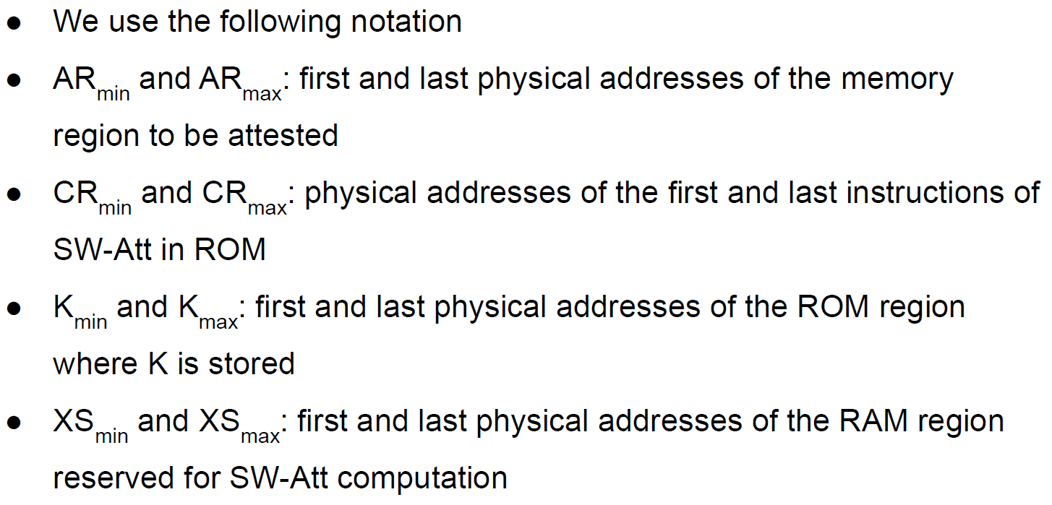

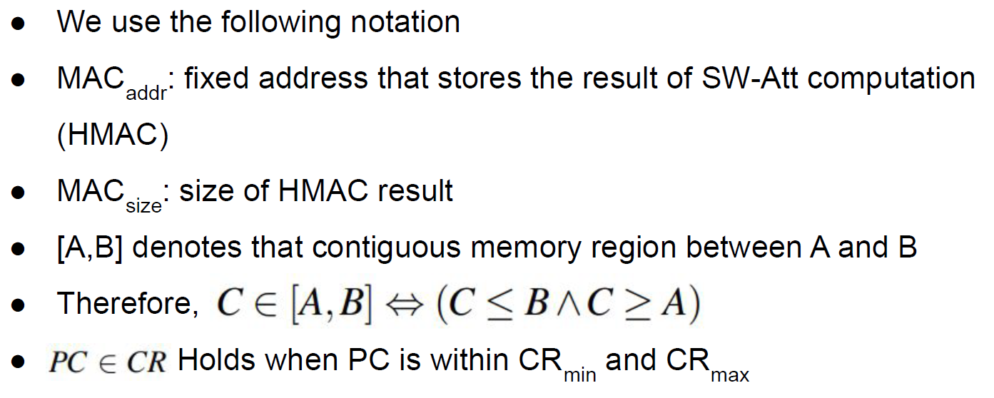

**FSM Representation**

* Each FSM output changes in time as a function of both the current state and current input values
* Each FSM has as inputs a subset of the following signals and wires



* Each FSM has only one output, reset, that indicates whether any security property was violated. Implicit representation:
  + reset is 1 whenever FSM transitions to reset state
  + reset remains 1 until a transition leaving the reset state is triggered
  + reset is 0 in all other states

**RA Soundness**

* RA soundness corresponds to computing an integrity ensuring function over memory at time t.
* We use an HMAC computed on memory AR with a one-time key derived from K and Chal.
* Since SW-Att is not instantaneous, RA soundness must endure that attested memory does not change during the computation of the HMAC (temporal consistency).
* In other words, the result of SW-Att call must reflect the entire state of the attested memory at the time when SW-Att is called.
* In other words, the result of SW-Att call must reflect the entire state of the attested memory at the time when SW-Att is called.





**VRASED SW-Att**

* To minimize required hardware feature, hybrid RA approaches implement integrity ensuring functions (e.g., HMAC) in software.
* Derive a new unique context-specific key (key) from the master key K via HMAC-based key derivation function on Chal.
* Call HACL*’s HMAC using key as the HMAC key.
* Sw-Att resides in ROM. guaranteeing software immutability.
* Moreover, HW-Mod enforces that no other software running on Prv can access memory allocated by SW-Att.

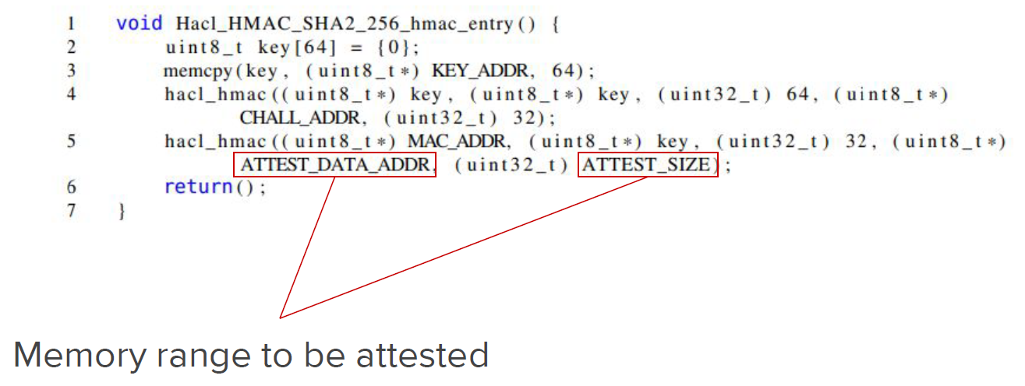

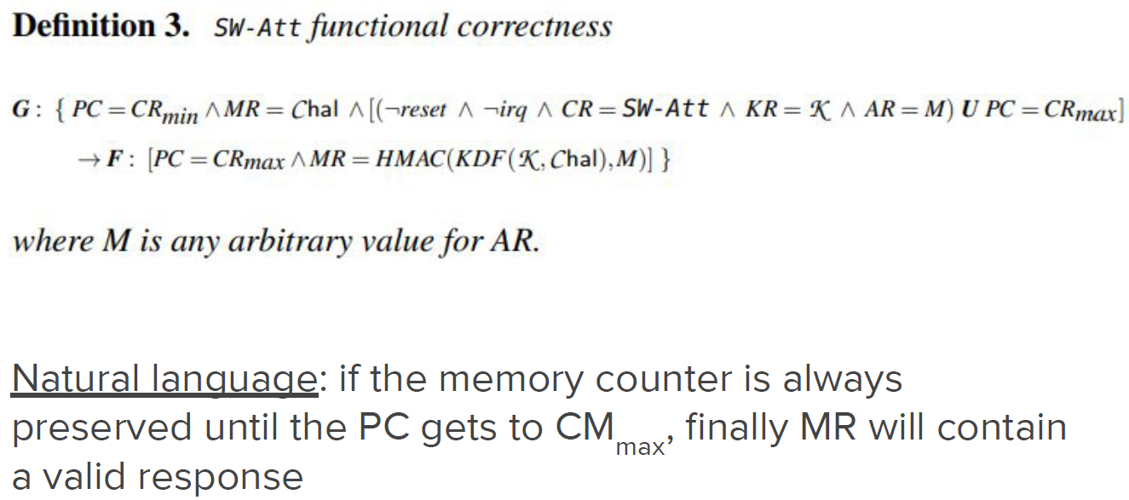

**Key Access Control (HW-Mod)**

* If malware manages to read K from ROM, it can reply to Vrf with a forged result.
* MW-Mod access control (AC) sub-module enforces that K can only be accessed bt SW-Att.



* The system must transition to the Reset state whenever code from outside CR tries to read from Daddr within the key space.
* We design a FSM from the LTL specification with two states: run and reset.
* Outputs sìreset =1 when the AC submodule transitions to reset, implying a hard reset on the MCU.



* We define two LTL specifications for atomic execution and controlled invocation.



* Enforce that the only way for SW-Att execution to terminate is through its last instruction PC=CRmax.
* Specified by checking current and next PC values using ne**X**t operator.
* If current PC value is within SW-Att region and next PC value is out of SW-Att region, then either current PC values is the address of the last instruction in SW-Att(CRmax), or reset is triggered in the next cycle.



* Enforce that the only way for PC to enter SW-Att region is through the very first instruction CRmin.
* This and the previous invariant (LTL specification) imply that it is impossible to jump into the middle of SW-Att or leave SW-Att before reaching the last instruction.
* Atomicy is verified by the following LTL specification.
* Although atomicity could be violated by interrupts, this LTL specification prevents an interrupt to happen while SW-Att is executing.
* Therefore, if interrupts are not disabled by software running on Prv before calling SW-Att, any interrupt that could violate SW-Att atomicity will necessarily cause an MCU reset.



**Verified Model**

* The FSM has 5 states
  + Two basic states notCR and midCR represent movements when PC points to an address 1)outside CR, and 2) within CR, respectively
  + Two fstCR and lstCR represent states when the PC points to the first and last instructions of SW-Att, respectively
  + A reset state
* Transition to reset state whenever 1) any sequence of values for PC does not obey the aforementioned conditions, 2) irq is logical 1 while executing SW-Att.



**An Example of Collective RA**

* Let us consider an IoT distributed system where nodes communicate in an asynchronous manner via a publish/subscribe pattern.
* The verifier performs attestation in two steps: initialization at time T0 and attestation at time T1.
* During initialization time, the verifier initiates the attestation procedure with one or more services (publishers).
* The publisher then performs the local attestation and publishes the result together with the data it produced.
* Every subscriber service receives the publish the data and also perform the attestation
* At attestation time, verifier sends an attestation request to one or more subscribers, which act as prover for the whole network.
* Subscribers report an attestation result that includes the result of all the previous services that were directly or indirectly involved in triggering a given event to which the subscriber was registered.

